

NEWS RELEASE

For Release: IMMEDIATELY With Art: Digital Image

Editorial Michael McCue OPEN MIND Alan Levine
Contact: McCue & Associates LLC Contact: OPEN MIND Technologies USA, Inc.
978-733-1353 339-225-4557 mmccue@mccueassociates.com alan.levine@openmind-tech.com

OPEN MIND Technologies to Highlight ADDITIVE Manufacturing Capability
for hyperMILL® CAM Software at AMUGexpo 2025

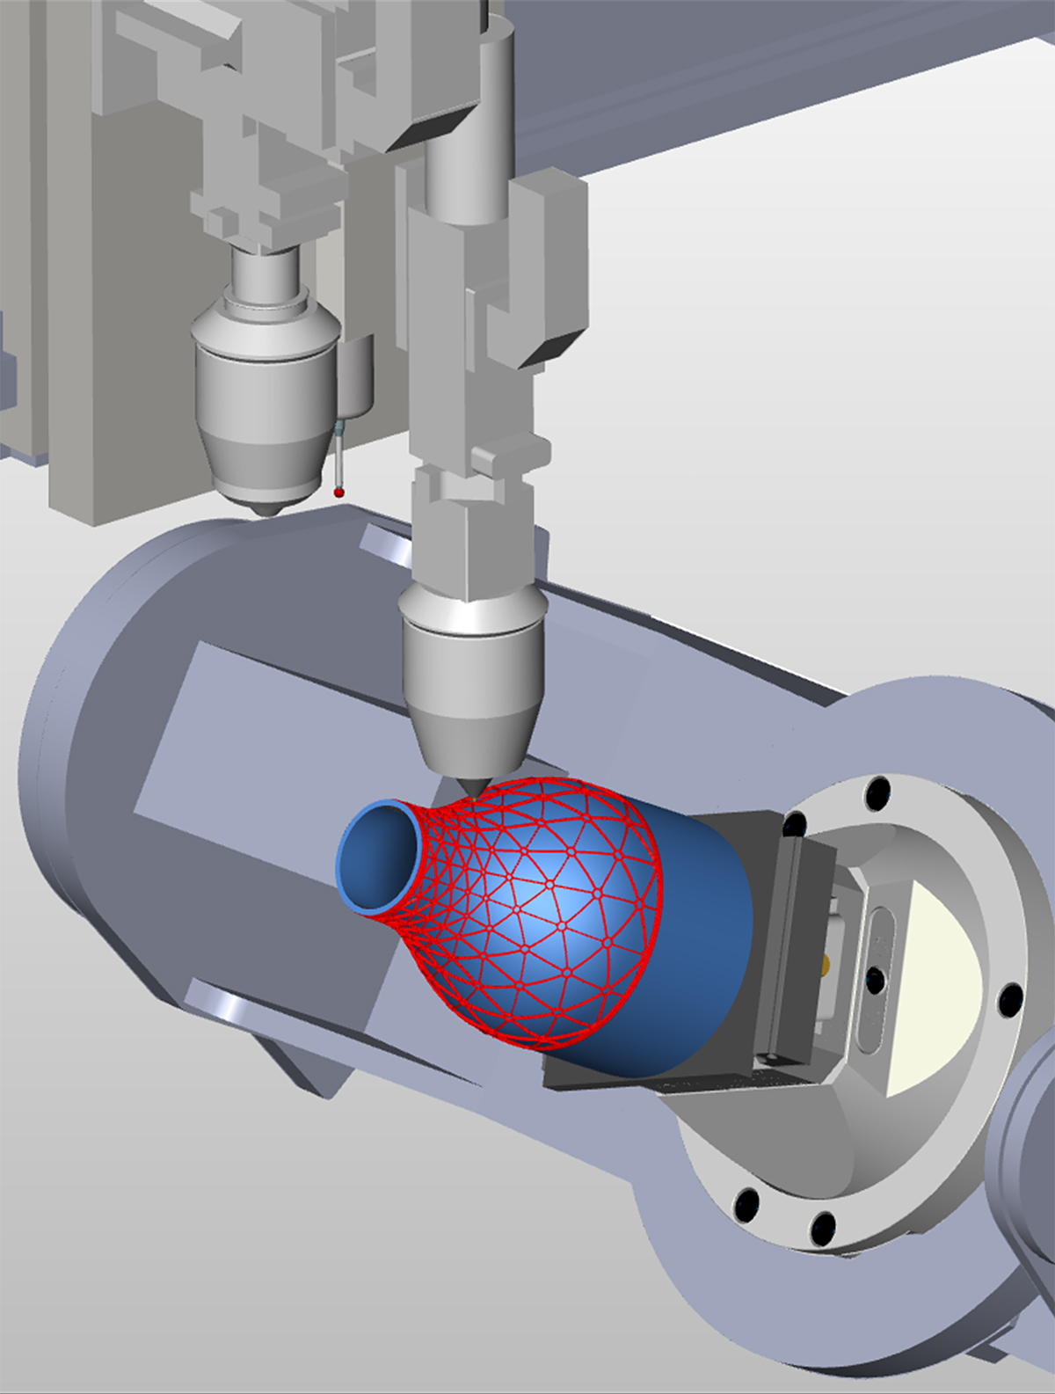
NEEDHAM, MA U.S.A. (January 23, 2025) – OPEN MIND Technologies , a leading developer of CAD/CAM software solutions worldwide, announced it will be highlighting and demonstrating an ADDITIVE Manufacturing capability option in its hyperMILL® CAD/CAM Software Suite to support 3D printing/ additive and hybrid processes at the Additive Manufacturing Users Group (AMUG) Exhibition “AMUGexpo”, Booth #38 located at Hilton Chicago, Chicago IL from March 30 – April 1, 2025. AMUGexpo is open exclusively to AMUG Education and Training Conference attendees. The AMUG conference takes place from March 30 – April 3.
A hyperMILL® VIRTUAL Machining capability is now available for additive manufacturing processes.

hyperMILL® ADDITIVE Manufacturing provides efficient hybrid processing with simultaneous additive and subtractive processing on one machine. As an early adopter of driving forward the implementation of integrated process chains, OPEN MIND has optimized hyperMILL® ADDITIVE Manufacturing technology to boost the efficiency, precision and process reliability of additive and hybrid manufacturing. At AMUGexpo, attendees can see additive part examples that were programmed and optimized with hyperMILL® ADDITIVE Manufacturing.

For highly complex 5-axis simultaneous processing, hyperMILL® ADDITIVE Manufacturing enables an array of flexible options for Directed Energy Deposition processes (DED) and Wire Arc Additive Manufacturing (WAAM). Both laser-based powder nozzle machining heads and WAAM can be controlled using hyperMILL® ADDITIVE Manufacturing for selective material deposition, as well as conveniently programmed and automatically simulated for collision avoidance. Using Powder Bed Fusion (PBF) and any necessary rework, hyperMILL® supports the full potential of additive manufacturing. hyperMILL® enables users to perfectly program cladding and milling together. True-to-detail additive and subtractive simulation as well as stock tracking between the individual process steps guarantee the greatest possible reliability. Key additive applications include repair of damaged components, cladding of additional surface skins, or creation of new components from a substrate. This also creates totally new options for combining different materials, such as when high-quality material layers need to be applied to carrier materials.

A VIRTUAL Machining capability for Additive Manufacturing processes is also offered, where machines often have limited axis ranges. Now hyperMILL® VIRTUAL Machining Optimizer can be used during NC code generation to simulate additive tool paths to optimize them for the machining.

For more information about hyperMILL® ADDITIVE Manufacturing, visit Additive Manufacturing | CAM software | OPEN MIND (openmind-tech.com).

About OPEN MIND Technologies AG
OPEN MIND Technologies AG is one of the world’s leading developers of powerful CAD/CAM software solutions for machine and controller-independent programming. OPEN MIND develops optimized CAD/CAM solutions that include innovative and unique features that can deliver significantly higher performance in both programming and machining. hyperMILL® is a completely modular CAD/CAM solution that provides state-of-the-art CAM technologies on its own CAD platform: from 2.5D, 3D and 5-axis machining as well as turning strategies and solutions for additive manufacturing, HSC and HPC machining. Whether automation, simulation or virtual machine – trendsetting technologies expand the product range and enable continuous digital process chains. Special applications, seamless interaction with all popular CAD solutions and exceptional customer service rounds out the company’s products and capabilities.
According to the "NC Market Analysis Report 2024" compiled by CIMdata, hyperMILL® is a leading, worldwide CAD/CAM solution. Innovative CAD/CAM technologies fulfill the highest demands in the automotive, tool and mold manufacturing, production machining, medical, job shops, energy, semiconductor and aerospace industries. OPEN MIND is a Mensch und Maschine company and has subsidiaries and qualified sales partners on all continents. You can find more information at https://www.openmind-tech.com/en-us/.
# # # # #

