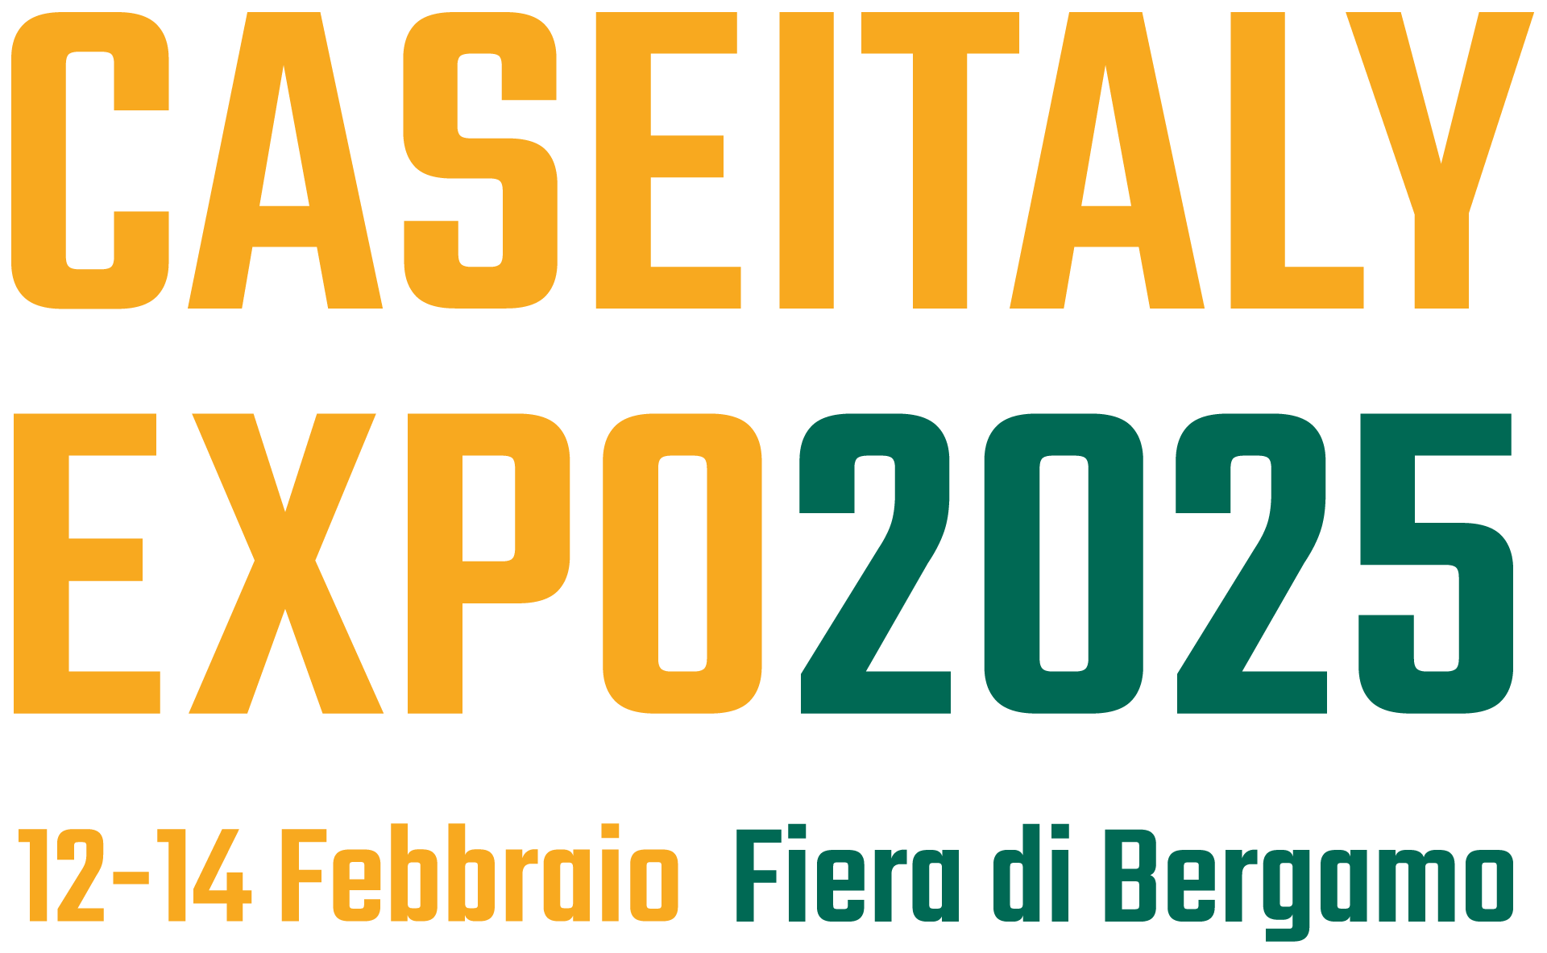
Press release
Schröder Group at CASEITALY EXPO 2025
Precise folding of pluggable profiles
Pavilion B,
Stand 114/118–196/200
Wessobrunn-Forst (Germany), 22 January 2025 – The Schröder Group will be represented by its partner Evomach at CASEITALY EXPO 2025, the international trade fair for the facade industry. From February 12 to 14, the MAKU folding machine will be exhibited at the Fiera de Bergamo (Pavilion B Stand 114/118-196/200). This machine with a working length of 3220 mm folds sheet steel up to 1.5 mm thick. An innovative function: In combination with the POS 2000 Professional graphic control and a fence that can be moved at an angle via two servo drives, it is possible to fold conical edges with extreme precision. This allows profiles to be created that can be plugged together precisely.
The pluggable profiles produced with precision in the tenth of a millimeter range using the two-axis back gauge save a lot of time on the construction site. Applications that require edges that are not parallel include parapet or wall covers, roof edge finishes, verge flashings and cladding with a gradient.

Available images
The following images are available for download in printable format at:
https://kk.htcm.de/press-releases/schroeder/

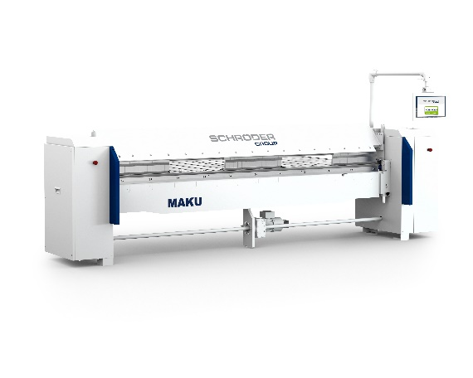

Image source: Schröder Group
Building facades made of sheet metal? Visitors to CASEITALY EXPO 2025 will get to know the MAKU folding machine from Schröder.

About Schröder Group
The Schröder Group consists of Hans Schröder Maschinenbau GmbH, which is located in Wessobrunn-Forst, Germany, SCHRÖDER-FASTI Technologie GmbH, located in Wermelskirchen, Germany and the SMU GmbH, located in Leinburg-Weißenbrunn.
Founded in 1949, Hans Schröder Maschinenbau GmbH unifies traditional and modern approaches in machine building: Successfully managed as a quality and customer-oriented, family-owned company, Hans Schröder Maschinenbau is specialized in the development of modern machine concepts for bending and cutting sheet metal.
The successful integration of the Fasti Company in 2006 and its worldwide presence make the Schröder Group one of today‘s leading providers of machines for bending, cutting, beading, flanging, and circular bending all types of sheet metal. The company‘s precision machines range from proven solutions for craftsmen to innovative, high-performance machines for automatic industrial production processes. 2021 the Schröder Group was expanded by the tool manufacturer SMU GmbH. Overall, the Schröder Group currently employs more than 300 people at various locations at home and abroad.
Further information is available at www.schroedergroup.eu/en.

Press contact:
Schröder Group
Hans Schröder Maschinenbau GmbH
Janina Biró
Feuchten 2
82405 Wessobrunn-Forst
Germany
T: +49 8809 9220-68
E-mail: jj@schroedergroup.eu
Website: www.schroedergroup.eu

HighTech communications GmbH
Brigitte Basilio
Brunhamstraße 21
81249 München
Germany
T: +49 89 500778-20
E-mail: b.basilio@htcm.de
Website: www.htcm.de

