FOR THE MEDIA
Versatile Performer: Panel Level Pick & Place Solution with Multi-Purpose Capabilities –NUCLEUS XLplus from ASMPT
Fan-Out Packaging: Booster for the AI Revolution
Singapore, January 14, 2025 – ASMPT, the world's leading supplier of hardware and software for semiconductor and electronics production, presents the multi-purposes precision pick & place solution NUCLEUS XLplus. ASMPT thus underlines the growing importance of advanced packaging in generative AI and high-performance computing (HPC).
“As the AI industry continues to push the boundaries of computing power, the demand for HPC and AI chips have become a driving force behind innovations in advanced packaging technologies,” explains Nelson Fan, Vice President of Business Development for Advanced Packaging at ASMPT. “With NUCLEUS XLplus, we are supplying exactly the right solution to enable the digital world.”
Fan-out packaging is becoming a key technology for high volume semiconductor manufacturing in the AI era. With the NUCLEUS series from ASMPT, for 2.5D, fan-out and embedded packaging as well as for complete wafer-level and panel-level assembly, ASMPT is addressing to this trend. NUCLEUS series offer more performance and additional functions in a more cost-effective manner.
Versatile in use
The NUCLEUS XLplus is the innovative ASMPT platform for Fan-Out Panel-Level Packaging (FOPLP). Developed according to SEMI 3D20 standard, it offers exceptional accuracy in SiP bonding and flexibility in the fan-out process. Key features of the NUCLEUS XLplus include:
- Support for a wide range of package configurations, from flip-chip to direct die attach for multi-die applications to meet the requirements of Heterogeneous Integration (HI) chipsets
- Processing of extra-large substrates up to 600 x 600 mm
- Optional high bond force and temperature capabilities for high-end applications
- High degree of automation with auto material load/unload and tooling change, meeting the SECS/GEM standard
“ASMPT is a pioneer in fan-out packaging technology,” summarizes Nelson Fan. “We can build on our lead in development and technology. With our machines, manufacturers around the world will bring next-generation AI applications to the market.”

Illustrations for downloading
The following print-ready artwork is available on the internet for downloading:
http://www.htcm.de/kk/asm

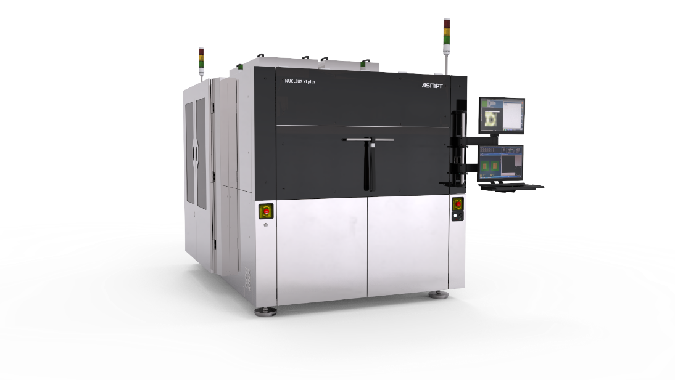
NUCLEUS XLplus fan-out panel-level packaging (FOPLP) system from ASMPT: innovative packaging for next-generation AI chips.
Image credit: ASMPT

About ASMPT Limited (“ASMPT”)
ASMPT Limited is a leading global supplier of hardware and software solutions for the manufacture of semiconductors and electronics. Headquartered in Singapore, ASMPT’s offerings encompass the semiconductor assembly & packaging, and SMT (surface mount technology) industries, ranging from wafer deposition to the various solutions that organise, assemble and package delicate electronic components into a vast range of end-user devices, which include electronics, mobile communications, computing, automotive, industrial and LED (displays). ASMPT partners with customers very closely, with continuous investment in R&D helping to provide cost-effective, industry-shaping solutions that achieve higher productivity, greater reliability, and enhanced quality.
ASMPT is listed on the Stock Exchange of Hong Kong (HKEX stock code: 0522), and is one of the constituent stocks of the Hang Seng TECH Index, Hang Seng Composite MidCap Index under the Hang Seng Composite Size Indexes, the Hang Seng Composite Information Technology Industry Index under the Hang Seng Composite Industry Indexes, the Hang Seng Corporate Sustainability Benchmark Index, and the Hang Seng HK 35 Index.
To learn more about ASMPT, please visit us at asmpt.com.

About ASMPT Semiconductor Solutions (“ASMPT SEMI”)
ASMPT SEMI is the leading supplier in advanced packaging and semiconductor assembly solutions. With a commitment to innovation and customer satisfaction, ASMPT SEMI provides a comprehensive range of products and services that cater to the evolving needs of the microelectronics industry. Their expertise spans across areas such as flip-chip and wafer-level packaging, advanced interconnect technologies, and more. ASMPT SEMI's cutting-edge solutions enable customers to achieve higher performance, increased reliability, and improved cost-efficiency when producing their semiconductor devices.
For more information about ASMPT SEMI, visit semi.asmpt.com.
Media contacts:
Global ASMPT Semiconductor Solutions Press Office
ASMPT Limited Hong Kong
Jessica Ho
Semiconductor Solutions
E-Mail: semi_stratmkt@asmpt.com
Website: semi.asmpt.com

Global ASMPT Press Office
ASMPT Ltd.
Susanne Oswald
Rupert-Mayer-Strasse 48
81379 Munich
Germany
Tel: +49 89 20800-26439
E-Mail: susanne.oswald@asmpt.com
Website: asmpt.com

