PRESS RELEASE

Hufschmied Zerspanungssysteme uses fully automatic quality control from VisCheck
AI-supported visual quality inspection
Bobingen/Winterlingen (Germany), January 8, 2025 – Hufschmied Zerspanungssysteme GmbH, together with VisCheck GmbH, an expert in intelligent image processing, has introduced a state-of-the-art solution for automated quality control in the production of tool blades. Thanks to the AI-based solution “OPDRA Qualität”, Hufschmied has been able to significantly reduce the time and effort required for quality control of its tool blades. The entire measurement of the tools and their visual inspection is now fully automated using a collaborative robot. This makes it possible to run the process around the clock. All measurement results are also stored in a digital twin. For this purpose, each blade is marked with a data matrix code, which enables the test results to be clearly assigned to the respective blade.
In addition to milling tools, Hufschmied also manufactures so-called cold-cut blades at its plant in Winterlingen in the Swabian Alb region of Germany. These blades are used in the automotive industry for cutting airbags to size. These extremely delicate 20mm × 5mm blades undergo an optical inspection: a machine vision system with machine learning software examines the blade tip in a grid of just 50 × 50 µm for potential damage. The overall geometry is then recorded with all lengths and angles. To fully automate quality assurance, a collaborative robot removes the blades from a rack with more than 150 slots and performs the optical measurements overnight. The images and measurement values generated in the inspection process are then stored in the cloud.
“For high-precision products such as Hufschmied tools, the time and effort required for quality control sometimes exceeds that for production. With our intelligent, adaptive image processing systems, we increase the efficiency of the inspection processes and make them fully automatable,” says Lutz Schaufuss, member of the management board of VisCheck GmbH.

Available images
The following images can be downloaded from the Internet in printable quality:
https://kk.htcm.de/press-releases/hufschmied/

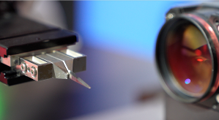Image source: VisCheck  Exact geometry and angle measurement | 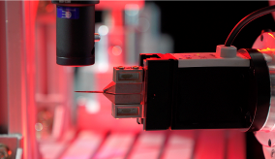Image source: VisCheck  Inspection of the blade tip in a grid of only 50 × 50 µm
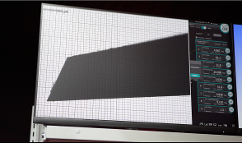Image source: VisCheck  Visualization and documentation of measurement results | 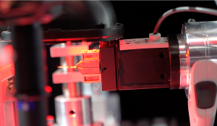Image source: VisCheck  Precise identification of the blades by scanning the data matrix codes
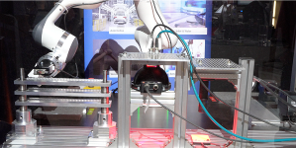Image source: VisCheck
Compact test stand with collaborative robot

About VisCheck GmbH
VisCheck GmbH was founded in 2015 by von Ralph Hufschmied and Guido Bruch with a focus on the development of advanced image processing solutions and is based in Bobingen near Augsburg. Initially, the focus was on research projects for quality control in the production of carbon materials and optical character recognition. Since 2023, standard applications have been developed that use fast, cost-effective and user-friendly computer vision solutions to serve quality control and process automation.
For more information: https://vischeck.de/

About Hufschmied Zerspanungssysteme GmbH
Established in 1991 and headquartered in Bobingen near Augsburg, Hufschmied Zerspanungssysteme GmbH is a manufacturer of high-quality tools for machinable production and friction stir welding. By specializing at an early stage in the machining of plastics, fiberglass materials and carbon fiber, Hufschmied has become a leader in Europe in the development of solutions for new materials. The company is an established system supplier to renowned machine tool manufacturers. Tools and manufacturing process consulting from Hufschmied are particularly valued in the automotive and aerospace industries as well as in medical technology. The company is involved in numerous organizations, including Composites United Deutschland e. V. Hufschmied's manufacturing operations are located in Bobingen, Winterlingen and Sigmaringen on the Swabian Alb. Hufschmied is certified according to ISO 9001:2015 (quality management) and ISO 14001:2015 (environmental management).

Hufschmied Zerspanungssysteme GmbH – One Cut Ahead
For more information: www.hufschmied.net

Additional information:  Hufschmied Zerspanungssysteme GmbH  Marco Beigl  Edisonstrasse 11d  86399 Bobingen  Germany  Phone: +49 8234 9664-0  Telefax: +49 8234 9664-99  E-Mail: info@hufschmied.net  www.hufschmied.net | Press contact:  HighTech communications GmbH  Brigitte Basilio  Brunhamstrasse 21  81249 Munich  Germany  Phone: +49 89 500778-20  E-Mail: b.basilio@htcm.de  www.htcm.de

