PRESS RELEASE

Würth Elektronik presents its dual-wire ICLEDs
Easy to Integrate, Quick to React
Waldenburg (Germany), January 8, 2025 – Würth Elektronik expands its range of WL-ICLEDs – RGB-LEDs with integrated controller (IC) – to include dual-wire ICLEDs. The components are addressable as pixels and consist of a red, green, and blue LED, as well as a pre-programmed IC in one package. They allow data transmission up to 13 times faster than with single-wire ICLEDs. The dual-wire ICLEDs offer precise control in LED applications that require individual color and brightness control, thereby significantly simplifying the wiring complexity. The integrated sleep mode makes them even more energy efficient.
These intelligent LEDs can be individually controlled in their pixel color across the full RGB spectrum and are digitally dimmable with 0 to 100 percent brightness levels – and all this with fast PWM rates of 20 kHz. This makes them ideal for high-speed animation and flicker-free display. Applications include industrial displays and HMI systems, full-color matrix displays, signal control systems, as well as smart and decorative lighting solutions, or gaming peripherals.
Würth Elektronik's dual-wire ICLEDs not only allow precise control of LEDs, but also offer innovative features such as the integrated sleep mode that reduces current consumption to around 1 µA per ICLED when not in operation. This enables significantly more energy-efficient use, especially in battery-powered systems. In addition, the clock frequency of the data signal is freely adjustable up to 15 MHz for flexible and fast data transmission. This combination of low power consumption and high adaptability makes the dual-wire ICLEDs particularly attractive for modern smart lighting applications.
The dual-wire ICLEDs support daisy chaining of multiple LEDs. They can be operated with supply voltages of 3.3 and 5.5 V_{DD}. The components, available in 1616 (1.6 × 1.6 mm) and 5050 (5.0 × 5.0 mm) packages, feature the industry-standard footprint and can thus replace less advanced LEDs without changes to the layout. With an MSL3 rating, they have an ideal moisture-sensitivity threshold. Samples can now be ordered.

Available images
The following images can be downloaded from the Internet in printable quality: https://kk.htcm.de/press-releases/wuerth/
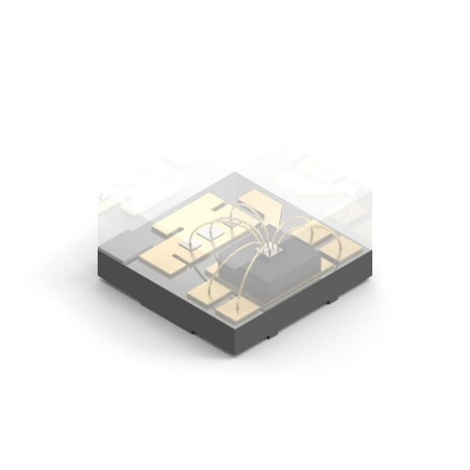Image source: Würth Elektronik  The new dual-wire ICLEDs consist of a red, green, and blue LED, as well as a control IC, enabling up to 13 times faster data transmission than with single-wire ICLEDs. (package size 1.6 × 1.6 mm) | 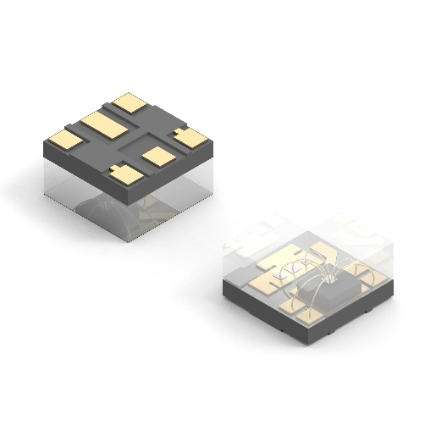Image source: Würth Elektronik  The components have the industry-standard footprint.
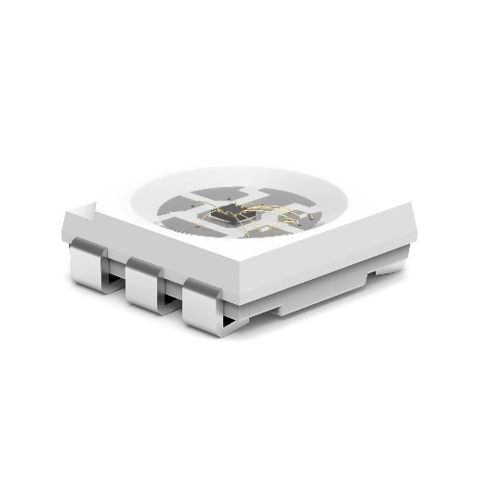Image source: Würth Elektronik  The 5050 package model is now also available as a dual wire version. | 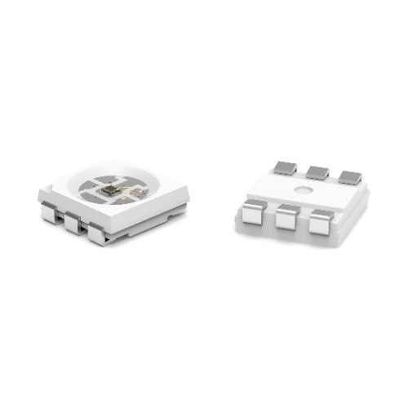Image source: Würth Elektronik  The 5.0 × 5.0 mm ICLEDs have a PLCC6 footprint.

About the Würth Elektronik eiSos Group
Würth Elektronik eiSos Group is a manufacturer of electronic and electromechanical components for the electronics industry and a technology company that spearheads pioneering electronic solutions. Würth Elektronik eiSos is one of the largest European manufacturers of passive components and is active in 50 countries. Production sites in Europe, Asia and North America supply a growing number of customers worldwide.
The product range includes EMC components, inductors, transformers, RF components, varistors, capacitors, resistors, quartz crystals, oscillators, power modules, Wireless Power Transfer, LEDs, sensors, radio modules, connectors, power supply elements, switches, push-buttons, connection technology, fuse holders and solutions for wireless data transmission. The portfolio is complemented by customized solutions.
The unrivaled service orientation of the company is characterized by the availability of all catalog components from stock without minimum order quantity, free samples and extensive support through technical sales staff and selection tools.
Würth Elektronik is part of the Würth Group, the global market leader in the development, production, and sale of fastening and assembly materials, and employs 7,900 people. In 2023, the Würth Elektronik Group generated sales of 1.24 Billion Euro.
Würth Elektronik: more than you expect!
Further information at www.we-online.com

Further information:  Würth Elektronik eiSos GmbH & Co. KG  Sarah Hurst  Clarita-Bernhard-Strasse 9  81249 Munich  Germany  Phone: +49 7942 945-5186  E-mail: sarah.hurst@we-online.de  www.we-online.com | Press contact:  HighTech communications GmbH  Brigitte Basilio  Brunhamstrasse 21  81249 Munich  Germany  Phone: +49 89 500778-20  E-mail: b.basilio@htcm.de  www.htcm.de

