FOR THE MEDIA
Backchannel production planning in
electronics manufacturing with WORKS
Dynamic planning for
highly efficient production
Shanghai (China), December 16, 2024 – The WORKS Software Suite from ASMPT raises production planning in electronics manufacturing to a new level. With its seamless integration of ERP systems and continuous data feedback loop, the software optimizes the planning process in real time – from receiving an order to starting its production run. The bottom line: absolute deadline compliance, shorter setup times, maximized machine utilization, and a resilient production that can respond to changes with great flexibility.
“In today’s dynamic electronics manufacturing environment, production planning is no longer a linear process,” explains Thomas Marktscheffel, Director Product Management Software Solutions at ASMPT SMT Solutions. “The only way to maximize your flexibility and machine utilization is with a closed-loop planning process where data streams flow between applications in a continuous optimization loop.”
After a customer order has been entered into the ERP system, the data is transferred to the two-stage planning system of WORKS, which automatically initiates a purely customer-oriented rough planning process that determines a suitable production window while taking into account factors like minimized setup times, material bottlenecks and the specific availability of resources.
Seamless integration and transparency
As modern high-mix/low-volume production environments must deal with constantly changing situations, flexibility is an absolute must. Accordingly, WORKS reacts dynamically. It automatically optimizes planning and production data in a continuous feedback loop until the best production strategy has been determined just as the production run commences.
This detailed planning approach combines the due date requirements taken from the ERP system with the current production situation on the shop floor while also taking factors like new orders, cancellations and quantity changes into account. Since completed production jobs can be automatically reported back to the ERP system, schedulers have an accurate overview of available production capacities when they talk to customers.
From an order's acceptance to its start of production, the planning process is designed to always find the most efficient solution that makes the best possible use of existing machine and personnel capacities. This reduces idle times and costs and increases the factory’s flexibility so that it can respond more effectively to schedule changes and rush jobs.
Significant competitive advantages
With its backchannel planning approach, ASMPT continues to implement its intelligent factory strategy, which relies on the continuous non-proprietary exchange of data via standardized interfaces in order to provide customers with investment protection and significant competitive advantages.

Illustrations for downloading
The following print-ready artwork is available on the internet for downloading:
https://kk.htcm.de/press-releases/asmpt/

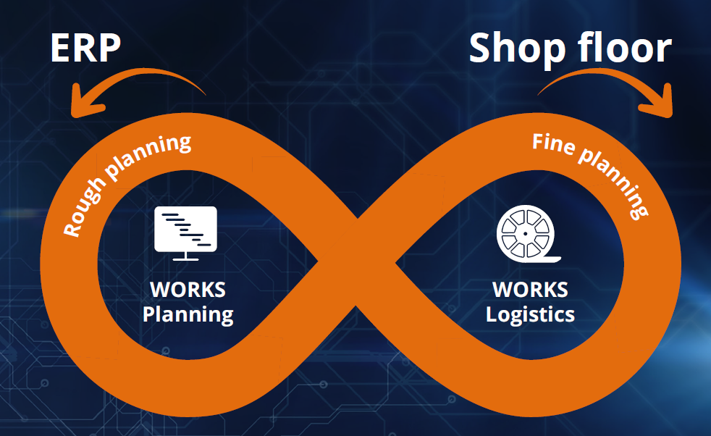 | 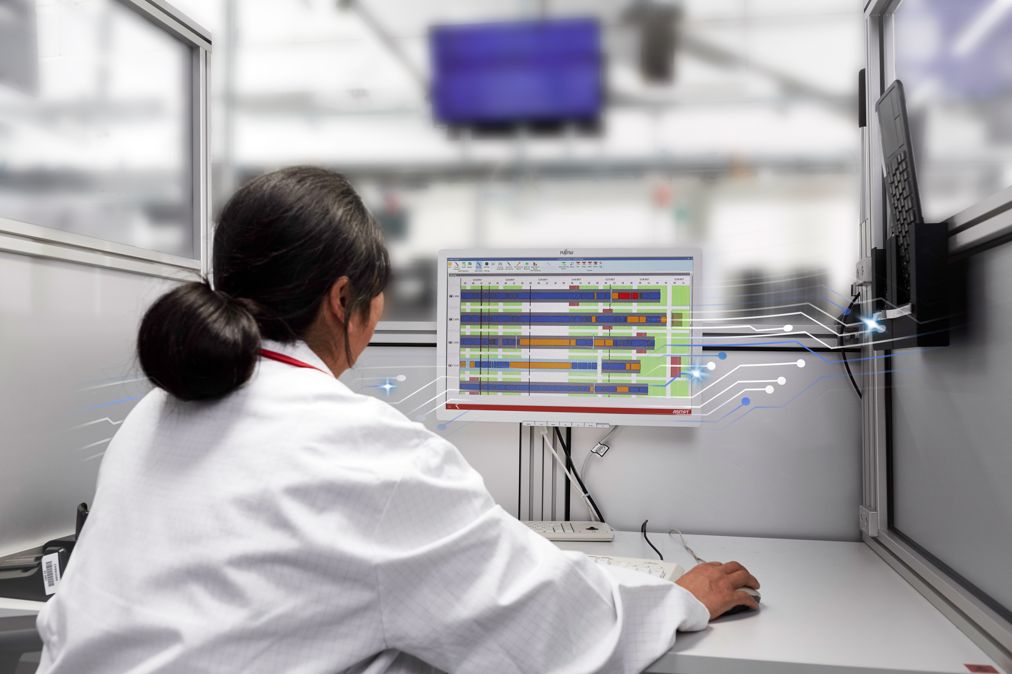
To enable a continuous planning and optimization process, WORKS Planning and WORKS Logistics work together in a backchannel loop.  Image credit: ASMPT | Integrated and dynamic production planning in the intelligent factory reduces costs and increases productivity, efficiency and flexibility.  Image credit: ASMPT

About ASMPT Limited (“ASMPT”)
ASMPT Limited is a leading global supplier of hardware and software solutions for the manufacture of semiconductors and electronics. Headquartered in Singapore, ASMPT’s offerings encompass the semiconductor assembly & packaging, and SMT (surface mount technology) industries, ranging from wafer deposition to the various solutions that organise, assemble and package delicate electronic components into a vast range of end-user devices, which include electronics, mobile communications, computing, automotive, industrial and LED (displays). ASMPT partners with customers very closely, with continuous investment in R&D helping to provide cost-effective, industry-shaping solutions that achieve higher productivity, greater reliability, and enhanced quality. ASMPT is also a founding member of the Semiconductor Climate Consortium.
ASMPT is listed on the Stock Exchange of Hong Kong (HKEX stock code: 0522), and is one of the constituent stocks of the Hang Seng TECH Index, Hang Seng Composite MidCap Index under the Hang Seng Composite Size Indexes, the Hang Seng Composite Information Technology Industry Index under the Hang Seng Composite Industry Indexes, the Hang Seng Corporate Sustainability Benchmark Index, and the Hang Seng HK 35 Index.
To learn more about ASMPT, please visit us at asmpt.com.

The ASMPT SMT Solutions segment
The mission of the SMT Solutions segment within ASMPT is to implement and support the Intelligent Factory at electronics manufacturers worldwide.
ASMPT solutions support the networking, automation, and optimization of central workflows with hardware, software and services that enable electronics manufacturers to transition to the Intelligent Factory in stages and enjoy dramatic improvements in productivity, flexibility, and quality. With its integrated open automation concept, ASMPT opens the door for its customers to economically feasible automation, entirely in accordance with their individual requirements – modular, flexible, and vendor-independent.
The product range includes hardware and software such as SIPLACE placement solutions, DEK printing solutions, inspection and storage solutions, and the Software Suite WORKS. With WORKS, ASMPT offers electronics manufacturers high-quality software for planning, controlling, analyzing and optimizing all processes on the shop floor. Maintaining close relationships with customers and technology partners is a central component of ASMPT’s strategy.
For more information about ASMPT SMT Solutions visit smt.asmpt.com.
Media contacts:
China ASMPT Press Office
SMT Solutions
Guan Jing
Phone: +86 (755) 26934550-2109
E-mail: jing.guan@asmpt.com
Website: smt.asmpt.com

Global ASMPT Press Office
ASMPT Ltd.
Susanne Oswald
Rupert-Mayer-Strasse 48
81379 Munich
Germany
Phone: +49 89 20800-26439
E-Mail: susanne.oswald@asmpt.com
Website: asmpt.com

