FOR THE MEDIA
Innovative bonding for power electronics
Silver sintering with SilverSAM
Singapore, December 9, 2024 –ASMPT presents with its SilverSAM™ SilverSAM machine a highlight for makers of modern power electronics: an innovative and versatile silver sintering machine that meets the great demands on bonding, which is particularly critical in the field of electromobility. SilverSAM sets new standards in interconnect technology for power electronics, particularly in the rapidly growing electric vehicle market.
Heat generation at the joints is unavoidable in power modules. With traditional bonding methods using tin or lead, however, this tends to create problems because the different materials expand at different rates when they get warm. This creates mechanical stresses that soft solder joints are often unable to cope with.
Sintering instead of soldering
One solution to this problem is silver sintering, which uses heat and pressure to solidify the silver-based solder paste far below the metal’s melting point (961°C or 1,762°F). Such a connection is characterized by high electrical and thermal conductivity and remains stable even under strong temperature fluctuations.
ASMPT’s versatile SilverSAM platform sinters silver particles into the previously applied paste with a combination of pressure, temperature, and time in a vacuum or in a nitrogen atmosphere, both of which are oxidation-free and copper-friendly environments. The machine operates with up to three presses with temperatures of up to 300 °C (572 °F) and a pressure of up to 30 mPA.
Versatile and easily scalable platform
The machine has an automatic tool changer and can process many materials, such as DBC (direct bonded copper) and AMB (active metal brazing). The SilverSAM also supports processes using wet and dry pastes as well as die transfer films.
With features like these, the SilverSAM opens the door to a wide range of applications in the volume production of power modules as well as in the assembly of heat sinks. One major area of application is in the rapidly growing market for electric vehicles with its modern DC fast-charging stations.
Complete sintering line from ASMPT
“Our product portfolio covers almost the entire sintering process,” says Dr. Johann Weinhändler, Managing Director of ASMPT AMICRA and in charge of ASMPT Semiconductor Solutions in Europe. “Our versatile DEK Galaxy printer applies the solder paste, our HiPO oven dries it, our POWER VECTOR platform places the components, and our SilverSAM platform does the sintering.” If you employ solutions from technology and market leader ASMPT, you get everything from a single source.”

Illustrations for downloading
The following print-ready artwork is available on the internet for downloading:
https://kk.htcm.de/press-releases/asmpt/

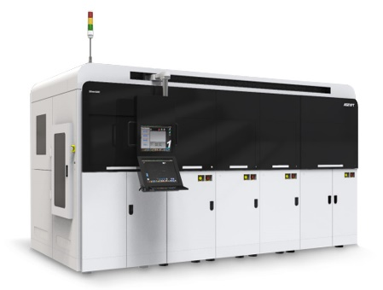

High-volume manufacturing with up to three presses: The SilverSAM sintering platform delivers an oxidation-free, copper-friendly environment for the production of power modules.

Image credit: ASMPT

About ASMPT Limited (“ASMPT”)
ASMPT Limited is a leading global supplier of hardware and software solutions for the manufacture of semiconductors and electronics. Headquartered in Singapore, ASMPT’s offerings encompass the semiconductor assembly & packaging, and SMT (surface mount technology) industries, ranging from wafer deposition to the various solutions that organise, assemble and package delicate electronic components into a vast range of end-user devices, which include electronics, mobile communications, computing, automotive, industrial and LED (displays). ASMPT partners with customers very closely, with continuous investment in R&D helping to provide cost-effective, industry-shaping solutions that achieve higher productivity, greater reliability, and enhanced quality. ASMPT is also a founding member of the Semiconductor Climate Consortium.
ASMPT is listed on the Stock Exchange of Hong Kong (HKEX stock code: 0522), and is one of the constituent stocks of the Hang Seng TECH Index, Hang Seng Composite MidCap Index under the Hang Seng Composite Size Indexes, the Hang Seng Composite Information Technology Industry Index under the Hang Seng Composite Industry Indexes, the Hang Seng Corporate Sustainability Benchmark Index, and the Hang Seng HK 35 Index.
To learn more about ASMPT, please visit us at asmpt.com.

About ASMPT Semiconductor Solutions (“ASMPT SEMI”)
ASMPT SEMI is the leading supplier in advanced packaging and semiconductor assembly solutions. With a commitment to innovation and customer satisfaction, ASMPT SEMI provides a comprehensive range of products and services that cater to the evolving needs of the microelectronics industry. Their expertise spans across areas such as flip-chip and wafer-level packaging, advanced interconnect technologies, and more. ASMPT SEMI's cutting-edge solutions enable customers to achieve higher performance, increased reliability, and improved cost-efficiency when producing their semiconductor devices.
For more information about ASMPT SEMI, visit semi.asmpt.com.
Media contacts:
Global ASMPT Semiconductor Solutions Press Office
ASMPT Limited Hong Kong
Jessica Ho
Semiconductor Solutions
E-Mail: semi_stratmkt@asmpt.com
Website: semi.asmpt.com

Global ASMPT Press Office
ASMPT Ltd.
Susanne Oswald
Rupert-Mayer-Strasse 48
81379 Munich
Germany
Phone: +49 89 20800-26439
E-Mail: susanne.oswald@asmpt.com
Website: asmpt.com

