PRESS RELEASE

Hufschmied presents solution for manufacturing tools for embossing bipolar plates
The key for the fuel cell
Bobingen (Germany), December 4, 2024 – Hufschmied Zerspanungssysteme GmbH is introducing milling tools under the name Bumble-Bi® that make the machining of stamping tools for the production of bipolar plates more economical. The successful series production of bipolar plate stacks depends on these stamping tools, which must have burr-free surfaces with a flatness of <20 μm. The new tool family includes high-feed roughing tools as well as ball and torus tools for roughing and finishing. The Bumble-Bi® tools enable machining strategies with very high cutting pressure.
“Fuel cell technology is one of the keys to sustainable mobility. High production costs have been one of the obstacles to widespread use so far. We saw an opportunity to contribute to more efficient production in the area of mold making,” explains Christel Hufschmied, managing director of Hufschmied Zerspanungssysteme GmbH. “The new Bumble-Bi® tool series, with significantly increased tool life and improved feed parameters, is the result of extensive research and development work. This has been achieved not least through an optimized transition from the tool cutting edge to the tool neck.”
Channels for the reaction gases
The bipolar plate is the heart of every fuel cell. It simultaneously acts as a structural carrier plate and forms the poles of the fuel cell. The anode plate conducts H₂, the cathode plate O₂. The bipolar plate ensures an even distribution of the reaction gases and conducts them into the reaction zone via flow profiles on both sides. The requirements for embossing tools to produce these profiles are immense. The materials metal, graphite and composite used as bipolar plates must fulfill the requirements for dimensional accuracy and surface quality at very high cycle times.

Available images
The following images can be downloaded from the Internet in printable quality:
https://kk.htcm.de/press-releases/hufschmied/
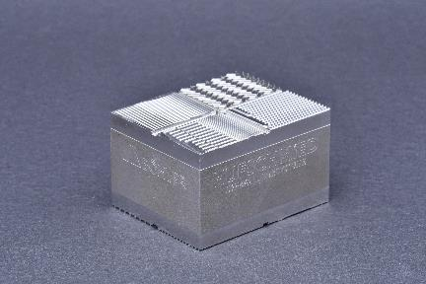  Image source:  Hufschmied Zerspanungssysteme  An example of different bipolar geometries, manufactured in cooperation with OPEN MIND (hyperMILL), rödersTEC, Zeiss, MHT and Böhler. | 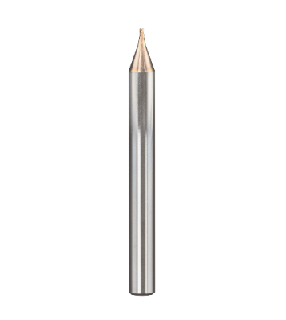  Image source:  Hufschmied Zerspanungssysteme  Bumble-Bi® is a Hufschmied's answer to the challenges of mold making for fuel cell technology.

About Hufschmied Zerspanungssysteme GmbH
Established in 1991 and headquartered in Bobingen near Augsburg, Hufschmied Zerspanungssysteme GmbH is a manufacturer of high-quality tools for machinable production and friction stir welding. By specializing at an early stage in the machining of plastics, fiberglass materials and carbon fiber, Hufschmied has become a leader in Europe in the development of solutions for new materials. The company is an established system supplier to renowned machine tool manufacturers. Tools and manufacturing process consulting from Hufschmied are particularly valued in the automotive and aerospace industries as well as in medical technology. The company is involved in numerous organizations, including Composites United Deutschland e. V. Hufschmied's manufacturing operations are located in Bobingen, Winterlingen and Sigmaringen on the Swabian Alb. Hufschmied is certified according to ISO 9001:2015 (quality management) and ISO 14001:2015 (environmental management).

Hufschmied is the only tool manufacturer with its own diamond coating plant.
For more information: www.hufschmied.net

Additional information:  Hufschmied Zerspanungssysteme GmbH  Marco Beigl  Edisonstrasse 11d  86399 Bobingen  Germany  Phone: +49 8234 9664-0  Telefax: +49 8234 9664-99  E-Mail: info@hufschmied.net  www.hufschmied.net | Press contact:  HighTech communications GmbH  Brigitte Basilio  Brunhamstrasse 21  81249 Munich  Germany  Phone: +49 89 500778-20  E-Mail: b.basilio@htcm.de  www.htcm.de

