PRESS RELEASE

Würth Elektronik introduces its Metis-e radio module
Optimized for Metering Applications
Waldenburg (Germany), December 3, 2024 – Würth Elektronik presents a small, cost-optimized radio module for transmitting meter readings in accordance with the wireless M-Bus standard EN 13757-4. It can be used both as a transmitter for a meter as well as a receiver for a gateway or data collector. Metis-e is based on the SoC CC1310 chipset from Texas Instruments and operates on the 868 MHz frequency band.
The metering radio module from Würth Elektronik has a range up to 1500 meters and, with dimensions of just 12 × 8 × 2 mm³, is more than 50 percent smaller than comparable models on the market. Metis-e is optimized for automatic meter reading and for use in battery-powered devices. The module has two energy-saving modes, requiring 1.6 µA in standby mode and just 200 nA in shutdown mode. The different wM-Bus modes S, T, and C can also be selected to support various applications with different requirements.
The module offers developers great flexibility with its extensive features, which can be accessed via the UART interface. Metis-e has a comprehensive user manual and a software development kit available.

Available images
The following images can be downloaded from the Internet in printable quality: https://kk.htcm.de/press-releases/wuerth/
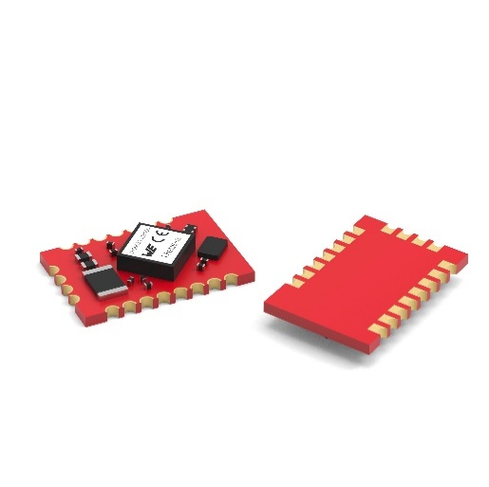Image source: Würth Elektronik
Metis-e is a cost-effective and power-saving radio module for measuring points.

About the Würth Elektronik eiSos Group
Würth Elektronik eiSos Group is a manufacturer of electronic and electromechanical components for the electronics industry and a technology company that spearheads pioneering electronic solutions. Würth Elektronik eiSos is one of the largest European manufacturers of passive components and is active in 50 countries. Production sites in Europe, Asia and North America supply a growing number of customers worldwide.
The product range includes EMC components, inductors, transformers, RF components, varistors, capacitors, resistors, quartz crystals, oscillators, power modules, Wireless Power Transfer, LEDs, sensors, radio modules, connectors, power supply elements, switches, push-buttons, connection technology, fuse holders and solutions for wireless data transmission. The portfolio is complemented by customized solutions.
The unrivaled service orientation of the company is characterized by the availability of all catalog components from stock without minimum order quantity, free samples and extensive support through technical sales staff and selection tools.
Würth Elektronik is part of the Würth Group, the global market leader in the development, production, and sale of fastening and assembly materials, and employs 7,900 people. In 2023, the Würth Elektronik Group generated sales of 1.24 Billion Euro.
Würth Elektronik: more than you expect!
Further information at www.we-online.com

Further information:  Würth Elektronik eiSos GmbH & Co. KG  Sarah Hurst  Clarita-Bernhard-Strasse 9  81249 Munich  Germany  Phone: +49 7942 945-5186  E-mail: sarah.hurst@we-online.de  www.we-online.com | Press contact:  HighTech communications GmbH  Brigitte Basilio  Brunhamstrasse 21  81249 Munich  Germany  Phone: +49 89 500778-20  E-mail: b.basilio@htcm.de  www.htcm.de

