PRESS RELEASE
FIDO token meets smart access control: Swissbit presents the iShield Key MIFARE
Westford, Massachusetts, USA / Bronschhofen, Switzerland, December 5, 2024 – Swissbit is expanding its range of authentication solutions with a unique innovation: the iShield Key MIFARE. The new hardware security key is the first of its kind to combine the advantages of a FIDO Security Key with the NFC technology MIFARE DESFire EV3. The iShield Key MIFARE thus opens up a wide range of applications that go far beyond traditional user authentication and set new standards, particularly in the field of smart access control. The iShield Key MIFARE is available now.
All-round talent for more security
The iShield Key MIFARE provides businesses and users with a comprehensive range of functions. Powered by MIFARE DESFire EV3, it ensures secure, phishing-resistant authentication while supporting diverse applications such as access control, time tracking and payment systems. By consolidating multiple functions into a single token, the iShield Key MIFARE enhances security, streamlines business operations, and reduces costs.
The iShield Key MIFARE seamlessly integrates the latest IT security standards with the practical needs of modern businesses. Along with secure logins to operating systems, websites, and online services via FIDO2 and FIDO U2F, the Security Key enables the generation of one-time passwords using HOTP and TOTP. It supports PIV (Personal Identity Verification) for document signing and encryption and can store at least 300 passkeys for passwordless website logins. With its wide range of features, the iShield Key MIFARE is an ideal solution for meeting today’s IT security demands.
MIFARE DESFire: More than just access control
By integrating MIFARE DESFire EV3, the latest addition to the Swissbit iShield Key family offers a broad spectrum of applications that go far beyond traditional access control. Companies and institutions can utilize this security key for time tracking, micropayments, loyalty programs, campus and student ID cards, and even advanced public transportation systems. The versatility of MIFARE DESFire technology makes the iShield Key MIFARE a flexible solution for a wide range of industries and needs.
Quality “Made in Germany”
The iShield Key MIFARE is manufactured in-house at Swissbit’s own semiconductor facility in Berlin to industrial-grade standards. With its robust construction and high reliability, the iShield Key MIFARE meets the requirements of today’s businesses while providing the flexibility that modern IT infrastructures need.

Versions, Availability, and Distribution
The Swissbit iShield Key MIFARE is available in two versions: a Pro version that supports FIDO2 along with additional security protocols such as PIV, HOTP, and TOTP, and a FIDO2 version that focuses on FIDO2/WebAuthn and its predecessor, U2F. At launch, both versions will be offered with a USB-A interface and are available through Swissbit's distribution partners. For more information, please visit swissbit.com/ishield-key.

Available images
The following images are available for downloading in printable format at: https://kk.htcm.de/press-releases/swissbit/
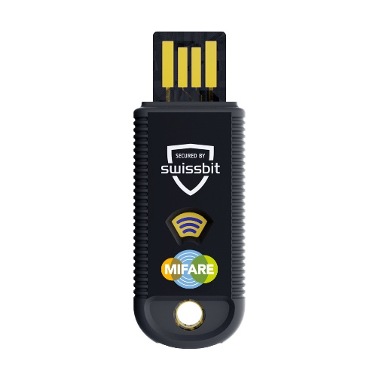  Image source: Swissbit  The new iShield Key MIFARE from Swissbit. | 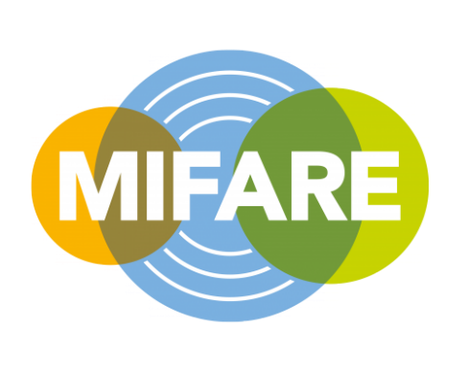  Image source: NXP  MIFARE technology: The basis for numerous identification and transaction systems.

About Swissbit
Swissbit AG is the leading European technology company for data storage and security solutions. Our vision is to build a connected world where data and identities are trusted, ensuring digital sovereignty. Combining unique expertise in hardware and firmware design with advanced packaging know-how, Swissbit develops and manufactures innovative data storage, data protection and digital identity solutions.
Swissbit's solutions are utilized across many industries, including industrial automation, networking & communications, edge computing, transportation, critical infrastructure, defense, and the public sector.
Founded in 2001, Swissbit has offices in Switzerland (HQ), Germany, the USA, Japan, and Taiwan, and maintains its own semiconductor production facility in Berlin, Germany.
For further information, please visit www.swissbit.com.

Regional Headquarters North and South America:
Swissbit NA Inc.
238 Littleton Rd #202b
Westford, MA 01886
USA
Tel: +1 (978) 490-3252
Email: salesna@swissbit.com
www.swissbit.com

Contact Headquarters:  Swissbit AG  Marian Weber  Industriestrasse 4  9552 Bronschhofen  Switzerland  Tel: +49 172 854 88 26  Email: marian.weber@swissbit.com  www.swissbit.com | Press Agency:  HighTech communications GmbH  Brigitte Basilio  Brunhamstrasse 21  81249 Munich  Germany  Tel: +49 89 500778-20  Email: b.basilio@htcm.de  www.htcm.de

