PRESS RELEASE

Würth Elektronik improves and expands its balun series
Creating Symmetry in Applications over a Wide Frequency Range
Waldenburg (Germany), November 27, 2024 – Würth Elektronik has expanded its WE-BAL series of baluns. The components for coupling symmetrical and asymmetrical transmission lines feature improved materials and manufacturing processes, and now cover wider frequency ranges from 673 MHz to 5900 MHz.
In numerous applications, such as antenna systems, audio and video devices, wireless communication systems, PoE systems, and measuring instruments, it is necessary to couple symmetrical and asymmetrical transmission lines in such a way that prevents signal loss. Thanks to their wide frequency range, the SMT baluns from Würth Elektronik enhance signal transmission and minimize interference across a large number of applications. The SMT baluns with symmetrical impedance ranging from 50 to 200 ohms feature a compact design (in 0603 and 0805 packages) and low insertion loss of up to a maximum of 2.0 dB.
The components are now available from stock without a minimum order quantity. Free samples are available.

Available images
The following images can be downloaded from the Internet in printable quality: https://kk.htcm.de/press-releases/wuerth/
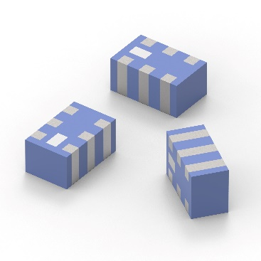
The WE-BAL SMT baluns from Würth Elektronik cover a wide frequency spectrum.
Image source: Würth Elektronik

About the Würth Elektronik eiSos Group
Würth Elektronik eiSos Group is a manufacturer of electronic and electromechanical components for the electronics industry and a technology company that spearheads pioneering electronic solutions. Würth Elektronik eiSos is one of the largest European manufacturers of passive components and is active in 50 countries. Production sites in Europe, Asia and North America supply a growing number of customers worldwide.
The product range includes EMC components, inductors, transformers, RF components, varistors, capacitors, resistors, quartz crystals, oscillators, power modules, Wireless Power Transfer, LEDs, sensors, radio modules, connectors, power supply elements, switches, push-buttons, connection technology, fuse holders and solutions for wireless data transmission. The portfolio is complemented by customized solutions.
The unrivaled service orientation of the company is characterized by the availability of all catalog components from stock without minimum order quantity, free samples and extensive support through technical sales staff and selection tools.
Würth Elektronik is part of the Würth Group, the global market leader in the development, production, and sale of fastening and assembly materials, and employs 7,900 people. In 2023, the Würth Elektronik Group generated sales of 1.24 Billion Euro.
Würth Elektronik: more than you expect!
Further information at www.we-online.com

Further information:  Würth Elektronik eiSos GmbH & Co. KG  Sarah Hurst  Clarita-Bernhard-Strasse 9  81249 Munich  Germany  Phone: +49 7942 945-5186  E-mail: sarah.hurst@we-online.de  www.we-online.com | Press contact:  HighTech communications GmbH  Brigitte Basilio  Brunhamstrasse 21  81249 Munich  Germany  Phone: +49 89 500778-20  E-mail: b.basilio@htcm.de  www.htcm.de

