PRESS RELEASE
New Würth Elektronik reference guide “ABC of Shielding”
Shielded
Waldenburg (Germany), November 13, 2024 – In a recently released compendium, Würth Elektronik presents the basic principles and practice-oriented application examples for modern EMC shielding technologies: In “ABC of Shielding” five expert authors share their knowledge and experience in a concise and easy-to-understand format.
Today, electromagnetic compatibility is critical to the success of any electronic device. A new product only receives a CE mark and may only be sold if it does not emit unacceptable interference signals and its functionality is not affected by electromagnetic waves. Careful shielding is a basic requirement for EMC compliance. That’s reason enough for Würth Elektronik to dedicate an entire book to this important topic.
From theory to practice in four steps
The work by Antonio Alcarria, Victor Martinez, Dr. Adrian Suarez, Dr. Jorge Victoria, and Dr.-Ing. (Doctor of Engineering) Heinz Zenkner is divided into four sections:
- Basic principles: The first part focuses on the impact of PCB, housing, and system design on the shielding effectiveness, basic physical effects and parameters, as well as emission and immunity requirements. It also covers the relevant standards and how to meet them using shielding materials.
- Components: The second part of the book describes various shielding materials and provides detailed characterization. The reader picks up valuable information on material compatibility, compression forces, and assembly.
- Applications: This chapter includes many specific examples of using various shielding materials, such as for shielding at the PCB level, wireless power supplies, as well as NFC and RFID applications.
- Tips for EMC shielding design: The final chapter provides a comprehensive overview with numerous specific examples for selecting and using shielding materials.

The “ABC of Shielding” reference guide, 1st edition, language: English, can now be ordered directly from Würth Elektronik. It will also be available as an e-book from early 2025.

Available images
The following images can be downloaded from the Internet in printable quality: https://kk.htcm.de/press-releases/wuerth/
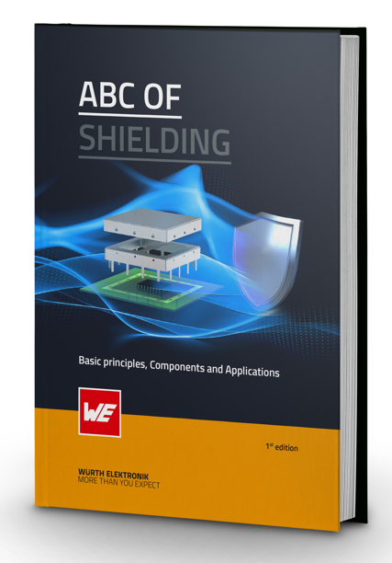
Image source: Würth Elektronik
“ABC of Shielding”, first issue: Shielding in Theory and Practice

About the Würth Elektronik eiSos Group
Würth Elektronik eiSos Group is a manufacturer of electronic and electromechanical components for the electronics industry and a technology company that spearheads pioneering electronic solutions. Würth Elektronik eiSos is one of the largest European manufacturers of passive components and is active in 50 countries. Production sites in Europe, Asia and North America supply a growing number of customers worldwide.
The product range includes EMC components, inductors, transformers, RF components, varistors, capacitors, resistors, quartz crystals, oscillators, power modules, Wireless Power Transfer, LEDs, sensors, radio modules, connectors, power supply elements, switches, push-buttons, connection technology, fuse holders and solutions for wireless data transmission. The portfolio is complemented by customized solutions.
The unrivaled service orientation of the company is characterized by the availability of all catalog components from stock without minimum order quantity, free samples and extensive support through technical sales staff and selection tools.
Würth Elektronik is part of the Würth Group, the global market leader in the development, production, and sale of fastening and assembly materials, and employs 7,900 people. In 2023, the Würth Elektronik Group generated sales of 1.24 Billion Euro.
Würth Elektronik: more than you expect!
Further information at www.we-online.com

Further information:  Würth Elektronik eiSos GmbH & Co. KG  Sarah Hurst  Clarita-Bernhard-Strasse 9  81249 Munich  Germany  Phone: +49 7942 945-5186  E-mail: sarah.hurst@we-online.de  www.we-online.com | Press contact:  HighTech communications GmbH  Brigitte Basilio  Brunhamstrasse 21  81249 Munich  Germany  Phone: +49 89 500778-20  E-mail: b.basilio@htcm.de  www.htcm.de

