MEDIA INFORMATION

Hufschmied introduces high-performance roughing tools for aluminum
Lots of small chips very quickly
Bobingen (Germany), November 11, 2024 – Hufschmied Zerspanungssysteme GmbH is expanding its range of specialized machining tools for aluminum. Anyone machining aluminum workpieces with a high chip volume from solid material will reach their goal faster with the HC403BDSR high-performance roughing tool. Available in diameters from 6 to 20 mm, the tool enables full slot milling up to a depth of 3xD at maximum feed rates in all common aluminum alloys. Thanks to its special cord toothing, it produces small, easy-to-handle chips so that the chip container rarely needs to be emptied despite high material removal rates.
Following in the fierce footsteps of Hufschmied‘s Wolverine® HC403BD roughing/finishing tool, the HC403BDSR takes aluminum machining to the next level. It is a solid carbide high-performance roughing tool with extreme material removal rates. The cutting edge with cord serration is particularly stable thanks to a corner radius, and a special face geometry which allows high ramp angles when plunging. A newly developed coating called "ALX1" is being used for the first time on this tool. Polished flutes and the central internal cooling ensure that chips are optimally removed.
The HC403BDSR high-performance roughing cutter was specially developed for machining from solid material and is suitable for applications in aerospace, automotive, motorsport or other areas where large volumes need to be machined in a short time in order to produce high-precision small batches.

Available image material
The following printable images are available for download on the Internet:
https://kk.htcm.de/press-releases/hufschmied/

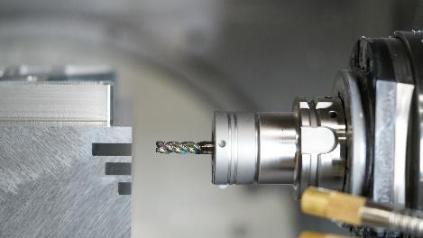  Image source: Hufschmied Zerspanungssysteme  HC403BDSR enables full slot milling up to a depth of 3xD at maximum feed rates in all common aluminum alloys. | 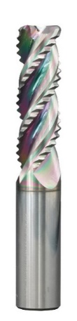  Image source: Hufschmied Zerspanungssysteme  Thanks to its special cord toothing, the HC403BDSR high-performance roughing tool produces small, easy-to-handle chips.

About Hufschmied Zerspanungssysteme GmbH
Established in 1991 and headquartered in Bobingen near Augsburg, Hufschmied Zerspanungssysteme GmbH is a manufacturer of high-quality tools for machinable production and friction stir welding. By specializing at an early stage in the machining of plastics, fiberglass materials and carbon fiber, Hufschmied has become a leader in Europe in the development of solutions for new materials. The company is an established system supplier to renowned machine tool manufacturers. Tools and manufacturing process consulting from Hufschmied are particularly valued in the automotive and aerospace industries as well as in medical technology. The company is involved in numerous organizations, including Composites United Deutschland e. V. Hufschmied's manufacturing operations are located in Bobingen, Winterlingen and Sigmaringen on the Swabian Alb. Hufschmied is certified according to ISO 9001:2015 (quality management) and ISO 14001:2015 (environmental management).

Hufschmied is the only tool manufacturer with its own diamond coating plant.
For more information: www.hufschmied.net

Additional information:  Hufschmied Zerspanungssysteme GmbH  Marco Beigl  Edisonstrasse 11d  86399 Bobingen  Germany  Phone: +49 8234 9664-0  Telefax: +49 8234 9664-99  E-Mail: info@hufschmied.net  www.hufschmied.net | Press contact:  HighTech communications GmbH  Brigitte Basilio  Brunhamstrasse 21  81249 Munich  Germany  Phone: +49 89 500778-20  E-Mail: b.basilio@htcm.de  www.htcm.de

