PRESS RELEASE
cts Introduces Filling Automation for Radiopharmaceuticals at EANM’24
Compact Open Vial Dispensing System impresses nuclear medicine professionals
Burgkirchen (Germany), November 6, 2024 – cts GmbH presented its Open Vial Dispensing System (OVD) for the first time to a broad specialist audience at EANM’24, held from October 19–23 in Hamburg. The device quickly resonated with the nuclear medicine community, drawing strong interest from members of the European Association of Nuclear Medicine. This compact system addresses a critical need in clinical practice by enabling precise dosing and filling of radiopharmaceuticals into open injection vials, essential for SPECT and PET radiodiagnostics as well as therapeutic applications. The cGMP-compliant system was well-received for its potential to streamline this sensitive process.
At the Nuclear Medicine Congress in Hamburg, cts’s automation specialists made a bold statement with the presentation of their Open Vial Dispensing System (OVD), confidently demonstrating that their system fully meets the specific demands of the industry. The enthusiastic response from experts has strengthened the innovative company’s expansion plans; with a new production facility and increased manufacturing capacity, cts is set to make the OVD system available to an even broader market.
The device’s compact design, tailored for integration and operation in Class A isolators, was praised as highly practical and easy to clean. The same was said for its convenient operation and precision. "We never anticipated such a warm welcome as a new provider in this market," says Alfred Pammer, VP of Sales, Marketing, and Product Management at cts. "Visitors at our small information stand consistently showed a sharp eye for technical details, and they especially recognized that we’ve developed significantly better solutions in many areas compared to currently available devices."
Convincing with technical details designed for the demands of nuclear medicine
The compact hygienic design of cts’s Open Vial Dispensing System (OVD) impressed attendees, with professionals particularly noting the switch from pneumatics to electronics for added precision. The flexibility to use standardized, sterilized applicator kits from any manufacturer also drew praise, as did the software’s robust permission system and compliance with GAMP and 21 CFR Part 11, ensuring seamless workflow management.
“Many questions reflected genuine interest, and our willingness to make custom adjustments - such as vial size modifications or adaptations for practices in other continents - pleasantly surprised some of our international visitors,” says Alfred Pammer. “We collaborated with a German hospital during development, but the feedback from international contacts has shown us that the OVD will be very well-received in radiology departments worldwide.”

Available images
The following images are available for download on the Internet: https://kk.htcm.de/press-releases/cts/
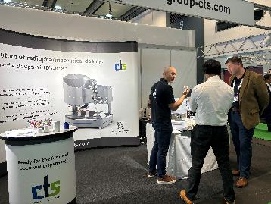  Bildquelle: cts  Alfred Pammer, VP of Sales, Marketing, and Product Management at cts (left), in discussion with nuclear medicine professionals at the EANM Congress. | 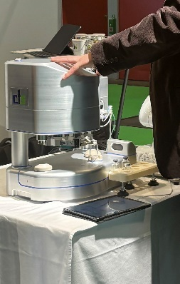  Bildquelle: cts  The highly functional design of the cts OVD, optimized for laminar flow and VHP cleaning, lends an elegance that made it a focal point at the event.

About cts GmbH
"cts - more than automation": cts GmbH, Burgkirchen, founded in 2006, offers customers a complete range of services for process and production automation. More than 350 employees develop innovative solutions at several locations in Germany, Austria, the Czech Republic and Slovenia. These range from the construction of a single control cabinet to the automation of complete production plants, including information management. The comprehensive range of services offered by the established system integrator from southern Bavaria includes feasibility studies, conceptual design, planning, implementation, maintenance and servicing of running systems and plants.
cts installs stationary and mobile robots in plant and mechanical engineering for high-tech industries such as automotive, electronics, radiopharmaceuticals and the semiconductor industry. As one of the leading companies for the integration and operation of heterogeneous fleets of autonomous, intelligent transport vehicles (AMR/AIV/AGV/FTS), cts also sets standards in automated material supply. Here, cts solutions are often used in combination with production-related or centralized automated storage systems.
In highly sensitive industry segments such as chemicals and petrochemicals, life sciences or pharmaceuticals, cts supports its customers in plant automation from planning to qualification. The Robotics business field at cts includes the programming, installation and optimization of welding and production robots as well as fully automated packaging systems. The extensive portfolio of the specialist for process and production automation is complemented by software solutions for data acquisition, evaluation, visualization and optimization of machines and systems as well as a suitable service and support offering.

Further information can be found at www.group-cts.de

Contact:  cts GmbH  Susanne Meidl  Fuhrmannstrasse 10  84508 Burgkirchen  Germany  Mobil: +49 163 3054 186  E-Mail: Susanne.Meidl@group-cts.de  www.group-cts.de | Press agency:  HighTech communications GmbH  Brigitte Basilio  Brunhamstrasse 21  81249 Munich  Germany  Telefon: +49 89 500778-20  E-Mail: b.basilio@htcm.de  www.htcm.de

