Press Release
Distance measurement compliant with EN ISO 13849 PLd with LPR-SAFE
Radar for functional safety
Neubiberg (Germany), November 5, 2024 – With LPR®-SAFE, Symeo presents a system for safe distance measurement compliant with the functional safety standard EN ISO 13849 PLd. It is suitable for semi-automatic and automatic crane systems, rail-bound vehicles, and other applications. The system allows manufacturers to integrate an already certified solution during their development of functionally safe lifting and handling equipment installations. LPR-SAFE is based on a certified function block (EN ISO 13849 PLd) on a fail-safe Siemens PLC and the redundant measurement of distances with radar sensors.
Symeo’s chosen approach of certifying the function block in which the redundant measurements are compared has a particular advantage. The solution can be retrofitted wherever the Symeo LPR-1DHP-291 (60 GHz) or LPR-1D24 (24 GHz) radar sensors intended for LPR-SAFE are already in use. All that is needed is another pair of sensors and the certified function block (EN ISO 13849 PLd) on a fail-safe Siemens S7 PLC.
Functionality
Two redundant measuring sections, each with two sensors (all of the same type), are set up for functionally safe distance measurement. Both measuring sections operate in redundant secondary radar mode and ensure that the measurement is only carried out between the correspondingly configured partner unit. Each of the two redundant measuring sections provides distance values that are forwarded to the fail-safe PLC, where the measured distances are compared in the certified function block (EN ISO 13849 PLd). The measured values can be read on one or both sides of the measuring section and compared in a separate PLC. If the difference in the measured distances between the two sections is within the permissible tolerances, the measured values are marked as safe. If not, the measurement is marked as unsafe, and corresponding actions can be triggered on the system side.
Maintenance-free and wear-free radar sensors
LPR-SAFE can either be equipped with four LPR-1DHP-291 radar sensors for a range of up to 300 m, a measuring accuracy of up to ±10 mm, and a measuring rate of 50 Hz, or with four LPR-1D24 sensors. These have a range of up to 1000 m, an accuracy of up to ±5 cm, and a measuring rate of 20 Hz.
All devices and software modules of the LPR-SAFE system can be purchased from Symeo, and installation is simple: The sensors of the respective measuring section are configured via WebUI.
LPR-SAFE is expected to be available in Europe from mid-2025 once certification compliant with EN ISO with PLd has been completed.
We expect to complete NRTL/UL with PLd certification for the North American market by the end of 2025.

Available image material
The following printable images are available for download on the Internet:
https://kk.htcm.de/press-releases/symeo/

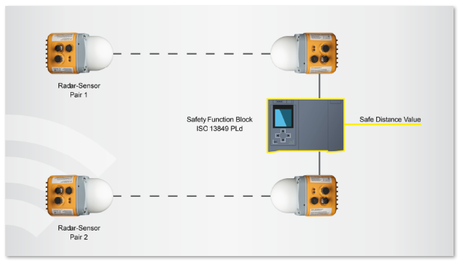 Image source: Symeo
How LPR-SAFE works: A safe distance value is determined by comparing two measured values in the function block.

Symeo
Symeo develops and markets products and solutions for precise, non-contact, maintenance-free position detection, distance measurement, and collision avoidance. Symeo’s products feature extremely robust designs to make them suitable for applications in harsh industrial environments.
Symeo’s LPR® locating technology offers a wireless and real-time-capable measuring system that is ideally suited for industrial applications. Symeo has many years of experience in the development of cost-efficient and customer-specific industrial solutions on the basis of LPR® technology.
The company delivers standardized products and complete solutions to system integrators, original equipment manufacturers (OEMs), and end customers worldwide.
Headquarters: Symeo GmbH, Prof.-Messerschmitt-Strasse 3 a, 85579 Neubiberg, Germany
Phone: (+49-89) 6607-7960, Fax: (+49-89) 66077-96190
E-mail: info@symeo.com, Website: www.symeo.com

Press contact:
HighTech communications GmbH
Marcus Planckh
Brunhamstrasse 21 (Building 202/2nd floor)
81249 Munich
Germany
Phone: (+49-89) 500-77822
E-mail: m.planckh@htcm.de
Website: www.htcm.de

