FOR THE MEDIA
Factory Material Manager from ASMPT
More control, greater yields
Singapore, October 24, 2024 – Having accurate inventory data is the basis for making any improvements in your material flow, and the Factory Material Manager application delivers total data transparency. By optimizing your setup procedures and ensuring that components make it to the line in time, it provides a significant productivity boost in electronics manufacturing.
“A modern SMT factory can have up to 100,000 component packages in the warehouse and on the shop floor,” says Rob Raine, Senior Product Manager for Automation Solutions at ASMPT. “Factory Material Manager is aware of each of them and knows its location at all times.”
Where is which component reel located? Which materials are needed for the next production run? Was the expiration date taken into account during picking? By having the answers to questions like these with reliable real-time data, the Factory Material Manager relieves valuable operators of time-consuming routine tasks such as manual data entries or inventory checks. This leads to a considerable gain in efficiency, especially in modern high-mix/low-volume productions that must deal with a wide range of production orders, a broad spectrum of components, and storage locations that are often spread over the entire plant.
Up-to-date inventory data – from receiving to production
As soon as goods are received, each package or reel gets a label with a unique user ID (UID), The UID is linked to data on the manufacturer, batch number, delivery date, and special features such as MSD (moisture-sensitive device) or the expiration date.
Whenever a component package changes its location, its ID gets scanned and logged in the system. As a result, Factory Material Manager always works with current real-time data. Based on all this information, the software generates path-optimized pick lists, supports setup procedures, and ensures seamless material tracking along the entire production cycle.
Factory Material Manager also communicates with automatic storage systems, including those made by third parties. Operating on a strict first in, first out basis protects against losses due to expired materials, and a tracking system that’s always up to date prevents inventory shortfalls and line stops resulting from material shortages. This kind of permanent and fully automated inventory monitoring does not only improve your process stability and efficiency, it also reduces your costs because it cuts down on your need for emergency stocks. According to findings made by SMT manufacturers, material inventories can be reduced by 5 percent.
A powerful pair for the Intelligent Factory
“Factory Material Manager implements the Intelligent Factory principle in a consistent manner,” says Raine. “It collects data from a broad spectrum of sources ranging from the shop floor to the enterprise level, processes it, and uses it to make your processes more efficient.”
In combination with WORKS Logistics, which is ASMPT’s application for optimizing the material flows on the shop floor, Factory Material Manager optimizes and automates material flows throughout the entire production. The two connected applications from ASMPT ensure the demand-oriented supply of materials, reduce transportation and setup costs, trigger operators and autonomous mobile robots (AMRs), and even support automatic program changeovers on the line. With this software combination, electronics manufacturers can maximize their ROI and gain a clear competitive advantage.

Illustrations for downloading
The following print-ready artwork is available on the internet for downloading:
https://kk.htcm.de/press-releases/asmpt/

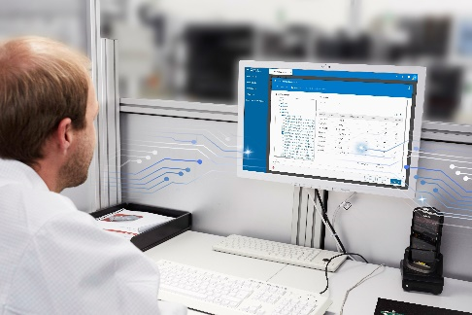 | 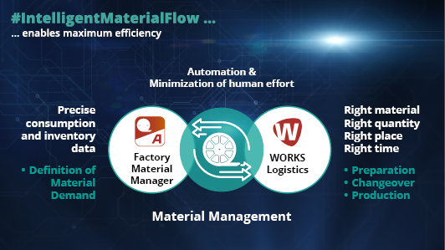
With Factory Material Manager, operators have access to real-time inventory data at all times.  Image credit: ASMPT | A strong pair: Factory Material Manager and WORKS Logistics ensure a seamlessly automated flow of materials in the entire factory.  Image credit: ASMPT

About ASMPT Limited (“ASMPT”)
ASMPT Limited is a leading global supplier of hardware and software solutions for the manufacture of semiconductors and electronics. Headquartered in Singapore, ASMPT’s offerings encompass the semiconductor assembly & packaging, and SMT (surface mount technology) industries, ranging from wafer deposition to the various solutions that organise, assemble and package delicate electronic components into a vast range of end-user devices, which include electronics, mobile communications, computing, automotive, industrial and LED (displays). ASMPT partners with customers very closely, with continuous investment in R&D helping to provide cost-effective, industry-shaping solutions that achieve higher productivity, greater reliability, and enhanced quality. ASMPT is also a founding member of the Semiconductor Climate Consortium.
ASMPT is listed on the Stock Exchange of Hong Kong (HKEX stock code: 0522), and is one of the constituent stocks of the Hang Seng TECH Index, Hang Seng Composite MidCap Index under the Hang Seng Composite Size Indexes, the Hang Seng Composite Information Technology Industry Index under the Hang Seng Composite Industry Indexes, the Hang Seng Corporate Sustainability Benchmark Index, and the Hang Seng HK 35 Index.
To learn more about ASMPT, please visit us at asmpt.com.

The ASMPT SMT Solutions segment
The mission of the SMT Solutions segment within ASMPT is to implement and support the Intelligent Factory at electronics manufacturers worldwide.
ASMPT solutions support the networking, automation, and optimization of central workflows with hardware, software and services that enable electronics manufacturers to transition to the Intelligent Factory in stages and enjoy dramatic improvements in productivity, flexibility, and quality. With its integrated open automation concept, ASMPT opens the door for its customers to economically feasible automation, entirely in accordance with their individual requirements – modular, flexible, and vendor-independent.
The product range includes hardware and software such as SIPLACE placement solutions, DEK printing solutions, inspection and storage solutions, and the Software Suite WORKS. With WORKS, ASMPT offers electronics manufacturers high-quality software for planning, controlling, analyzing and optimizing all processes on the shop floor. Maintaining close relationships with customers and technology partners is a central component of ASMPT’s strategy.
For more information about ASMPT SMT Solutions visit smt.asmpt.com.
Media contacts:
ASMPT ROA Press Office
SMT Solutions
ASMPT SMT Singapore Pte. Ltd.
Janet Loh
Phone: +65 6877 3948
E-mail: Janet.loh@asmpt.com
Website: smt.asmpt.com

Global ASMPT Press Office
ASMPT Ltd.
Susanne Oswald
Rupert-Mayer-Strasse 48
81379 Munich
Germany
Phone: +49 89 20800-26439
E-Mail: susanne.oswald@asmpt.com
Website: asmpt.com

