
PRESS RELEASE
Swissbit makes its debut at Supercomputing 2024 with high-performance PCIe solutions
November 17-22, 2024
Booth #617
Westford, Massachusetts, USA, October 23, 2024 – Swissbit, the leading European provider of storage solutions, is proud to announce its first-ever participation in Supercomputing 2024 (SC24), taking place November 17-22 in Atlanta, Georgia, USA. As a major international conference dedicated to high-performance computing, networking, storage and analysis, SC24 provides an ideal platform for Swissbit to present its latest innovations in storage technology. Attendees can visit Swissbit at booth 617, where the company will be highlighting its state-of-the-art PCIe solutions, including the PCIe Gen5 D2200 series and the N3000 series.
Swissbit's decision to join the premier event for the high-performance computing (HPC) community underscores its commitment to driving innovation in the field of data storage.
D2200 Series: Unmatched efficiency and performance
The D2200 series, Swissbit's first PCIe Gen5 SSD, combines speed and energy efficiency for enterprise servers and edge data centers. With sequential read speeds of up to 14 GB/s and write speeds of up to 10 GB/s, the D2200 delivers impressive performance while maintaining a read efficiency of 970 MB/s per watt. This energy-saving design reduces server heat by up to 20°C (36°F), lowering cooling costs. The D2200 supports NVMe 2.0, OCP 2.0 and PCIe Gen4 for future compatibility and is available in U.2 and E1.S form factors with capacities of 8 TB and 16 TB. Offering up to 2.6 million read IOPS and comprehensive data security features like AES256 encryption and TCG Opal 2.0, the D2200 is ideal for latency-sensitive applications.
N3000 Series: Optimized for consistent performance and high endurance
The N3000 series provides dependable storage with its PCIe Gen4 architecture, making it particularly suitable for networking systems such as routers or switches and edge servers. Built with a DRAM-based controller, the series ensures consistent performance through advanced temperature and power management, making it suitable for edge servers and networking devices. Available in M.2 form factors, it offers capacities from 240 GB to 4 TB for TLC, and up to 320 GB for high-endurance pSLC models. Swissbit’s powersafe™ PLP technology safeguards data during power failures, while security features like AES256 encryption, TCG Opal 2.0, and Crypto-Erase ensure data integrity, meeting the needs of applications requiring reliable, secure storage.
Visit Swissbit at booth 617 during SC24 to learn more about its innovative PCIe solutions and to experience firsthand the company’s latest advances in storage technology.

Available images
The following images are available for download in printable format at: https://kk.htcm.de/press-releases/swissbit/
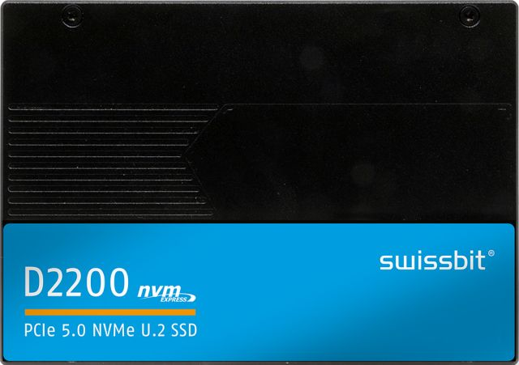  Image source: Swissbit  First PCIe Gen5 SSD from Swissbit: The D2200 in U.2 format. | 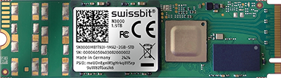  Image source: Swissbit  Swissbit’s N3000 series: Optimized for constant performance and high endurance
About Swissbit
Swissbit AG is the leading European technology company for data storage and security solutions. Our vision is to build a connected world where data and identities are trusted, ensuring digital sovereignty. Combining unique expertise in hardware and firmware design with advanced packaging know-how, Swissbit develops and manufactures innovative data storage, data protection and digital identity solutions.
Swissbit's solutions are utilized across many industries, including industrial automation, networking & communications, edge computing, transportation, critical infrastructure, defense, and the public sector.
Founded in 2001, Swissbit has offices in Switzerland (HQ), Germany, the USA, Japan, and Taiwan, and maintains its own semiconductor production facility in Berlin, Germany.
For further information, please visit www.swissbit.com.

Regional Headquarters North and South America:
Swissbit NA Inc.
238 Littleton Rd #202b
Westford, MA 01886
USA
Tel: +1 (978) 490-3252
Email: salesna@swissbit.com
www.swissbit.com

Headquarters Switzerland:
Swissbit AG
Industriestrasse 4
9552 Bronschhofen
Switzerland
Tel: +41 71 913 03 00
Email: info@swissbit.com
www.swissbit.com

Contact Headquarters:  Swissbit AG  Marian Weber  Industriestrasse 4  9552 Bronschhofen  Switzerland  Tel: +49 172 854 88 26  Email: marian.weber@swissbit.com  www.swissbit.com | Press Agency:  HighTech communications GmbH  Brigitte Basilio  Brunhamstrasse 21  81249 Munich  Germany  Tel: +49 89 500778-20  Email: b.basilio@htcm.de  www.htcm.de

