PRESS RELEASE

Würth Elektronik expands ferrite range for electromobility applications
EMI Suppression in the Low-Frequency Range Directly on the Busbar
Waldenburg (Germany), October 22, 2024 – With the WE-OEFA-LFS ferrite, Würth Elektronik is releasing an oval-shaped ferrite ring for interference suppression at low frequencies. Thanks to its unique oval shape, the ferrite ring is particularly easy to slide over busbars for interference suppression. Its MnZn core material makes it perfect for suppressing low-frequency interference. The main application area for the new ferrite is electric vehicles.
The AEC-Q200-certified WE-OEFA-LFS, with an operating temperature range of -40 to 105°C, is designed for high-current applications and the frequency range from 1 to 100 MHz. This enables the ferrite to suppress electromagnetic interference in battery management systems, inverters, on-board chargers, cable harnesses and many other applications. The latest interference suppression ferrite in Würth Elektronik's portfolio measures 15.6 × 65.4 × 35.4 mm, while the cable or busbar it encloses can measure 43 × 13 mm. WE-OEFA-LFS is available ex-stock, and free samples are provided for developers.

Available images
The following images can be downloaded from the Internet in printable quality: https://kk.htcm.de/press-releases/wuerth/
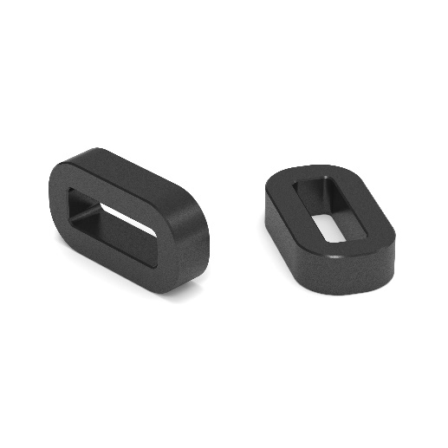
Image source: Würth Elektronik
WE-OEFA-LFS is an EMI suppression ferrite for low frequencies that can be plugged directly onto a busbar in electromobility applications.

About the Würth Elektronik eiSos Group
Würth Elektronik eiSos Group is a manufacturer of electronic and electromechanical components for the electronics industry and a technology company that spearheads pioneering electronic solutions. Würth Elektronik eiSos is one of the largest European manufacturers of passive components and is active in 50 countries. Production sites in Europe, Asia and North America supply a growing number of customers worldwide.
The product range includes EMC components, inductors, transformers, RF components, varistors, capacitors, resistors, quartz crystals, oscillators, power modules, Wireless Power Transfer, LEDs, sensors, radio modules, connectors, power supply elements, switches, push-buttons, connection technology, fuse holders and solutions for wireless data transmission. The portfolio is complemented by customized solutions.
The unrivaled service orientation of the company is characterized by the availability of all catalog components from stock without minimum order quantity, free samples and extensive support through technical sales staff and selection tools.
Würth Elektronik is part of the Würth Group, the global market leader in the development, production, and sale of fastening and assembly materials, and employs 7,900 people. In 2023, the Würth Elektronik Group generated sales of 1.24 Billion Euro.
Würth Elektronik: more than you expect!
Further information at www.we-online.com

Further information:  Würth Elektronik eiSos GmbH & Co. KG  Sarah Hurst  Clarita-Bernhard-Strasse 9  81249 Munich  Germany  Phone: +49 7942 945-5186  E-mail: sarah.hurst@we-online.de  www.we-online.com | Press contact:  HighTech communications GmbH  Brigitte Basilio  Brunhamstrasse 21  81249 Munich  Germany  Phone: +49 89 500778-20  E-mail: b.basilio@htcm.de  www.htcm.de

