PRESS RELEASE

Intelligent power supply and charging interface
USB Power According to the EU Standard
Waldenburg (Germany), October 16, 2024 – Just in time for EU interface standardization, Würth Elektronik presents its new USB socket
WR-COM USB 3.1 PD Type C – Power Only SMT. Used exclusively for power transmission, it supports the USB Power Delivery (USB-PD) communication protocol for adaptive charging up to 240 W.
By the end of 2024, the proliferation of charger types for small electronic devices will come to an end. The EU is making USB-C connectors and the USB Power Delivery standard mandatory across the board.
The new USB-C socket from Würth Elektronik, designed exclusively as a power supply and charging interface, meets the new standard. It communicates with the power supply and automatically determines the maximum charging power. In EPR (Extended Power Range) mode, up to 240 W flows into the batteries. Intelligent communication ensures particularly short charging times and prevents damage to circuits due to excessive currents.
Robust, easy-to-install design
For mechanically and electrically reliable installation, the six-pin socket is designed as a horizontal receptacle SMT component with six solder pins: four pins for power supply (Vbus and GND) and two for communication to determine the operating voltage (CC). The contacts come with a nickel barrier layer and a flash gold coating. A nickel coating provides the shielding plating (housing) with high corrosion protection. The thermostable LCP (Liquid Crystal Polymer) plastic parts used are suitable for the reflow soldering process. Moreover, the LCP is ideally suited for the high demands of mechanical durability required by the USB standard.
The intelligent USB socket is used wherever the USB interface is used only for power transmission, for example:
- Industrial PCs and laptops
- Displays
- Mobile input devices
- Handheld controllers
- Power banks

Available images
The following images can be downloaded from the Internet in printable quality: https://kk.htcm.de/press-releases/wuerth/
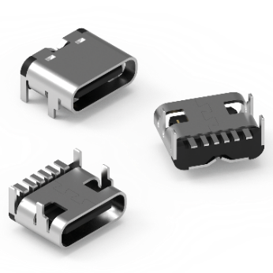
Image source: Würth Elektronik
WR-COM USB 3.1 PD Type C - Power Only SMT: intelligent charging up to 240 W

About the Würth Elektronik eiSos Group
Würth Elektronik eiSos Group is a manufacturer of electronic and electromechanical components for the electronics industry and a technology company that spearheads pioneering electronic solutions. Würth Elektronik eiSos is one of the largest European manufacturers of passive components and is active in 50 countries. Production sites in Europe, Asia and North America supply a growing number of customers worldwide.
The product range includes EMC components, inductors, transformers, RF components, varistors, capacitors, resistors, quartz crystals, oscillators, power modules, Wireless Power Transfer, LEDs, sensors, radio modules, connectors, power supply elements, switches, push-buttons, connection technology, fuse holders and solutions for wireless data transmission. The portfolio is complemented by customized solutions.
The unrivaled service orientation of the company is characterized by the availability of all catalog components from stock without minimum order quantity, free samples and extensive support through technical sales staff and selection tools.

Würth Elektronik is part of the Würth Group, the global market leader in the development, production, and sale of fastening and assembly materials, and employs 7,900 people. In 2023, the Würth Elektronik Group generated sales of 1.24 Billion Euro.
Würth Elektronik: more than you expect!
Further information at www.we-online.com

Further information:  Würth Elektronik eiSos GmbH & Co. KG  Sarah Hurst  Clarita-Bernhard-Strasse 9  81249 Munich  Germany  Phone: +49 7942 945-5186  E-mail: sarah.hurst@we-online.de  www.we-online.com | Press contact:  HighTech communications GmbH  Brigitte Basilio  Brunhamstrasse 21  81249 Munich  Germany  Phone: +49 89 500778-20  E-mail: b.basilio@htcm.de  www.htcm.de

