FOR THE MEDIA
ASMPT at Electronica 2024
Innovative bonding technologies for AI and electromobility
Munich (Germany), October 14, 2024 – The Electronica 2024, one of the world’s most important trade fairs for electronics being held from November 12 to 15, will once again bring leading experts, users and manufacturers to Munich. ASMPT will present its latest technical innovations in the field of bonding for co-packaged optics components and power modules in Hall C3, Booth 300.
“Artificial intelligence and electromobility will be the main trends and drivers of technological and economic change in the coming years,” says Dr. Johann Weinhändler, Managing Director of ASMPT AMICRA and responsible for ASMPT’s Semiconductor Solutions Division in Europe. “These rapidly growing markets place special demands on interconnect technologies in semiconductor manufacturing. With hybrid bonding and silver sintering we are opening up new opportunities in these fields.”
AMICRA NANO: Hybrid bonding for super-fine structures
Exploiting the power of future high-performance computers and AI systems to the fullest requires extremely fast fiber-optic data links. Co-packaged optical components, in which tiny light-emitting and light-receiving components must be placed with an exceptional degree of precision, are essential for such connections.
Hybrid bonding is the right technology for such highly miniaturized structures because it does not require any solder paste or adhesives. In a two-stage process, a chemical bond is first created between two silicon oxide layers, and then the underlying copper layers are activated through thermal treatment so that they form a mechanically stable and electrically conductive bond.
The highly flexible die and flip-chip AMICRA NANO bonder was developed for such tasks and will be on display at the booth. With a placement accuracy of ±0.2 µm, several integrated heating systems and a high-purity processing environment, the AMICRA NANO is extremely flexible and can be used for various bonding technologies.
SilverSAM: Sintering instead of soldering
For power modules that must withstand high currents, conventional soft soldering is not always suitable. With videos and sample products, ASMPT will show at this year’s Electronica how the sintering process can be used to create temperature-resistant and highly conductive connections in power electronics.
The versatile SilverSAM platform uses a combination of pressure, temperature and time to bond silver particles in the previously applied paste. To protect the components, this is done at temperatures that are well below the melting point of silver (961°C or 1,762°F). The machine can process different materials such as DBC (direct bonded copper) and AMB (active metal brazing) and supports various processes such as wet and dry pastes as well as die transfer films (DTF). With an automatic tool changer and a bonding force of up to 588 N, the SilverSAM delivers high productivity and scalability for the mass production of power modules. The SilverSAM platform thus combines flexibility, productivity and high sintering quality, making it ideal for applications in modern power electronics.

Illustrations for downloading
The following print-ready artwork is available on the internet for downloading:
https://kk.htcm.de/press-releases/asmpt/

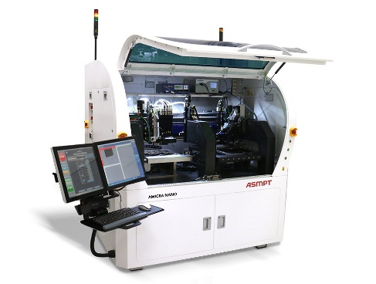 | 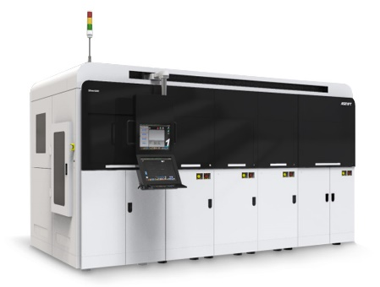
The AMICRA NANO high-precision die and flip-chip bonder was specifically designed for the production of co-packaged optics and features a placement accuracy of ± 0.2 µm @ 3 σ.  Image credit: ASMPT | The versatile SilverSAM sintering platform provides an oxidation-free, copper-friendly environment for the production of power modules and can handle various substrate formats.  Image credit: ASMPT
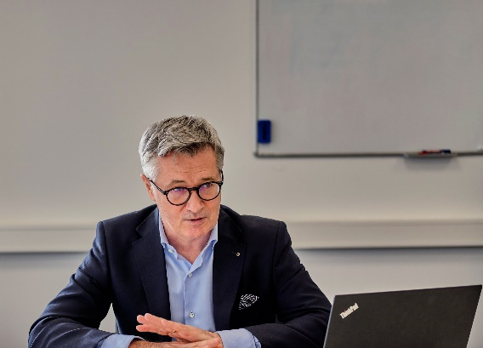
Dr. Johann Weinhändler, Managing Director at ASMPT AMICRA GmbH in Regensburg, is responsible for ASMPT’s Semiconductor Solutions segment in EMEA.

Image credit: ASMPT

About ASMPT Limited (“ASMPT”)
ASMPT Limited is a leading global supplier of hardware and software solutions for the manufacture of semiconductors and electronics. Headquartered in Singapore, ASMPT’s offerings encompass the semiconductor assembly & packaging, and SMT (surface mount technology) industries, ranging from wafer deposition to the various solutions that organise, assemble and package delicate electronic components into a vast range of end-user devices, which include electronics, mobile communications, computing, automotive, industrial and LED (displays). ASMPT partners with customers very closely, with continuous investment in R&D helping to provide cost-effective, industry-shaping solutions that achieve higher productivity, greater reliability, and enhanced quality. ASMPT is also a founding member of the Semiconductor Climate Consortium.
ASMPT is listed on the Stock Exchange of Hong Kong (HKEX stock code: 0522), and is one of the constituent stocks of the Hang Seng TECH Index, Hang Seng Composite MidCap Index under the Hang Seng Composite Size Indexes, the Hang Seng Composite Information Technology Industry Index under the Hang Seng Composite Industry Indexes, the Hang Seng Corporate Sustainability Benchmark Index, and the Hang Seng HK 35 Index.
To learn more about ASMPT, please visit us at asmpt.com.

About ASMPT Semiconductor Solutions (“ASMPT SEMI”)
ASMPT SEMI is the leading supplier in advanced packaging and semiconductor assembly solutions. With a commitment to innovation and customer satisfaction, ASMPT SEMI provides a comprehensive range of products and services that cater to the evolving needs of the microelectronics industry. Their expertise spans across areas such as flip-chip and wafer-level packaging, advanced interconnect technologies, and more. ASMPT SEMI's cutting-edge solutions enable customers to achieve higher performance, increased reliability, and improved cost-efficiency when producing their semiconductor devices.
For more information about ASMPT SEMI, visit semi.asmpt.com.
Media contacts:
Global ASMPT Press Office
ASMPT Ltd.
Susanne Oswald
Rupert-Mayer-Strasse 48
81379 Munich
Germany
Phone: +49 89 20800-26439
E-Mail: susanne.oswald@asmpt.com
Website: asmpt.com

HighTech communications GmbH
Barbara Ostermeier
Brunhamstrasse 21
81249 Munich
Germany
Phone: +49-89 500778-10
E-Mail: b.ostermeier@htcm.de
Website: www.htcm.de

