PRESS RELEASE
ÖBB and Symeo sign new eight-year
framework agreement
Successful development cooperation
to be continued
Neubiberg, Vienna, October 10, 2024 – To continue their existing development cooperation, ÖBB-Infrastruktur AG and Symeo GmbH have signed a new framework agreement. The contract extends over eight years. Symeo has been supporting ÖBB (Austrian Federal Railways) already for twelve years with the development, delivery, and maintenance of energy measurement systems for railway traction vehicles.
The Railpower Box is a device for acquiring and transmitting energy- and position data that Symeo and ÖBB developed in accordance with the international EN 50463, TSI ENE, TSI LOC & PAS standards. With two load profiles that can be accessed simultaneously, it is used for energy billing and energy-efficiency evaluation. ÖBB successfully sells the Railpower Box in many European countries. Symeo GmbH is primarily known as a provider of industrial radar sensor solutions and has repeatedly proven its competence in device construction for difficult operating conditions and in developing custom software for complex IT landscapes. The company, whose service operations have played a major role in the achievement of more than 99-percent operational availability of the Railpower Boxes over the past twelve years, has now been commissioned by ÖBB-Infrastruktur AG to develop a new generation of the devices.
“We are pleased to continue our cooperation with Symeo as the supplier of an important component on our trains. Their quality over the past twelve years has once more stood up to the European competition in the new tender,” said Markus Lebner, Head of Energy Services at ÖBB-Infrastruktur AG.
“This deal is a huge success for us that makes us enormously proud because we have greatly valued our cooperation with ÖBB over the past twelve years and invested a lot in our quality and services. We are pleased that we can hold our own in the European competition with the continuing evolution of our components,” said Thomas Hörl-Weinhold, VP Business Development at Symeo GmbH. “The new framework agreement is an honor and an incentive for us to apply our experience in product certification for railway applications to new radar-based products.”

Available image material
The following printable images are available for download on the Internet:
https://kk.htcm.de/press-releases/symeo/

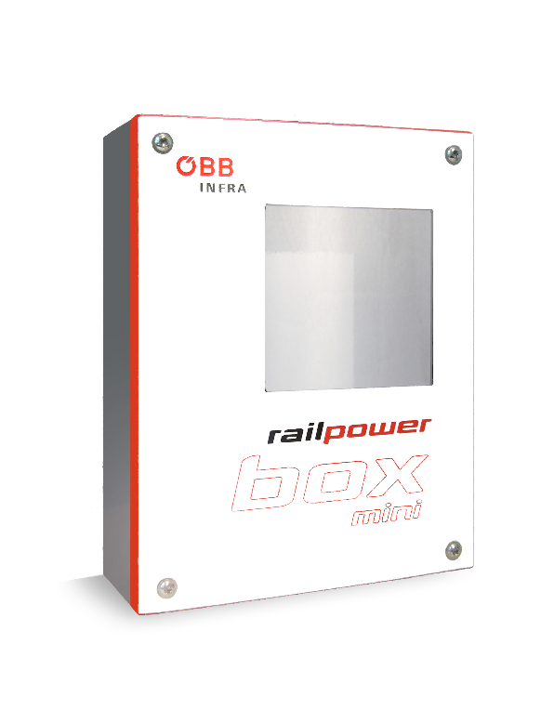
Image credit: Symeo
The Railpower Box is the result of many years of successful cooperation between Symeo GmbH and ÖBB-Infrastruktur AG.

About ÖBB
ÖBB has been shaping mobility in Austria for over 100 years. As a comprehensive mobility and logistics service provider, in 2023 ÖBB transported 494 million passengers and over 78 million tons of freight to their destinations in an environmentally friendly manner, because the electricity for trains and stations is generated entirely from renewable energy sources. With a punctuality of 95 percent in passenger traffic, ÖBB belongs to the most punctual railway operators in Europe. ÖBB invests more than 4.5 billion euros annually in its railway infrastructure and fleet as part of its drive to build a railway system for the future. Across the Group, over 45,000 bus and rail employees and about 2,000 apprentices ensure that around 1.4 million passengers reach their destination safely every day. As the backbone of the Austrian public transport system and Austria’s largest climate protection company in the mobility and logistics sector, ÖBB gets people and freight to their destinations safely and in an environmentally friendly manner. The strategic lead company of the Group is the ÖBB-Holding AG.
https://infrastruktur.oebb.at

Symeo
Symeo develops and markets products and solutions for precise, non-contact, maintenance-free position detection, distance measurement, and collision avoidance. Symeo’s products feature extremely robust designs to make them suitable for applications in harsh industrial environments.
Symeo’s LPR® locating technology offers a wireless and real-time-capable measuring system that is ideally suited for industrial applications. Symeo has many years of experience in the development of cost-efficient and customer-specific industrial solutions on the basis of LPR® technology.
The company delivers standardized products and complete solutions to system integrators, original equipment manufacturers (OEMs), and end customers worldwide.
Headquarters: Symeo GmbH, Prof.-Messerschmitt-Strasse 3 a, 85579 Neubiberg, Germany
Phone: (+49-89) 6607-7960, Fax: (+49-89) 66077-96190
E-mail: info@symeo.com, Website: www.symeo.com

Press contact:
HighTech communications GmbH
Marcus Planckh
Brunhamstrasse 21 (Building 202/2nd floor)
81249 Munich
Germany
Phone: (+49-89) 500-77822
E-mail: m.planckh@htcm.de
Website: www.htcm.de

