PRESS RELEASE
OPEN MIND successful at AMB 2024
hyperMILL® at the center of digital processes
Wessling (Germany), October 2, 2024 – OPEN MIND can look back on an extremely successful appearance at AMB in Stuttgart. With presentations of the hyperMILL® CAD/CAM suite and the Hummingbird-MES manufacturing execution system, the provider showcased innovative functions for efficient CAM programming and solutions for digitalized process chains and virtual machines.
"The discussions at AMB showed that optimizing machining production through connected digitalized processes is a challenge that many visitors are currently facing," explains Claudio Jorio, Sales Director DACH and Global Reseller, OPEN MIND Technologies AG. "Our focus on demonstrating the digital possibilities of a comprehensive process chain was spot on. By integrating hyperMILL® into the Hummingbird-MES, we can virtually map and adapt every sub-process for our customers."
The hyperMILL® TURNING Solutions were one of the main topics related to daily practice. One of the software package's new features also explained how to work with digital twins: In hyperMILL® VIRTUAL Machining, lathes with turrets and Siemens controls are reproduced in detail with all tools. The placement is thus part of the NC code simulation.

Available image material
The following printable images are available for download on the Internet:
https://kk.htcm.de/press-releases/open-mind/

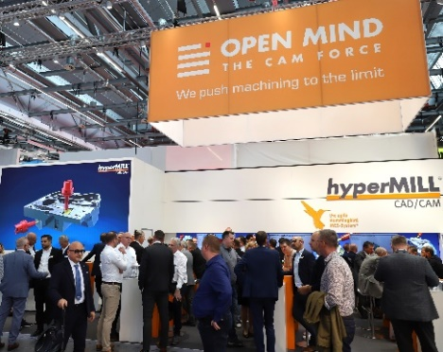  Source: OPEN MIND  The OPEN MIND stand at AMB was very busy. | 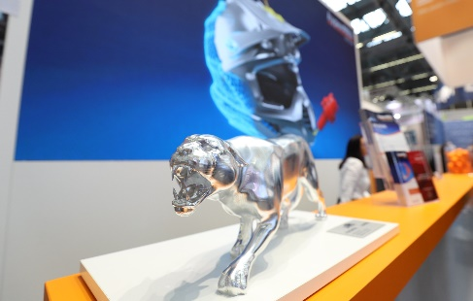  Source: OPEN MIND  An aluminium panther was one of the "eye-catchers" at the trade fair stand.

Available video material
You can find the following video material on our YouTube channel:
https://youtu.be/aEAK8RGX1GY
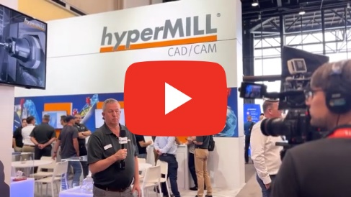
Source: OPEN MIND

Successful trade fairs for OPEN MIND: AMB in Stuttgart and IMTS in Chicago

About OPEN MIND Technologies AG
OPEN MIND Technologies AG is one of the world’s leading developers of powerful CAD/CAM solutions for machine and controller-independent programming.
OPEN MIND develops optimized CAD/CAM solutions that include innovative and unique features that can deliver significantly higher performance in both programming and machining.
hyperMILL® is a completely modular CAD/CAM solution that provides state-of-the-art CAM technologies on its own CAD platform: from 2.5D, 3D and 5-axis machining as well as turning strategies and solutions for additive manufacturing, HSC and HPC machining. Whether automation, simulation or virtual machine – trendsetting technologies expand the product range and enable continuous digital process chains. Special applications, seamless interaction with all popular CAD solutions and exceptional customer service rounds out the company’s products and capabilities.
According to the “NC Market Analysis Report 2024” compiled by CIMdata, hyperMILL® is a leading, worldwide CAD/CAM solution. Innovative CAD/CAM technologies fulfill the highest demands in the aerospace, automotive, tool and mold manufacturing, production machining, medical, job shops, energy and semiconductor industries. OPEN MIND is a Mensch und Maschine company and has subsidiaries and qualified sales partners on all continents.
OPEN MIND's majority stake in manufacturing execution system (MES) developer Hummingbird expands the CAD/CAM manufacturer's product portfolio and enhances the range of connected digitalized manufacturing technologies.
OPEN MIND is a Mensch und Maschine company and has subsidiaries and qualified sales partners on all continents.
You can find more information at www.openmind-tech.com.

OPEN MIND Technologies UK Ltd., Oxford
Unit 3
Bicester Business Park
Telford Road
Bicester
Oxfordshire OX26 4LN
England
Phone: +44 1869 290 003
Fax: +44 1869 369 429
E-mail: Info.UK@openmind-tech.com

OPEN MIND Technologies USA, Inc.
1492 Highland Avenue, Unit 3
Needham MA 02492
USA
Phone: +1 339 225 4557 office
Phone: +1 888 516 1232 x0 toll-free
Fax: +1 270 912 5822
E-mail: Info.Americas@openmind-tech.com

OPEN MIND Technologies Asia Pacific Pte Ltd
MOVA Building, 22 Jalan Kilang #03-00
Singapore 159419
Phone: +65 6742 95-56
E-mail. Info.Asia@openmind-tech.com

Head office:
OPEN MIND Technologies AG, Argelsrieder Feld 5, 82234 Wessling, Germany
Tel.: (+49-8153) 933-500, Fax: (+49-8153) 933-501
E-mail: Info@openmind-tech.com, website: www.openmind-tech.com

Press contact:
HighTech communications GmbH
Brigitte Basilio
Brunhamstrasse 21
81249 Munich
Germany
Tel.: (+49-89) 500778-20
E-mail: b.basilio@htcm.de
Website: www.htcm.de

