PRESS RELEASE
Factory Equipment Center from ASMPT
for intelligent SMT production
Connected asset and maintenance management redefined
Suwanee (USA), September 25, 2024 – Operating with maximum efficiency is crucial when it comes to competitiveness and profitability in modern SMT manufacturing. Factory Equipment Center from ASMPT offers a unique approach to asset and maintenance management in the Intelligent Factory by automating and optimizing the administration, maintenance and repairs of thousands of movable assets such as placement headers, feeders, and nozzles.
In the modern electronics factory, all components must work together seamlessly because even a single defective feeder can bring an entire SMT line to a screeching halt. Reconciling the continuous availability of all movable assets with day-to-day production requirements is no easy task. Questions about the location of feeders, the use of nozzles or the maintenance status of placement heads must be answered all day long. But with the thousands of mobile assets, many of which frequently change their location on the shop floor, it was difficult if not impossible to keep track of everything – until now.
Connectivity provides clarity
The Factory Equipment Center software redefines asset management and makes it possible to fully network all assets being used. It does not just track assets but uses the data integratively to provide maximum connectivity in line with ASMPT’s Intelligent Factory concept. After installation, the software automatically scans all SMT lines and takes a digital inventory of the machines, placement heads, feeders and nozzles, all of which have their own IDs. This type of fully automatic detection is currently unrivaled on the market. It also saves a lot of time and money, considering that the average factory has between 10,000 and 15,000 feeders in use. “Only third-party systems must still be entered manually,” says Jim Leather, Director IoT Solutions at ASMPT SMT Solutions.
Factory Equipment Center automatically collects and updates the asset data, analyzes it, and visualizes it in clear tables and graphs on real-time dashboards that show the location, condition, configuration and maintenance history of each asset. Precise logging allows for the creation of detailed performance and maintenance reports that can be used for internal analyses as well as for external audits. In addition, comprehensive tracking enables the kind of proactive maintenance that is no longer carried out according to rigid schedules but based on actual use and wear.
Efficient and dynamic maintenance management
Through dynamic order tracking, the software makes it possible to flexibly coordinate the maintenance planning with the actual use of assets. It automatically marks maintenance jobs as complete as soon as they are executed and enters the next inspection date accordingly. A central maintenance calendar makes it easier to coordinate activities, avoids scheduling conflicts, and ensures that all parties are notified of any upcoming maintenance work. Automatic monitoring and reporting deliver maximum transparency and lock faulty assets, thus minimizing downtimes and increasing the reliability of production operations.
Digital workflows and modern software
Modern digital processes support the maintenance staff with clear real-time dashboards, multimedia displays and checklists that show clearly structured work steps and reduce errors. With the web-based user interfaces, all software functions can be conveniently controlled from any device that is capable of running a browser. Factory Equipment Center is offered via a modern subscription license that makes its operating costs scalable and predictable. It also includes all Remote Smart Factory functions so that settings and updates can be executed centrally and efficiently.
Conclusion
With its Factory Equipment Center, ASMPT offers a sophisticated solution for optimizing the management and maintenance of SMT production assets. By combining real-time tracking, automated maintenance planning and extensive reporting tools, the software helps electronics factories to maximize their operating efficiency, lower their costs, and improve their competitiveness. It integrates seamlessly into existing production environments and provides a solid database for modern maintenance management.

Illustrations for downloading
The following print-ready artwork is available on the internet for downloading:
https://kk.htcm.de/press-releases/asmpt/

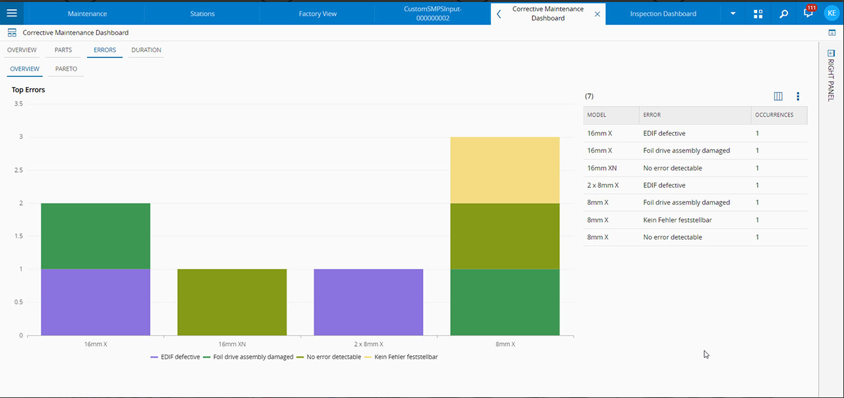 | 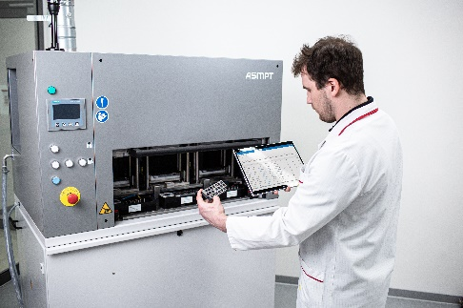
Error statistics by feeder type: Factory Equipment Center recognizes defective feeders and blocks them.  Image credit: ASMPT | Each SmartNozzle has its own ID with which it can be scanned and evaluated – whether it is in use or, as shown here, in the Nozzle Cleaning Station.  Image credit: ASMPT
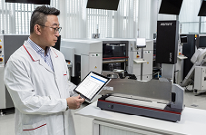 | 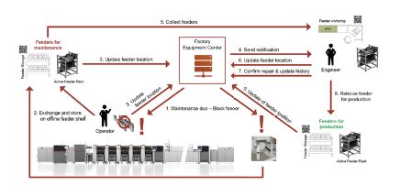
Factory Equipment Center continuously monitors the counters of all feeders in use on the shop floor. Once a preset number of operating cycles has been reached, the system locks the respective unit and e-mails a maintenance request to appropriately qualified employees.  Image credit: ASMPT | Complete maintenance cycle of a feeder: As a central management instance, Factory Equipment Center continuously controls and monitors the asset’s location and status – even if it is no longer on the shop floor.  Image credit: ASMPT

About ASMPT Limited (“ASMPT”)
ASMPT Limited is a leading global supplier of hardware and software solutions for the manufacture of semiconductors and electronics. Headquartered in Singapore, ASMPT’s offerings encompass the semiconductor assembly & packaging, and SMT (surface mount technology) industries, ranging from wafer deposition to the various solutions that organise, assemble and package delicate electronic components into a vast range of end-user devices, which include electronics, mobile communications, computing, automotive, industrial and LED (displays). ASMPT partners with customers very closely, with continuous investment in R&D helping to provide cost-effective, industry-shaping solutions that achieve higher productivity, greater reliability, and enhanced quality.
ASMPT is listed on the Stock Exchange of Hong Kong (HKEX stock code: 0522), and is one of the constituent stocks of the Hang Seng TECH Index, Hang Seng Composite MidCap Index under the Hang Seng Composite Size Indexes, the Hang Seng Composite Information Technology Industry Index under the Hang Seng Composite Industry Indexes, the Hang Seng Corporate Sustainability Benchmark Index, and the Hang Seng HK 35 Index.
To learn more about ASMPT, please visit us at asmpt.com.

The ASMPT SMT Solutions segment
The mission of the SMT Solutions segment within ASMPT is to implement and support the Intelligent Factory at electronics manufacturers worldwide.
ASMPT solutions support the networking, automation, and optimization of central workflows with hardware, software and services that enable electronics manufacturers to transition to the Intelligent Factory in stages and enjoy dramatic improvements in productivity, flexibility, and quality. With its integrated open automation concept, ASMPT opens the door for its customers to economically feasible automation, entirely in accordance with their individual requirements – modular, flexible, and vendor-independent.
The product range includes hardware and software such as SIPLACE placement solutions, DEK printing solutions, inspection and storage solutions, and the Software Suite WORKS. With WORKS, ASMPT offers electronics manufacturers high-quality software for planning, controlling, analyzing and optimizing all processes on the shop floor. Maintaining close relationships with customers and technology partners is a central component of ASMPT’s strategy.
For more information about ASMPT SMT Solutions visit smt.asmpt.com.
Media contacts:
AMCAS ASMPT Press Office
SMT Solutions
Mark Ogden
Phone: +1 (770) 797 3189
E-mail: ogden.mark@asmpt.com
Website: smt.asmpt.com

Global ASMPT Press Office
ASMPT Ltd.
Susanne Oswald
Rupert-Mayer-Strasse 48
81379 Munich
Germany
Phone: +49 89 20800-26439
E-Mail: susanne.oswald@asmpt.com
Website: asmpt.com

