FOR THE MEDIA
ASMPT presents leading-edge die bonding systems for Co-Packaged Optics (CPO) at ECOC
Next-Gen Connectivity with High-Precision CPO Technology
Munich (Germany), September 12, 2024 – ASMPT will participate in the upcoming European Conference on Optical Communication (ECOC) 2024, taking place from September 23 to 25 in Frankfurt, Germany. At booth B126, the company will showcase its latest technological advancements in Silicon Photonics and cutting-edge Co-Packaged Optics (CPO) solutions, designed to enhance bandwidth density, improve energy efficiency, and optimize connectivity in modern data centres.
Co-Packaged Optics (CPO) is an innovative technology that integrates optical and electronic components within a single package. By utilizing advanced packaging techniques, CPO minimizes electrical interconnect lengths and enhances performance, making it ideal for high-speed data transmission in applications such as AI, IoT, and 5G. This positions CPO as a critical optoelectronics technology in today’s market. Dr. Johann Weinhaendler, General Manager at ASMPT AMICRA, stated, “Many electronics manufacturers are upgrading their lines to meet the growing demand in areas like optoelectronics or advanced packaging, particularly in the silicon photonics sector.”
The production of Co-Packaged Optics presents several challenges, including the precise alignment of optical and electronic elements and ensuring reliability under diverse conditions. ASMPT is addressing these hurdles through advanced manufacturing technologies that facilitate high-precision bonding, ensuring effective integration of components and leading to enhanced stability and performance in CPO applications.
At ECOC 2024, ASMPT will highlight their leading-edge CPO solution, spotlighting the AMICRA NANO and AMICRA NOVA Pro. This demonstration not only sets new benchmarks for the industry but also reaffirms ASMPT's dedication to delivering cutting-edge solutions tailored for the optoelectronics sector.
AMICRA NANO, the first in the industry to achieve a placement accuracy of < ± 0.2 μm at 3 sigma, is renowned for its unmatched and unparalleled accuracy. It firmly establishes the AMICRA NANO as a game-changer, revolutionizing the optoelectronics landscape.
AMICRA NOVA Pro represents a pinnacle in die bonding systems, delivering exceptional placement accuracy of < ± 1 μm at 3 sigma. Engineered to optimize production efficiency, it offers shorter cycle times and increased automation, making it an ideal solution for the rigorous demands of CPO manufacturing. This technology enables manufacturers to streamline their processes while maintaining the high precision necessary for effective integration.

Illustrations for downloading
The following images are available for download in printable format at:
https://kk.htcm.de/press-releases/asmpt/

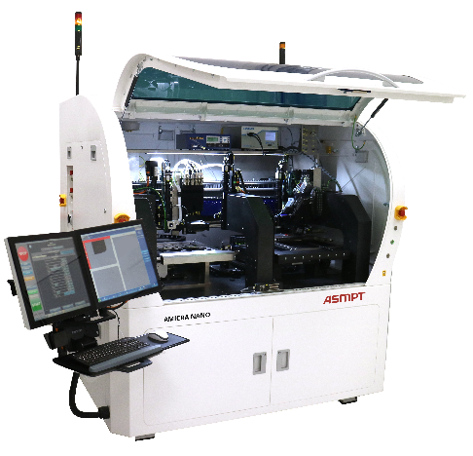 | 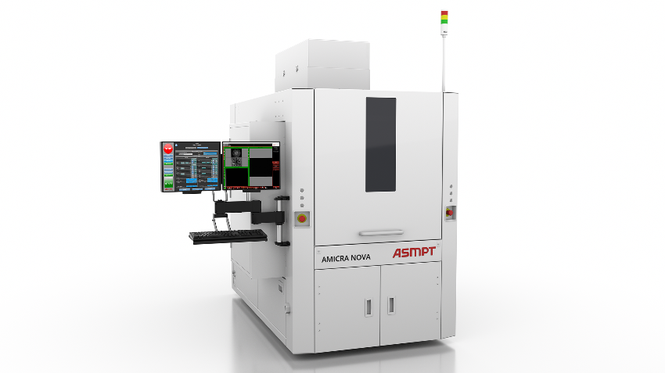
AMICRA NANO, the first in the industry to achieve a placement accuracy of< ± 0.2 μm at 3 sigma  Source: ASMPT | AMICRA NOVA Pro combines high placement accuracy with short cycle times and innovative bonding technologies.  Source: ASMPT

About ASMPT Limited (“ASMPT”)
ASMPT Limited is a leading global supplier of hardware and software solutions for the manufacture of semiconductors and electronics. Headquartered in Singapore, ASMPT’s offerings encompass the semiconductor assembly & packaging, and SMT (surface mount technology) industries, ranging from wafer deposition to the various solutions that organise, assemble and package delicate electronic components into a vast range of end-user devices, which include electronics, mobile communications, computing, automotive, industrial and LED (displays). ASMPT partners with customers very closely, with continuous investment in R&D helping to provide cost-effective, industry-shaping solutions that achieve higher productivity, greater reliability, and enhanced quality.
ASMPT is listed on the Stock Exchange of Hong Kong (HKEX stock code: 0522), and is one of the constituent stocks of the Hang Seng TECH Index, Hang Seng Composite MidCap Index under the Hang Seng Composite Size Indexes, the Hang Seng Composite Information Technology Industry Index under the Hang Seng Composite Industry Indexes, the Hang Seng Corporate Sustainability Benchmark Index, and the Hang Seng HK 35 Index.
To learn more about ASMPT, please visit us at asmpt.com.

About ASMPT Semiconductor Solutions (“ASMPT SEMI”)
ASMPT SEMI is the leading supplier in advanced packaging and semiconductor assembly solutions. With a commitment to innovation and customer satisfaction, ASMPT SEMI provides a comprehensive range of products and services that cater to the evolving needs of the microelectronics industry. Their expertise spans across areas such as flip-chip and wafer-level packaging, advanced interconnect technologies, and more. ASMPT SEMI's cutting-edge solutions enable customers to achieve higher performance, increased reliability, and improved cost-efficiency when producing their semiconductor devices.
For more information about ASMPT SEMI, visit semi.asmpt.com.
Media contacts:
Global ASMPT Press Office
ASMPT Ltd.
Susanne Oswald
Rupert-Mayer-Strasse 48
81379 Munich
Germany
Tel: +49 89 20800-26439
E-Mail: susanne.oswald@asmpt.com
Website: asmpt.com

HighTech communications GmbH
Barbara Ostermeier
Brunhamstrasse 21
81249 Munich
Germany
Tel.: +49-89 500778-10
E-Mail: b.ostermeier@htcm.de
Website: www.htcm.de

