PRESS RELEASE

Würth Elektronik presents its transformers for power line communication
Safe PLC Signal Isolation
Waldenburg (Germany), September 10, 2024 – Communication between charging stations and electric vehicles via an interface compliant with EN ISO 15118 is a fundamental requirement for the public charging infrastructure. Würth Elektronik now offers the WE-PLC product series of high-quality SMT transformers for Power Line Communication (PLC).
The new Würth Elektronik PLC transformers are ideal for galvanic isolation of the PLC system from the power supply. They are designed for data signals between 500 kHz and 30 MHz and reliably isolate the low-voltage range from the high-voltage range.
More precise data transmission
The WE-PLC product series offers an exceptionally high test voltage of 4500 V_{RMS} for transformers of this package size (13.6 × 9.9 mm footprint). Thanks to their high-quality design, they offer significantly lower leakage inductance (max. 0.2 µH) than competing products. The components ensure good magnetic coupling for precise data transmission.
The WE-PLC transformers are available with turns ratios of 1:1:1 and 1:4:3 for EV charging and AC interfaces for grid communication. The operating voltage is up to 250 V_{AC.}
The PLC transformers are now available from stock without a minimum order quantity. Free samples are available for developers.

Available images
The following images can be downloaded from the Internet in printable quality: https://kk.htcm.de/press-releases/wuerth/

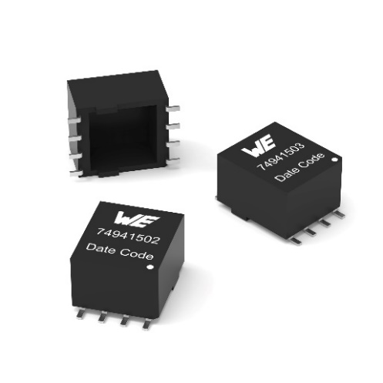
Image source: Würth Elektronik
PLC transformers (WE-PLC SMT)

About the Würth Elektronik eiSos Group
Würth Elektronik eiSos Group is a manufacturer of electronic and electromechanical components for the electronics industry and a technology company that spearheads pioneering electronic solutions. Würth Elektronik eiSos is one of the largest European manufacturers of passive components and is active in 50 countries. Production sites in Europe, Asia and North America supply a growing number of customers worldwide.
The product range includes EMC components, inductors, transformers, RF components, varistors, capacitors, resistors, quartz crystals, oscillators, power modules, Wireless Power Transfer, LEDs, sensors, radio modules, connectors, power supply elements, switches, push-buttons, connection technology, fuse holders and solutions for wireless data transmission. The portfolio is complemented by customized solutions.
The unrivaled service orientation of the company is characterized by the availability of all catalog components from stock without minimum order quantity, free samples and extensive support through technical sales staff and selection tools.
Würth Elektronik is part of the Würth Group, the global market leader in the development, production, and sale of fastening and assembly materials, and employs 7,900 people. In 2023, the Würth Elektronik Group generated sales of 1.24 Billion Euro.
Würth Elektronik: more than you expect!
Further information at www.we-online.com

Further information:  Würth Elektronik eiSos GmbH & Co. KG  Sarah Hurst  Clarita-Bernhard-Strasse 9  81249 Munich  Germany  Phone: +49 7942 945-5186  E-mail: sarah.hurst@we-online.de  www.we-online.com | Press contact:  HighTech communications GmbH  Brigitte Basilio  Brunhamstrasse 21  81249 Munich  Germany  Phone: +49 89 500778-20  E-mail: b.basilio@htcm.de  www.htcm.de

