PRESS RELEASE
Würth Elektronik presents its solderless coaxial sockets
Reproducible Transmission Quality for High-Frequency Lines
Waldenburg (Germany), September 4, 2024 – Würth Elektronik expands its SMA connector family for high-frequency applications to include WR-SMA PCB Solderless. The solderless approach allows quick and easy assembly without damage to the PCB. Besides simplifying the installation process, which requires no soldering equipment, the solderless SMA connectors can be reused multiple times, making them suitable for prototyping or temporary use. This makes them an affordable solution for efficient testing. What’s the biggest advantage of these sockets? Because no solder is required on the signal pin, reproducible connection quality is achieved, and impedance variation due to the amount of solder paste is avoided.
Würth Elektronik has opted to use brass instead of stainless steel for its connector family, which differs from many of its competitors by providing a cost advantage while maintaining the same electrical performance. The screwed clamp connector provides a highly robust mechanical connection. Additionally, the solderless coax connectors allow for easy repairs and hassle-free replacement in the field, without the need for special tools or knowledge. The SMA sockets are suitable for both strip and multistrip lines, as well as coplanar waveguides.
As the SMA interface complies with the MIL-STD-348 standard, is designed for 50 ohms, and supports up to 27 GHz, the solderless coax connectors are particularly suitable for high-frequency PCB applications that require precision. The connectors are recommended for test equipment, for evaluation boards, and for applications with an operating temperature range from -65°C to +165°C.
Developers looking to use these connectors in telecommunications, broadband, and antenna-related wireless applications or testing equipment can obtain free samples from Würth Elektronik.

Available images
The following images can be downloaded from the Internet in printable quality: https://kk.htcm.de/press-releases/wuerth/

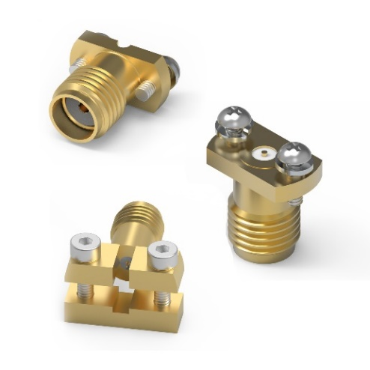Image source: Würth Elektronik
WR-SMA PCB Solderless are robust sockets from Würth Elektronik for high-frequency lines.

About the Würth Elektronik eiSos Group
Würth Elektronik eiSos Group is a manufacturer of electronic and electromechanical components for the electronics industry and a technology company that spearheads pioneering electronic solutions. Würth Elektronik eiSos is one of the largest European manufacturers of passive components and is active in 50 countries. Production sites in Europe, Asia and North America supply a growing number of customers worldwide.
The product range includes EMC components, inductors, transformers, RF components, varistors, capacitors, resistors, quartz crystals, oscillators, power modules, Wireless Power Transfer, LEDs, sensors, radio modules, connectors, power supply elements, switches, push-buttons, connection technology, fuse holders and solutions for wireless data transmission. The portfolio is complemented by customized solutions.
The unrivaled service orientation of the company is characterized by the availability of all catalog components from stock without minimum order quantity, free samples and extensive support through technical sales staff and selection tools.
Würth Elektronik is part of the Würth Group, the global market leader in the development, production, and sale of fastening and assembly materials, and employs 7,900 people. In 2023, the Würth Elektronik Group generated sales of 1.24 Billion Euro.
Würth Elektronik: more than you expect!
Further information at www.we-online.com

Further information:  Würth Elektronik eiSos GmbH & Co. KG  Sarah Hurst  Clarita-Bernhard-Strasse 9  81249 Munich  Germany  Phone: +49 7942 945-5186  E-mail: sarah.hurst@we-online.de  www.we-online.com | Press contact:  HighTech communications GmbH  Brigitte Basilio  Brunhamstrasse 21  81249 Munich  Germany  Phone: +49 89 500778-20  E-mail: b.basilio@htcm.de  www.htcm.de

