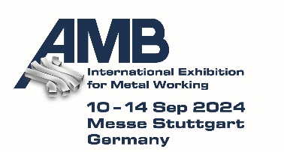
PRESS RELEASE

Hufschmied Zerspanungssysteme at the AMB 2024
Machining hard steels faster
Hall 3, Stand 3B67
Bobingen (Germany), August 22, 2024 - Hufschmied Zerspanungssysteme GmbH will be exhibiting at AMB in Stuttgart from September 10 to 14, 2024 (Hall 3, Stand 3B67). The focus of the presentation at the leading metalworking trade fair will be the Hard-Line milling tool series. To demonstrate the performance of its tools in producing high surface qualities, Hufschmied will be carrying out live machining of a steel injection mold on a Grob G150 5-axis universal machining center at the stand.
Two milling tools from the Hard-Line that are explicitly optimized for machining steels up to 72 HRC are the focus of Hufschmied's AMB presentation: HHF667 is an HVPT finishing cutter (high velocity performance tool). Both its special geometry and the TL12 multi-chamfer hard milling coating ensure low wear when machining stainless steels. Its polished chip geometry enables high chip flow rates and increases process reliability against chip jamming. The second tool presented is the HC643MUT mini torus milling cutter, the only Z3 mini (from D1=0.3mm) on the market. Thanks to its geometry and coating, this tool is also particularly well protected against wear when machining stainless steels. All tools in the series are provided with an individual QR code that refers to the respective digital twin with gauge block and recommends the tools for production processes that are optimized in terms of Industry 4.0.
Special tools and process optimization
At AMB, Hufschmied will not only be presenting itself as a manufacturer of special tools for certain materials, but also as a process optimizer. With individual consultation and test series in their own technology center, the machining experts find solutions for the respective challenges that companies face when machining particularly hard, brittle or temperature-sensitive materials, for example.
“In order to achieve the technical and economic optimum of a machining process, the tool and CAM programming must be matched to the material, the shape of the workpiece and the properties of the milling center. Challenge us: We are sure that we can undercut your previous machining times and top your tool life,” says Christel Hufschmied, Managing Director of Hufschmied Zerspanungssysteme GmbH.

Available images
The following images can be downloaded from the Internet in printable quality:
https://kk.htcm.de/press-releases/hufschmied/
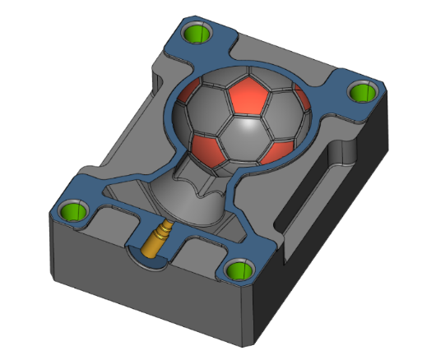  Image source:  Hufschmied Zerspanungssysteme  CAM programming is ready: Milling live at the AMB to demonstrate the performance of Hufschmied tools. | 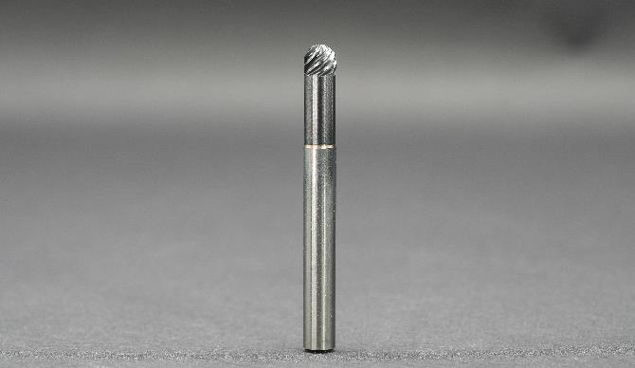  Image source: Hufschmied Zerspanungssysteme  HHF667 is an HVPT finishing cutter that is characterized by low wear when machining stainless steels.

About Hufschmied Zerspanungssysteme GmbH
Established in 1991 and headquartered in Bobingen near Augsburg, Hufschmied Zerspanungssysteme GmbH is a manufacturer of high-quality tools for machinable production and friction stir welding. By specializing at an early stage in the machining of plastics, fiberglass materials and carbon fiber, Hufschmied has become a leader in Europe in the development of solutions for new materials. The company is an established system supplier to renowned machine tool manufacturers. Tools and manufacturing process consulting from Hufschmied are particularly valued in the automotive and aerospace industries as well as in medical technology. The company is involved in numerous organizations, including Composites United Deutschland e. V. Hufschmied's manufacturing operations are located in Bobingen, Winterlingen and Sigmaringen on the Swabian Alb. Hufschmied is certified according to ISO 9001:2015 (quality management) and ISO 14001:2015 (environmental management).

Hufschmied is the only tool manufacturer with its own diamond coating plant.
For more information: www.hufschmied.net

Additional information:  Hufschmied Zerspanungssysteme GmbH  Marco Beigl  Edisonstrasse 11d  86399 Bobingen  Germany  Phone: +49 8234 9664-0  Telefax: +49 8234 9664-99  E-Mail: info@hufschmied.net  www.hufschmied.net | Press contact:  HighTech communications GmbH  Brigitte Basilio  Brunhamstrasse 21  81249 Munich  Germany  Phone: +49 89 500778-20  E-Mail: b.basilio@htcm.de  www.htcm.de

