FOR THE MEDIA
WORKS Software Suite from ASMPT
WORKS now also available with a subscription license
Suwanee (USA), August 27, 2024 – Innovation and market leader ASMPT now offers the proven WORKS Software Suite for the digital control and optimization of all processes on the SMT shop floor with an attractive subscription license. The flexible cost structure and the certainty of always working with the latest version bring many advantages to the user.
“Our WORKS Software Suite is already in use at many of our customers,” says Nicolas Bartschat, Head of Factory Solutions EMEA at ASMPT SMT Solutions. “WORKS bundles a multitude of practice-oriented applications that allow users to ensure a high level of quality in smart SMT production, improve the flow of materials, and make the deployment of personnel more effective and efficient. Many customers have asked us about a subscription-based licensing model, and we are now responding to this request.”
Simple, predictable cost structure
The WORKS Software Suite bundles eight powerful applications for the typical workflows on the SMT shop floor: programming, logistics, preparation, operations, monitoring, optimization, and integration. In addition to the traditional lifetime license, WORKS is now also being offered with a modern subscription license, which may be the better option for many users because it offers several advantages:
- With the new model, customers receive new features and continuing developments of the software free of charge and are therefore always up to date with the latest technology.
- Since no high initial investment is required, the software can be tested without having to overcome major financial hurdles. Due to the runtime model, the software generates added value that significantly exceeds the costs incurred on the first day of its use.
- Depending on the usage intensity, the new subscription model is much more scalable, which reduces risk and makes planning more reliable.
Thanks to the software's clear subscription structure and simple pricing, electronics manufacturers have their costs under control at all times and are well-equipped for the future.
“More than ever, productivity is a question of optimizing the use of data these days,” explains Nicolas Bartschat, “and our WORKS Software Suite accomplishes this perfectly. Each application can be subscribed to individually, but the subscription-based WORKS Ultimate complete version offers the best price-performance ratio for most customers because they can use all applications without having to spend a lot of money all at once. If you are interested in the new subscription model and would like to compare side-by-side cost examples of the lifetime and subscription models, you can request a remote demo on our website.”

Illustrations for downloading
The following print-ready artwork is available on the internet for downloading:
https://kk.htcm.de/press-releases/asmpt/

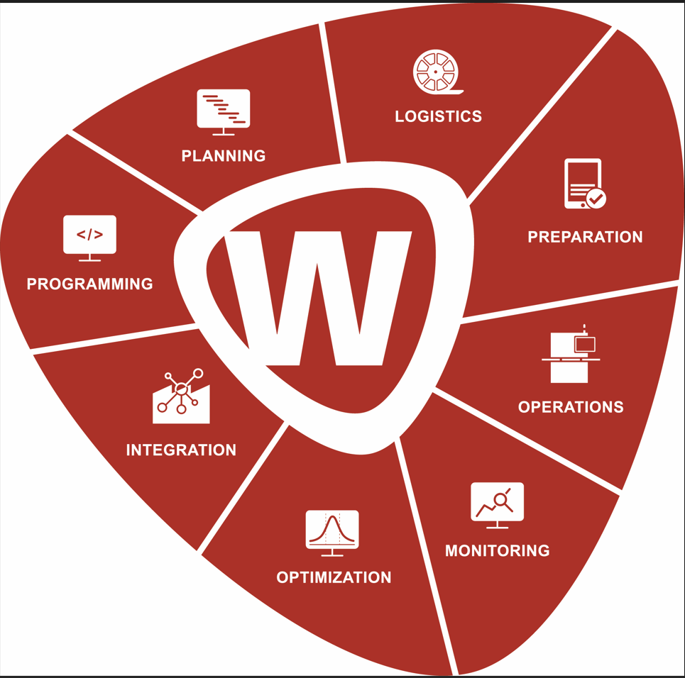
The WORKS Software Suite bundles eight powerful applications for the typical workflows on the SMT shop floor: programming, planning, logistics, preparation, operations, monitoring, optimization, and integration.

Image credit: ASMPT

About ASMPT Limited (“ASMPT”)
ASMPT Limited is a leading global supplier of hardware and software solutions for the manufacture of semiconductors and electronics. Headquartered in Singapore, ASMPT’s offerings encompass the semiconductor assembly & packaging, and SMT (surface mount technology) industries, ranging from wafer deposition to the various solutions that organise, assemble and package delicate electronic components into a vast range of end-user devices, which include electronics, mobile communications, computing, automotive, industrial and LED (displays). ASMPT partners with customers very closely, with continuous investment in R&D helping to provide cost-effective, industry-shaping solutions that achieve higher productivity, greater reliability, and enhanced quality.
ASMPT is listed on the Stock Exchange of Hong Kong (HKEX stock code: 0522), and is one of the constituent stocks of the Hang Seng TECH Index, Hang Seng Composite MidCap Index under the Hang Seng Composite Size Indexes, the Hang Seng Composite Information Technology Industry Index under the Hang Seng Composite Industry Indexes, the Hang Seng Corporate Sustainability Benchmark Index, and the Hang Seng HK 35 Index.
To learn more about ASMPT, please visit us at asmpt.com.

The ASMPT SMT Solutions segment
The mission of the SMT Solutions segment within ASMPT is to implement and support the Intelligent Factory at electronics manufacturers worldwide.
ASMPT solutions support the networking, automation, and optimization of central workflows with hardware, software and services that enable electronics manufacturers to transition to the Intelligent Factory in stages and enjoy dramatic improvements in productivity, flexibility, and quality. With its integrated open automation concept, ASMPT opens the door for its customers to economically feasible automation, entirely in accordance with their individual requirements – modular, flexible, and vendor-independent.
The product range includes hardware and software such as SIPLACE placement solutions, DEK printing solutions, inspection and storage solutions, and the Software Suite WORKS. With WORKS, ASMPT offers electronics manufacturers high-quality software for planning, controlling, analyzing and optimizing all processes on the shop floor. Maintaining close relationships with customers and technology partners is a central component of ASMPT’s strategy.
For more information about ASMPT SMT Solutions visit smt.asmpt.com.

Media contacts:
AMCAS ASMPT Press Office
SMT Solutions
Mark Ogden
Tel.: +1 (770) 797 3189
E-mail: ogden.mark@asmpt.com
Website: smt.asmpt.com

Global ASMPT Press Office
ASMPT Ltd.
Susanne Oswald
Rupert-Mayer-Strasse 48
81379 Munich
Germany
Tel: +49 89 20800-26439
E-Mail: susanne.oswald@asmpt.com
Website: asmpt.com

