FOR THE MEDIA
Meeting ASMPT at SEMICON India 2024

Driving the future of the Indian semiconductor industry
Singapore, August 21, 2024 – ASMPT Limited will exhibit trendsetting semiconductor assembly and packaging equipment at SEMICON India 2024, Greater Noida, September 11 – 13, 2024, IEML, Booth H1V01. The trade fair, coinciding with electronica and productronica India, is regarded as the most important meeting of the electronics industry in South Asia.
“As a leading manufacturer of semiconductor equipment, we also aim to proactively shape the future of the Indian semiconductor industry, together with our local customers”, promises Glenn Siew, Senior Sales Manager at ASMPT. “We are fully focused on the needs of local chip manufacturing and look forward to showcasing our innovative products and concepts at SEMICON India's debut.”
India's semiconductor industry is experiencing rapid growth, driven by escalating demands in smartphone, automotive, and data storage sectors, bolstered by government support. Projections indicate that India's semiconductor market is poised to reach $150 billion by 2030, a significant increase from $33 billion in 2023, showcasing an impressive CAGR of 24%.
The ASMPT booth will feature cutting-edge assembly and packaging equipment, highlighting the INFINITE die bonder and the Eagle AERO wire bonding system.
- INFINITE: Designed for 12-inch wafer processing, ensures precise chip placement and optimal bond line thickness (BLT) for various packaging types, meeting industry accuracy standards.
- Eagle AERO: Enhances productivity by up to 30% compared to traditional methods, with efficient error handling and patented bonding technology for precise bonds at reduced pressure and temperature. Supports small ball sizes and seamless smart factory operation with ASMPT's SkyEye technology.
“SEMICON India 2024 is the ideal platform for us to convince local semiconductor manufacturers of our market-leading products and our comprehensive solution expertise," says Glenn Siew. “Discover how our solutions integrate seamlessly into your production facilities. We look forward to talking to you personally at booth H1V01.”
More information about the SEMICON India 2024 is available at https://www.semiconindia.org/

Illustrations for downloading (add your link)
The following images are available for download in printable format at:
https://kk.htcm.de/press-releases/asmpt/

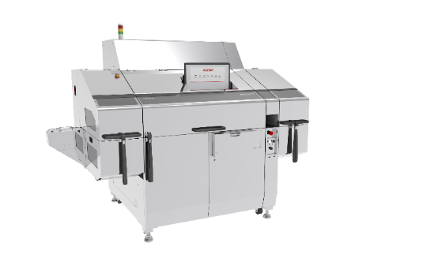 | 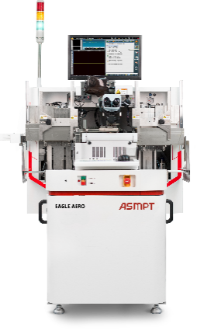
INFINITE die bonder  Source: ASMPT | Eagle AERO wire bonding system  Source: ASMPT

About ASMPT Limited (“ASMPT”)
ASMPT Limited is a leading global supplier of hardware and software solutions for the manufacture of semiconductors and electronics. Headquartered in Singapore, ASMPT’s offerings encompass the semiconductor assembly & packaging, and SMT (surface mount technology) industries, ranging from wafer deposition to the various solutions that organise, assemble and package delicate electronic components into a vast range of end-user devices, which include electronics, mobile communications, computing, automotive, industrial and LED (displays). ASMPT partners with customers very closely, with continuous investment in R&D helping to provide cost-effective, industry-shaping solutions that achieve higher productivity, greater reliability, and enhanced quality.
ASMPT is listed on the Stock Exchange of Hong Kong (HKEX stock code: 0522), and is one of the constituent stocks of the Hang Seng TECH Index, Hang Seng Composite MidCap Index under the Hang Seng Composite Size Indexes, the Hang Seng Composite Information Technology Industry Index under the Hang Seng Composite Industry Indexes, the Hang Seng Corporate Sustainability Benchmark Index, and the Hang Seng HK 35 Index.
To learn more about ASMPT, please visit us at asmpt.com.

The ASMPT Semiconductor Solutions Segment (“ASMPT SEMI”)
ASMPT SEMI is the leading supplier of advanced packaging and semiconductor assembly solutions. With a commitment to innovation and customer satisfaction, ASMPT SEMI provides a comprehensive range of products and services that cater to the evolving needs of the microelectronics industry. Their expertise spans areas such as flip-chip and wafer-level packaging, advanced interconnect technologies, and more. ASMPT SEMI's cutting-edge solutions enable customers to achieve higher performance, increased reliability, and improved cost-efficiency when producing their semiconductor devices.
To learn more about ASMPT SEMI, please visit us at semi.asmpt.com.

Media contacts:
ASMPT Global SEMI Press Office
Semiconductor Solutions
ASMPT Hong Kong Limited.
Jessica Ho
E-mail: semi_stratmkt@asmpt.com
Website: semi.asmpt.com

Global ASMPT Press Office
ASMPT Ltd.
Susanne Oswald
Rupert-Mayer-Strasse 48
81379 Munich
Germany
Tel: +49 89 20800-26439
E-Mail: susanne.oswald@asmpt.com
Website: asmpt.com

Authentic Staffing Agency - INDIA, USA, UAE

