FOR THE MEDIA
ASMPT at SEMICON Taiwan 2024

AI-Driven Evolution: ASMPT to Showcase Transformative Solutions at SEMICON Taiwan 2024
Munich (Germany), August 19 2024 – ASMPT Limited, the world's leading provider of hardware and software solutions for the semiconductor and electronics industries, will be exhibiting at SEMICON Taiwan 2024, Asia's leading electronics manufacturing event, from 4-6 September. ASMPT will showcase its advanced systems, NUCLEUS XLplus, POWER VECTOR, and VORTEX II, across three zones covering AI, Smart Automotive, and Intelligent Factory solutions at Booth N0762, TaiNEX 1&2.

Fan-Out Packaging: Powering the AI Era
The AI revolution continues to push the boundaries of computing power, driving the demand for high-performance AI chips, which in turn is accelerating innovation in advanced packaging. The fan-out process is shaping the future of semiconductor manufacturing, and ASMPT is at the forefront of this trend with its high-density Fan-Out Panel-Level Packaging (FOPLP) solution designed for 2.5D, fan-out, and embedded packages. NUCLEUS XLplus is precisely engineered to meet SEMI 3D20 standards, and it delivers exceptional accuracy on SiP bonding and flexibility in the fan-out process. Capable of handling extra-large substrates up to 600 x 600 mm, the solution supports a wide range of packaging configurations, from flip-chip to direct die attach, which exemplifies ASMPT’s dedication to pioneering technology and innovation in the rapidly evolving advanced packaging industry.

Smart Automotive Solutions: Driving the Future
AI is widely adopted by electric vehicle manufacturers for advanced driver assistance systems, autonomous driving features, and predictive maintenance, enabling enhanced performance, safety, and efficiency. To meet the dynamic needs of the automotive sector, ASMPT will present a range of Smart Automotive solutions tailored for the industry, encompassing sensing tech, power management, connectivity, infotainment, and more. ASMPT will also present the SiC power and advanced display solution, empowering EV manufacturers to improve quality, reliability, and efficiency in their production operations.
- POWER VECTOR - a die-tacking solution designed for Ag/Cu sintering in automotive power modules, offering strong bonding forces up to 588 N and process versatility. Coupled with
ASMPT’s SiC power solution, manufacturers can create robust modules with enhanced electrical and thermal characteristics.
- VORTEX II - designed explicitly for Mini LED Advanced Displays, efficiently handling Mini LED assembly and offering high-speed performance, exceptional precision, and innovative Zero-Delay XY-auto-correction, tending to transform visual experiences in modern vehicles with enhanced display quality and performances.

Intelligent Factory: Elevating Digital Transformation to New Heights
As the premier supplier of cutting-edge equipment and technological processes for the electronics industry, ASMPT enables electronics manufacturers worldwide to establish smart factories, championing automation and digitalisation. Through AI Enablement with machine learning algorithms incorporating the 4M framework (Man, Machine, Materials, Method), ASMPT solutions offer decision automation and optimisation, seamlessly integrating all operational levels from individual machines to production lines, factories, and enterprises. ASMPT’s comprehensive smart manufacturing solutions include SkyEye, the ecosystem for smart semiconductor manufacturing, and Intelligent Factory solutions, alongside its innovative SIPLACE placement and DEK printing solutions, as well as the modern Manufacturing Execution Systems (MES) from Critical Manufacturing will be displayed at SEMICON Taiwan. Together, this dynamic platform of advanced technologies will illustrate the latest automation and Digital Transformation advancements.

"ASMPT's presence at SEMICON Taiwan 2024 reflects our commitment to leading the industry with our developments and providing innovative solutions for semiconductor and electronics manufacturing. ASMPT will showcase its latest innovations in advanced packaging, smart automotive solutions and smart manufacturing, highlighting its leading role in semiconductor and electronics manufacturing technology. This will further strengthen our collaboration with our customers and partners and reinforce our role as a trusted industry leader that increases productivity, efficiency and competitiveness, " reassures Joseph Poh Tson Cheong, Senior Vice President at ASMPT.
About SEMICON Taiwan 2024, please visit the official website: https://semicontaiwan.org/

Illustrations for downloading
The following images are available for download in printable format at:
https://kk.htcm.de/press-releases/asmpt/

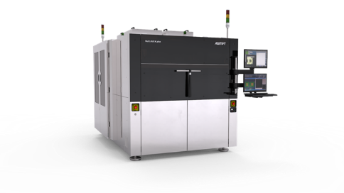 | 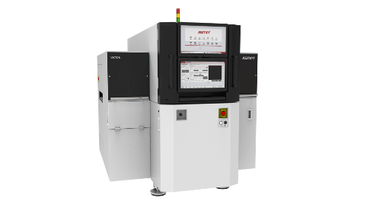
Engineered to meet SEMI3D20 standards, NUCLEUS XLplus is poised to play a crucial role in enabling the next generation of AI-powered devices.  Source: ASMPT | Coupled with ASMPT’s SiC power solution, POWER VECTOR is the ideal module bonding platform for high-performance automotive power module production lines.  Source: ASMPT

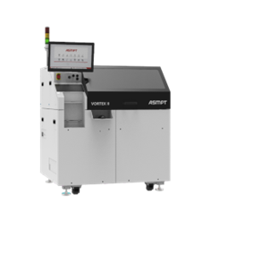
VORTEX II, the high-performance LED die bonder for ultra-fine pitch direct view displays, revolutionizing visual experiences in modern vehicles.

Source: ASMPT

About ASMPT Limited (“ASMPT”)
ASMPT Limited is a leading global supplier of hardware and software solutions for the manufacture of semiconductors and electronics. Headquartered in Singapore, ASMPT’s offerings encompass the semiconductor assembly & packaging, and SMT (surface mount technology) industries, ranging from wafer deposition to the various solutions that organise, assemble and package delicate electronic components into a vast range of end-user devices, which include electronics, mobile communications, computing, automotive, industrial and LED (displays). ASMPT partners with customers very closely, with continuous investment in R&D helping to provide cost-effective, industry-shaping solutions that achieve higher productivity, greater reliability, and enhanced quality.
ASMPT is listed on the Stock Exchange of Hong Kong (HKEX stock code: 0522), and is one of the constituent stocks of the Hang Seng TECH Index, Hang Seng Composite MidCap Index under the Hang Seng Composite Size Indexes, the Hang Seng Composite Information Technology Industry Index under the Hang Seng Composite Industry Indexes, the Hang Seng Corporate Sustainability Benchmark Index, and the Hang Seng HK 35 Index.
To learn more about ASMPT, please visit us at asmpt.com.

Media contacts:
Global ASMPT Press Office
ASMPT Ltd.
Susanne Oswald
Rupert-Mayer-Strasse 48
81379 Munich
Germany
Tel: +49 89 20800-26439
E-Mail: susanne.oswald@asmpt.com
Website: asmpt.com

HighTech communications GmbH
Barbara Ostermeier
Brunhamstrasse 21
81249 Munich
Germany
Tel.: +49-89 500778-10
E-Mail: b.ostermeier@htcm.de
Website: www.htcm.de

