Press Release
Symeo exhibits at the InnoTrans 2024
Radar in the service of reliability and safety for infrastructure
Neubiberg, Germany, August 14, 2024 – Symeo will be exhibiting at InnoTrans Berlin from 24 to 27 September 2024. At stand 785 in hall 27 of the international trade fair for transport technology, Symeo will be using a demonstrator to show how reliably its industrial radar sensors work under adverse conditions. At the center of the trade fair presentation is a concept for which the company is looking for development and application partners: HD Imaging Radar.
The HD Imaging Radar developed by Symeo combines the reliability of radar sensors with the high resolution of laser scanners. After six years of intensive research, the technology is ready for implementation in actual products. As a sensor array on rail vehicles, HD Imaging Radar has the potential to revolutionize track monitoring. "Every train with an HD Imaging Radar would collect detailed data on the track environment as it passes by. In conjunction with intelligent data analysis, for example with the help of AI, this turns the radar system into a virtual track walker. Damage and suspicious activities in the vicinity of track systems would be detected very quickly," explains Thomas Hörl-Weinhold, VP Industry Business Development at Symeo. "Thanks to many years of joint projects with railroad companies, we are confident that we will be able to establish forward-looking contacts at InnoTrans - both for the realization of the outlined HD imaging radar application and for other applications. Our fail-safe, maintenance-free, and extremely robust sensors are ideally suited for solutions in rail transportation.
The LPR-1DHP-291 radar sensor for precise real-time distance measurement up to 500 meters, the LPR-1D24 for measuring distances up to 1000 meters, and the compact LPR-1DHP-350 for short-range applications will be on display at the trade fair stand.

Available image material
The following printable images are available for download on the Internet:
https://kk.htcm.de/press-releases/symeo/

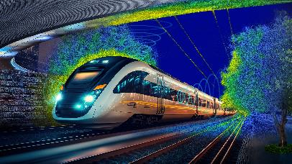
Image source: Symeo
At InnoTrans, Symeo will be presenting the concept of an HD imaging radar for automatic monitoring of the environment along railway lines.

Symeo
Symeo develops and markets products and solutions for precise, non-contact, maintenance-free position detection, distance measurement, and collision avoidance. Symeo’s products feature extremely robust designs to make them suitable for applications in harsh industrial environments.
Symeo’s LPR® locating technology offers a wireless and real-time-capable measuring system that is ideally suited for industrial applications. Symeo has many years of experience in the development of cost-efficient and customer-specific industrial solutions on the basis of LPR® technology.
The company delivers standardized products and complete solutions to system integrators, original equipment manufacturers (OEMs), and end customers worldwide.
Headquarters: Symeo GmbH, Prof.-Messerschmitt-Strasse 3 a, 85579 Neubiberg, Germany
Phone: (+49-89) 6607-7960, Fax: (+49-89) 66077-96190
E-mail: info@symeo.com, Website: www.symeo.com

Press contact:
HighTech communications GmbH
Marcus Planckh
Brunhamstrasse 21 (Building 202/2nd floor)
81249 Munich
Germany
Phone: (+49-89) 500-77822
E-mail: m.planckh@htcm.de
Website: www.htcm.de

