PRESS RELEASE

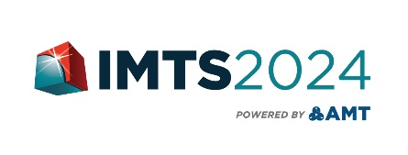
HZS - Hufschmied Tools Corp. appears for the first time at IMTS in Chicago
German specialist for machining problematic materials at IMTS
September 9-14, 2024
Booth: South Building,
Level 3 - 339386
Bobingen (Germany), Chicago, IL., August 2, 2024 – HZS - Hufschmied Tools Corp., the US subsidiary of German tool manufacturer Hufschmied Zerspanungssysteme GmbH, will be exhibiting at IMTS in Chicago from September 9-14. At its booth (South Building, Level 3 - 339386), which the company shares with machine tool manufacturer Roeders, HZS will provide an overview of its broad portfolio of special milling tools for material-optimized machining. This includes tools for machining fiber composites (e.g. CFRP, GFRP), ceramics, graphite, hardened steel, titanium, non-ferrous metals and aluminum as well as plastics and Plexiglas. Together with Roeders, a live machining of hardened steel will be demonstrated at the trade fair stand.
"Hufschmied is now represented at IMTS for the first time with its own subsidiary. We are looking forward to hearing about the machining challenges of the trade fair visitors and mastering them with process-optimized tools,” explains Daniel Sanchez, National Sales Manager of HZS - Hufschmied Tools Corp. “It is no coincidence that we are exhibiting here as a partner of the machine manufacturer Roeders, because we also work together with machine and CAM manufacturers to optimize our customers’ manufacturing processes. Machining is most efficient and produces the best quality when the tool and tool paths are matched to the material, workpiece and the capabilities of the machining center. That's why we attach great importance to consulting and often develop customer-specific tools."
A prominent example of the Hufschmied tools, which enjoy an excellent reputation in the German automotive industry, is “T-Rex®”, which achieves delamination-free cutting edges in CFRP and GFRP that do not need to be reworked. A patented coating ensures a long service life. Another tool on show at IMTS is the Graftor®, a patented roughing/finishing tool for the production of graphite erosion electrodes. The four compression peel cutters ensure a high chip volume and at the same time work with very low vibration. This means that even the most delicate structures can be produced without chipping.

Available images
The following images can be downloaded from the Internet in printable quality:
https://kk.htcm.de/press-releases/hufschmied/
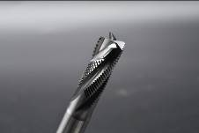  Image source:  Hufschmied Zerspanungssysteme  T-Rex® has the bite it takes to produce clean surfaces in CFRP and GFRP. | 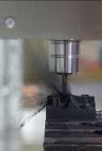  Image source:  Hufschmied Zerspanungssysteme  Exceptionally high removal rates combined with low cutting forces make the Graftor® the ideal graphite machining tool.

Image source:
Hufschmied Zerspanungssysteme

Daniel Sanchez, National Sales Manager of HZS - Hufschmied Tools Corp.

About Hufschmied Zerspanungssysteme GmbH
Established in 1991 and headquartered in Bobingen near Augsburg, Hufschmied Zerspanungssysteme GmbH is a manufacturer of high-quality tools for machinable production and friction stir welding. By specializing at an early stage in the machining of plastics, fiberglass materials and carbon fiber, Hufschmied has become a leader in Europe in the development of solutions for new materials. The company is an established system supplier to renowned machine tool manufacturers. Tools and manufacturing process consulting from Hufschmied are particularly valued in the automotive and aerospace industries as well as in medical technology. The company is involved in numerous organizations, including Composites United Deutschland e. V. Hufschmied's manufacturing operations are located in Bobingen, Winterlingen and Sigmaringen on the Swabian Alb. Hufschmied is certified according to ISO 9001:2015 (quality management) and ISO 14001:2015 (environmental management).

Hufschmied is the only tool manufacturer with its own diamond coating plant.
For more information: www.hufschmied.net

Additional information:  HZS - Hufschmied Tools Corp.  Daniel Sanchez  150 North Michigan Avenue, 35th Floor  Chicago, Illinois, 60601  USA  Phone: +1-312-763-2160  E-Mail: d.sanchez@hufschmied.net  www.hufschmied.net  Hufschmied Zerspanungssysteme GmbH  Marco Beigl  Edisonstrasse 11d  86399 Bobingen  Germany  Phone: +49 8234 9664-0  Telefax: +49 8234 9664-99  E-Mail: info@hufschmied.net  www.hufschmied.net | Press contact:  HighTech communications GmbH  Brigitte Basilio  Brunhamstrasse 21  81249 Munich  Germany  Phone: +49 89 500778-20  E-Mail: b.basilio@htcm.de  www.htcm.de

