PRESS RELEASE

New online customer platform
MyWE – 24/7 Service at a Glance
Waldenburg (Germany), July 31, 2024 – Orders, delivery status, important information, personal contacts and much more: The new online customer platform from the Würth Elektronik Group for its Electronic & Electromechanical Components and Printed Circuit business units integrates all important information and service offerings in one account.
“MyWE offers attractive added value for those working in development and purchasing,” Moritz Scelle, Product Owner MyWE at Würth Elektronik, explains. “The new customer platform is interesting for all customer groups, especially for SME customers: As an individual, you can register quickly and easily, as there are no complex company interfaces required.”
The following MyWE functions are currently available:
- Shipment tracking: Review current and past deliveries. Download information and all documents.
- Order processing: Request quotes and place orders. Review inquiries, offers and orders.
- Product overview: Obtain extensive information and documents on all products. Review all products already ordered. Compile your personal favorites list.
- Knowledge panel: Find links to interesting content and services from Würth Elektronik, such as events, design tools, application notes, to name a few.
- Contact: Find the details of your contact persons.
“With MyWE, those interested have direct access to all important data around the clock. Inquiries and orders can be created and sent with just a few clicks,” according to Scelle. “Today, many customers wish to control processes without e-mails or phone calls. Our new online customer platform keeps all your options open.”
MyWE supplements the service offering – but it is definitely not intended to replace personal contact. The relevant contact persons at Würth Elektronik with their contact details are displayed for all processes and you can still reach out to them as usual.
MyWE is now online: www.we-online.com/mywe

Available images
The following images can be downloaded from the Internet in printable quality: https://kk.htcm.de/press-releases/wuerth/
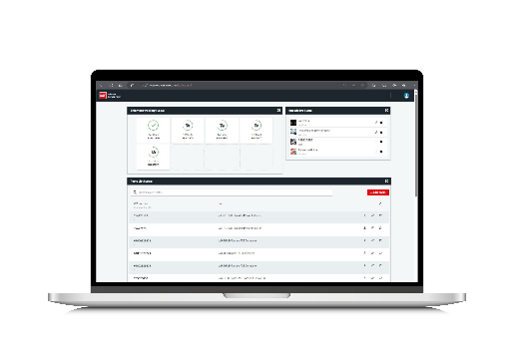
Image source: Würth Elektronik
New online customer platform MyWE

About the Würth Elektronik group of companies
The Würth Elektronik group of companies, founded in Niedernhall, Baden-Wuerttemberg, Germany, has about 7,900 employees worldwide and generated global sales of 1.24 Billion Euro in 2023.
With over 23 production locations worldwide, Würth Elektronik is one of the most successful companies of the Würth Group.
Würth Elektronik operates internationally with its three company areas in various markets:
- Electronic & electromechanical components (Headquarters: Waldenburg)
Würth Elektronik eiSos (electronic and electromechanical components) is one of Europe's biggest manufacturers of electronic & electromechanical components. More than 700 sales representatives worldwide make up a direct sales network that is unique for the electronics market. The customer is offered excellent design-in support on-site from the manufacturer. The production plants in Germany, Czech Republic, Bulgaria, USA, Mexico, Taiwan and China guarantee high availability on all markets. All catalog products are available from stock and samples are free of charge.

- PCBs (Headquarters: Niedernhall)
Founded in 1971, Würth Elektronik Circuit Board Technology is today Europe's leading PCB manufacturer and, thanks to the comprehensive portfolio, a reliable partner for both individual entrepreneurs and large corporations. Whether basic or high-end technologies, customer-specific requirements are met from the initial idea for a design to the production of prototypes on the online shop and finally, manufacturing of medium and large volumes in Germany or Asia.
- Intelligent Power & Control Systems (Headquarters: Niedernhall-Waldzimmern)
As a specialist for the development and production of electronic and electromechanical system solutions, such as central electronics, Würth Elektronik ICS (Intelligent Power & Control Systems) is a longtime partner for many commercial vehicles. Professional project management accompanies business partners from the product idea through to series maturity.

Further info at www.we-online.com

Further information:  Würth Elektronik eiSos GmbH & Co. KG  Sarah Hurst  Clarita-Bernhard-Strasse 9  81249 Munich  Germany  Phone: +49 7942 945-5186  E-mail: sarah.hurst@we-online.de  www.we-online.com | Press contact:  HighTech communications GmbH  Brigitte Basilio  Brunhamstrasse 21  81249 Munich  Germany  Phone: +49 89 500778-20  E-mail: b.basilio@htcm.de  www.htcm.de

