PRESS RELEASE
ASMPT Philippines at PSECE 2024
Intelligent Factory
generates great interest
Shanghai (China), July 31, 2024 – At the Philippines Semiconductor and Electronics Convention and Exhibition (PSECE) held from July 24 to 26 in Manila, ASMPT presented its Intelligent Factory concept to customers and interested parties with the help of hardware and software examples. The event created lots of interest and was rated very positively by attendees.
“I had already heard quite a lot about ASMPT’s Intelligent Factory concept,” said one happy attendee, “but this was the first time I could learn how it works in practice directly from ASMPT’s experts.”
“Holistic, data-driven, connected – our concept of the Intelligent Factory, which we first unveiled at the 2023 Productronica trade fair in Munich, is gradually becoming reality on many shop floors around the world,” says Peland Koh, Vice President Customer Relationship Management and Regional Managing Director Rest of Asia at ASMPT. “Being present at trade fairs like the PSECE strengthens our position in the Asian market and is highly appreciated by customers and other interested parties.”
Comprehensive use of data
“In the Intelligent Factory, hardware and software work hand-in-hand across lines and factories,” adds Peland Koh. “It allows users to increase their yields while providing relief for their employees’ workloads.”
Visitors were able to experience trailblazing hardware and software solutions from ASMPT at the booth. Highlights included:
- DEK TQ: The innovative solder paste printer that sets new standards in cycle time, process stability, and precision.
- SIPLACE TX micron: The high-speed placement machine that processes classic SMDs with maximum accuracy and efficiency as well as highly sensitive dies in advanced packaging applications.
- Factory Equipment Center: The manufacturer-independent software that supports the intelligent tracking and maintenance of all production assets with a special focus on smart nozzles and feeders.
- Virtual Assist: The AI-based assistant on the smartphone that makes all repair and maintenance tasks easier for technicians by allowing them to ask questions in natural language.
- WORKS Monitoring: The intelligent application from the WORKS Software Suite that delivers all KPIs for an SMT shop floor at a glance in real time.
“The Intelligent Factory continues to be on everyone’s mind in the industry,” says Peland Koh. “With innovative and fully networkable hardware and software, we give our customers a clear competitive advantage. The overwhelming success of our presence at the PSECE shows that our strategy delivers exactly what electronics manufacturers need and want today.”

Illustrations for downloading
The following print-ready artwork is available on the internet for downloading:
https://kk.htcm.de/press-releases/asmpt/

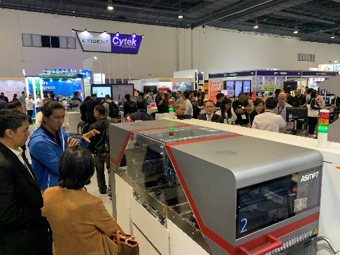 | 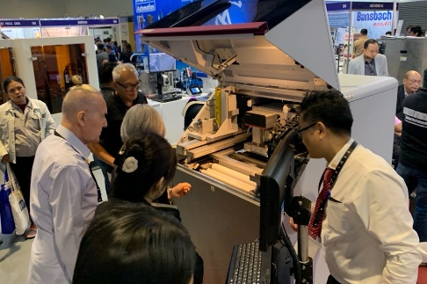
High-speed placement machine SIPLACE TX micron  Image credit: ASMPT | Innovative solder paste printer DEK TQ  Image credit: ASMPT
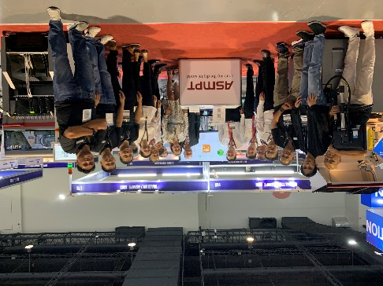 | 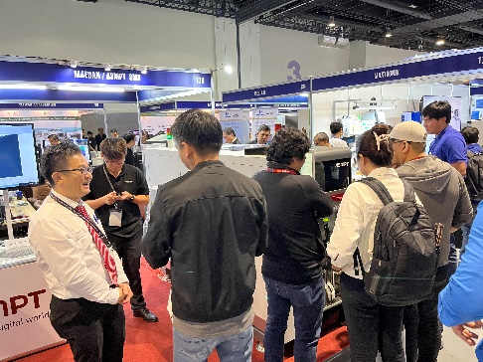
ASMPT Group at PSECE 2024  Image credit: ASMPT | ASMPT booth  Image credit: ASMPT

About ASMPT Limited (“ASMPT”)
ASMPT Limited is a leading global supplier of hardware and software solutions for the manufacture of semiconductors and electronics. Headquartered in Singapore, ASMPT’s offerings encompass the semiconductor assembly & packaging, and SMT (surface mount technology) industries, ranging from wafer deposition to the various solutions that organize, assemble and package delicate electronic components into a vast range of end-user devices, which include electronics, mobile communications, computing, automotive, industrial and LED (displays). ASMPT partners with customers very closely, with continuous investments in R&D helping to provide cost-effective, industry-shaping solutions that achieve higher productivity, greater reliability, and enhanced quality.
ASMPT is listed on the Stock Exchange of Hong Kong (HKEX stock code: 0522) and is one of the constituent stocks of the Hang Seng Composite MidCap Index under the Hang Seng Composite Size Indexes, the Hang Seng Composite Information Technology Industry Index under Hang Seng Composite Industry Indexes, the Hang Seng Corporate Sustainability Benchmark Index, and the Hang Seng HK 35 Index.
To learn more about ASMPT, please visit www.asmpt.com.

The ASMPT SMT Solutions segment
The mission of the SMT Solutions segment within ASMPT is to implement and support the Intelligent Factory at electronics manufacturers worldwide.
ASMPT solutions support the networking, automation, and optimization of central workflows with hardware, software and services that enable electronics manufacturers to transition to the Intelligent Factory in stages and enjoy dramatic improvements in productivity, flexibility, and quality. With its integrated open automation concept, ASMPT opens the door for its customers to economically feasible automation, entirely in accordance with their individual requirements – modular, flexible, and vendor-independent.
The product range includes hardware and software such as SIPLACE placement solutions, DEK printing solutions, inspection and storage solutions, and the Software Suite WORKS. With WORKS, ASMPT offers electronics manufacturers high-quality software for planning, controlling, analyzing and optimizing all processes on the shop floor. Maintaining close relationships with customers and technology partners is a central component of ASMPT’s strategy.
For more information about ASMPT SMT Solutions, visit smt.asmpt.com.

Media contacts:
China ASMPT Press Office
SMT Solutions
Guan Jing
Tel.: +86 (755) 26934550-2109
E-mail: jing.guan@asmpt.com
Website: smt.asmpt.com

Global ASMPT Press Office
ASMPT Ltd.
Susanne Oswald
Rupert-Mayer-Strasse 48
81379 Munich
Germany
Tel: +49 89 20800-26439
E-Mail: susanne.oswald@asmpt.com
Website: asmpt.com

