PRESS RELEASE
Brazil Technology Days
OEE in the Intelligent Factory
Suwanee (USA), July 31, 2024 – On July 23 and 25, customers and other interested parties in São Paulo and Manaus were able to get valuable information on new perspectives in SMT manufacturing with a special focus on maximum overall equipment effectiveness (OEE) in modern, intelligent electronics factories.
“The lineup of lectures showed me how I can maximize my equipment’s overall effectiveness, with ASMPT’s concept of the integrated intelligent factory playing a critical role,” said a satisfied attendee. “Today I could experience first-hand what this looks like in practice. It is always amazing to see how much additional yield you can achieve by making a few smart investment decisions.”
Availability, performance, quality
“The concept of overall equipment effectiveness is defined by three key points: availability, performance, and quality,” explains Cesar Takamine, Country Manager Brazil for ASMPT. “To optimize your OEE you must take all three into account in equal measure and view each project holistically. Hardware and software must interact seamlessly in modern SMT production. In practice, the actual OEE optimization is carried out through a bundle of individual measures that must be coordinated down to the last detail, which is why the overarching principle of the Intelligent Factory is so important. We once again addressed this in detail during the Brazil Technology Days and did so on all levels.”
One major component that was presented was the MES (manufacturing execution system) from the ASMPT subsidiary Critical Manufacturing, which was developed especially for electronics production and raises OEE on the factory and enterprise levels. Individual steps along the SMT line, such as the challenging solder paste printing process, were also addressed. Using the highly precise and process-stable DEK TQ printing platform as an example, the presenters showed how typical printing problems can be isolated and resolved step by step with intelligent hardware and software. Also presented was the highly flexible SIPLACE SX placement machine that improves availability and performance, especially in modern high-mix/low-volume production environments. The automobile industry, for example, requires mixed boards that must be populated with very small and very large components, for which the SIPLACE SX achieves by far the greatest OEE.
“OEE optimization is always the result of a strategy that extends from the machine to the enterprise level. At ASMPT, we cover almost the entire SMT production chain with our product portfolio. And our integrative intelligent factory concept makes us the ideal partner when it comes to getting the most out of your production equipment.” sums up Cesar Takamine.

Illustrations for downloading
The following print-ready artwork is available on the internet for downloading:
https://kk.htcm.de/press-releases/asmpt/

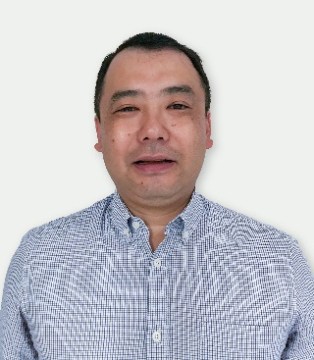 | 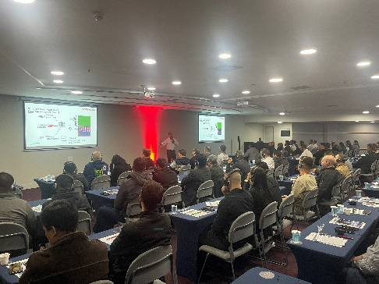
Cesar Takamine, Country Manager Brazil at ASMPT  Image credit: ASMPT | Many interested attendees followed the technical presentations in São Paulo. The presentations, some of which were held in English, were simultaneously translated into Portuguese via headphones.  Image credit: ASMPT
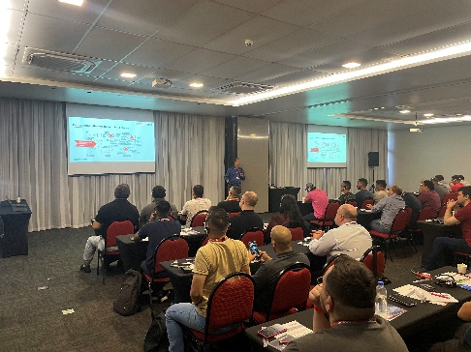
Interested attendees in Manaus listen to the technical presentation on factors that influence the printing process.

Image credit: ASMPT

About ASMPT Limited (“ASMPT”)
ASMPT Limited is a leading global supplier of hardware and software solutions for the manufacture of semiconductors and electronics. Headquartered in Singapore, ASMPT’s offerings encompass the semiconductor assembly & packaging, and SMT (surface mount technology) industries, ranging from wafer deposition to the various solutions that organize, assemble and package delicate electronic components into a vast range of end-user devices, which include electronics, mobile communications, computing, automotive, industrial and LED (displays). ASMPT partners with customers very closely, with continuous investments in R&D helping to provide cost-effective, industry-shaping solutions that achieve higher productivity, greater reliability, and enhanced quality.
ASMPT is listed on the Stock Exchange of Hong Kong (HKEX stock code: 0522) and is one of the constituent stocks of the Hang Seng Composite MidCap Index under the Hang Seng Composite Size Indexes, the Hang Seng Composite Information Technology Industry Index under Hang Seng Composite Industry Indexes, the Hang Seng Corporate Sustainability Benchmark Index, and the Hang Seng HK 35 Index.
To learn more about ASMPT, please visit www.asmpt.com.

The ASMPT SMT Solutions segment
The mission of the SMT Solutions segment within ASMPT is to implement and support the Intelligent Factory at electronics manufacturers worldwide.
ASMPT solutions support the networking, automation, and optimization of central workflows with hardware, software and services that enable electronics manufacturers to transition to the Intelligent Factory in stages and enjoy dramatic improvements in productivity, flexibility, and quality. With its integrated open automation concept, ASMPT opens the door for its customers to economically feasible automation, entirely in accordance with their individual requirements – modular, flexible, and vendor-independent.
The product range includes hardware and software such as SIPLACE placement solutions, DEK printing solutions, inspection and storage solutions, and the Software Suite WORKS. With WORKS, ASMPT offers electronics manufacturers high-quality software for planning, controlling, analyzing and optimizing all processes on the shop floor. Maintaining close relationships with customers and technology partners is a central component of ASMPT’s strategy.
For more information about ASMPT SMT Solutions, visit smt.asmpt.com.

Media contacts:
AMCAS ASMPT Press Office
SMT Solutions
Mark Ogden
Tel.: +1 (770) 797 3189
E-mail: ogden.mark@asmpt.com
Website: smt.asmpt.com

Global ASMPT Press Office
ASMPT Ltd.
Susanne Oswald
Rupert-Mayer-Strasse 48
81379 Munich
Germany
Tel: +49 89 20800-26439
E-Mail: susanne.oswald@asmpt.com
Website: asmpt.com

