PRESS RELEASE
ASMPT makes high-strength and high-conductivity joints possible with silver sintering
POWER VECTOR from ASMPT
Munich (Germany), July 30, 2024 – ASMPT, the world’s leading provider of hardware and software for semiconductor and electronics production, presents an innovative die and module bonding platform that can be used in a variety of ways for producing power modules.
“Whether for electromobility, renewable energies or industrial automation and motor control systems – in the course of the energy transition, electricity is increasingly becoming the dominant energy source,” explains David Felicetti, Business Development & Product Marketing Manager, at ASMPT. “But especially in power electronics, conventional joining technologies such as soft soldering are increasingly reaching their limits.”
Silver sintering instead of soldering
ASMPT has overcome these limitations with its line of products for silver sintering and, in future applications, copper sintering. POWER VECTOR, for pick and place or tacking dies and modules on heat sinks, completes the process chain in ASMPT's sintering production line.
The advantages of this process are obvious: While silver has a melting point of 961 degrees Celsius, it can be “cemented” at much lower temperatures when pressure is applied, resulting is a thermally and mechanically strong connection with excellent conductivity.
Process and feeding flexibility
With the POWER VECTOR, this method is now being translated into a practice-oriented manufacturing system. The platform features an automatic tool changer, achieves bonding forces of up to 588 N, and works with all popular processes: dry paste, wet paste, and die transfer film (DTF). Components can be supplied via wafer, tape-and-reel, waffle pack, or tray.
The POWER VECTOR uses a hot thermo-compression bond head to place dies on the substrate with outstanding precision. To achieve this, the bond head and platform can be heated to >200°C to create a pre-adhesion, which is finished using ASMPT's SilverSAM sintering platform at temperatures between 200 and 300 degrees Celsius and pressures between 5 and 30 MPa.
“Silver sintering creates reliable and highly conductive connections even in applications with high currents where components become quite hot,” says David Felicetti. “With the POWER VECTOR system, we have closed one of the last remaining gaps in our portfolio and are now able to offer a full-service production line for power modules.”

Illustrations for downloading
The following print-ready artwork is available on the internet for downloading:
http://www.htcm.de/kk/asm

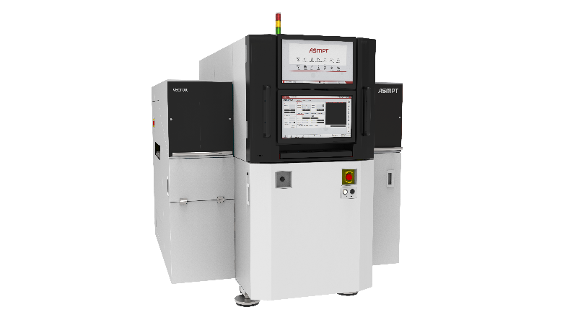
Powerhouse for power electronics: With a bonding force of up to 588 N, the POWER VECTOR is the ideal component for state-of-the-art power module production lines.

Image credit: ASMPT

About ASMPT Limited (“ASMPT”)
ASMPT Limited is a leading global supplier of hardware and software solutions for the manufacture of semiconductors and electronics. Headquartered in Singapore, ASMPT’s offerings encompass the semiconductor assembly & packaging, and SMT (surface mount technology) industries, ranging from wafer deposition to the various solutions that organize, assemble and package delicate electronic components into a vast range of end-user devices, which include electronics, mobile communications, computing, automotive, industrial and LED (displays). ASMPT partners with customers very closely, with continuous investments in R&D helping to provide cost-effective, industry-shaping solutions that achieve higher productivity, greater reliability, and enhanced quality.
ASMPT is listed on the Stock Exchange of Hong Kong (HKEX stock code: 0522) and is one of the constituent stocks of the Hang Seng Composite MidCap Index under the Hang Seng Composite Size Indexes, the Hang Seng Composite Information Technology Industry Index under Hang Seng Composite Industry Indexes, the Hang Seng Corporate Sustainability Benchmark Index, and the Hang Seng HK 35 Index.
To learn more about ASMPT, please visit www.asmpt.com.
About ASMPT Semiconductor Solutions (“ASMPT SEMI”)
ASMPT SEMI is the leading provider of forward-looking solutions for advanced packaging and semiconductor assembly. With its commitment to innovation and customer satisfaction, ASMPT SEMI offers a comprehensive range of products and services that meet the evolving needs of the microelectronics industry. Expert knowledge covers areas such as flip-chip and wafer-level packaging, advanced interconnect technologies, and more. ASMPT SEMI’s state-of-the-art solutions enable customers to achieve higher performance, greater reliability, and improved cost-efficiency in the manufacturing of their semiconductor devices.
For more information about ASMPT SEMI, visit semi.asmpt.com.

Media contacts:
Global ASMPT Press Office
ASMPT Ltd
Susanne Oswald
Rupert-Mayer-Strasse 48
81379 Munich
Germany
Tel: +49 89 20800-26439
E-mail: susanne.oswald@asmpt.com
Website: asmpt.com

HighTech communications GmbH
Barbara Ostermeier
Brunhamstrasse 21
81249 Munich
Germany
Tel.: +49-89 500778-10|
E-mail: b.ostermeier@htcm.de
Website: www.htcm.de

