PRESS RELEASE
Automatic Paste Transfer and
Quick Change Squeegee for ASMPT printers
More efficiency in the solder paste printing process
Singapore, July 23, 2024 – ASMPT, the market and innovation leader in SMT manufacturing technology, has added two new features to its proven DEK printing platforms that automate solder paste transfers and simplify squeegee changes.
ASMPT covers almost the entire SMT manufacturing process with its extensive product portfolio and is continuously working to further automate and simplify the various workflows. “Solder paste printing, which is already the most error-prone process in SMT production, still has many steps that must be done by hand,” explains Rick Goldsmith, Director Product Management at ASMPT. “Finding suitable people for these activities is becoming increasingly difficult, which is why our customers are asking for solutions that reduce personnel and material costs as well as error rates.”
Paste transfer
When the printer setup needs to be changed, the solder paste that remains on the old stencil needs to be transferred to the new one. “Until now, this was done manually with a spatula,” explains Goldsmith. “In most cases, some of the paste remained on the old stencil and was not fully transferred to the new one. In addition, there was always the risk that the paste would get contaminated or wind up in the wrong place, leading to short circuits and malfunctions.”
The new paste transfer unit for the DEK TQ simplifies this process. The paste gets transferred automatically during each stencil change, provided the process parameters permit this. To do this, the squeegee pushes the paste to a transfer unit, from which it gets applied to the new stencil. Next, the system uses the understencil cleaning system to clean off any paste residue.
“This fully automatic paste transfer relieves the already scarce operators,” says Goldsmith. “It works faster, more precisely and more efficiently than would be possible by hand. With the manual process, up to 10 percent of the paste remains on the stencil. Our automated paste transfer system reduces this to 5 percent. This will represent a significant cost saving in solder paste, reducing manufacturing cost per PCB.” The new paste transfer system can be easily installed on all DEK TQ-series solder paste printers.
Quick Change Squeegee
ASMPT has also improved the squeegee changeover process on its solder paste printers. “Previously, the squeegee was affixed with two thumbscrews,” explains Goldsmith. “To change the squeegee, the operator had to loosen and then tighten them again – a time-consuming process that often caused problems, for example, when someone tightened the thumbscrews too firmly and another operator was unable to loosen them. The time factor was also significant, because 20 changeovers over a 24-hour period are not uncommon.”
A new holder makes these changeovers much easier because the squeegee is automatically unlocked when it is removed out of the machine. It can then be switched out in a single step before the bracket locks automatically as the squeegee is retracted. This reduces the changeover time by up to 50 percent. In addition, a mechanical coding system prevents the incorrect insertion of squeegees. Quick Change Squeegee can be retrofitted in a few hours and is available for both the DEK TQ and the NeoHorizon platforms.
“Competition is getting tougher all the time in SMT manufacturing,” says Goldsmith. “To be successful in this field, you must continuously automate and streamline your operations. At ASMPT, we understand the challenges SMT manufacturers face and are able to offer our customers interesting solutions that provide them with tangible competitive advantages.”

Illustrations for downloading
The following print-ready artwork is available on the internet for downloading:
https://kk.htcm.de/press-releases/asmpt/

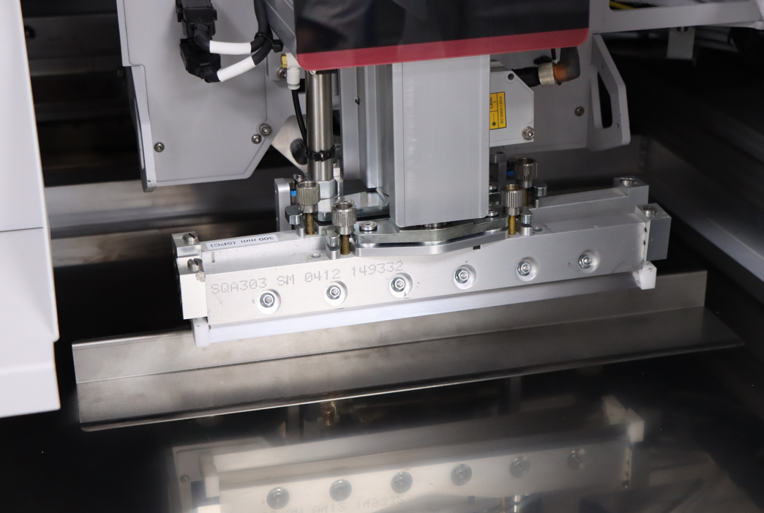 | 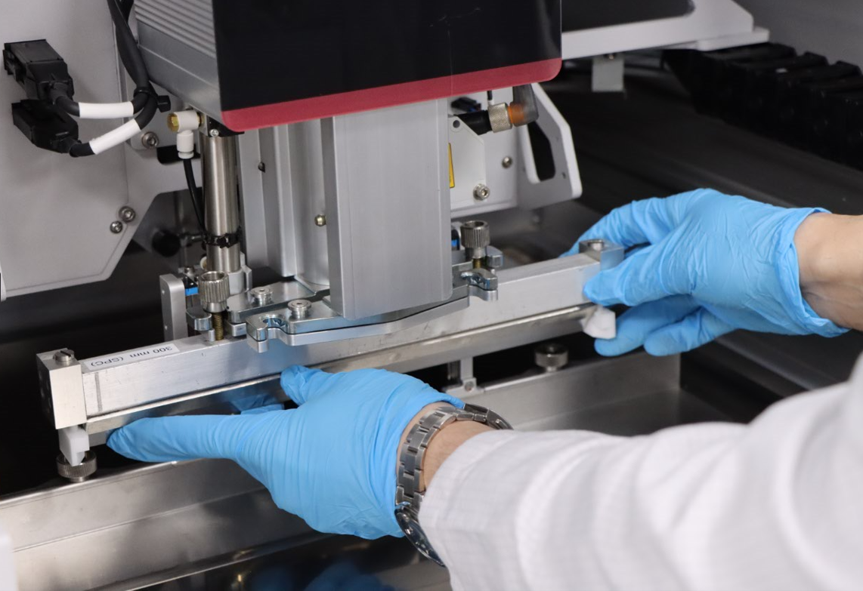
Paste transfer: ASMPT automates and accelerates the solder paste transfer process during stencil changeovers.  Image credit: ASMPT | Quick Change Squeegee: Automatic locking and unlocking reduces the squeegee changeover time by up to 50 percent.  Image credit: ASMPT

About ASMPT Limited (“ASMPT”)
ASMPT Limited is a leading global supplier of hardware and software solutions for the manufacture of semiconductors and electronics. Headquartered in Singapore, ASMPT’s offerings encompass the semiconductor assembly & packaging, and SMT (surface mount technology) industries, ranging from wafer deposition to the various solutions that organise, assemble and package delicate electronic components into a vast range of end-user devices, which include electronics, mobile communications, computing, automotive, industrial and LED (displays). ASMPT partners with customers very closely, with continuous investment in R&D helping to provide cost-effective, industry-shaping solutions that achieve higher productivity, greater reliability, and enhanced quality.
ASMPT is listed on the Stock Exchange of Hong Kong (HKEX stock code: 0522), and is one of the constituent stocks of the Hang Seng Composite MidCap Index under the Hang Seng Composite Size Indexes, the Hang Seng Composite Information Technology Industry Index under the Hang Seng Composite Industry Indexes, the Hang Seng Corporate Sustainability Benchmark Index, and the Hang Seng HK 35 Index.
To learn more about ASMPT, please visit us at asmpt.com.

The ASMPT SMT Solutions segment
The mission of the SMT Solutions segment within ASMPT is to implement and support the Intelligent Factory at electronics manufacturers worldwide.
ASMPT solutions support the networking, automation, and optimization of central workflows with hardware, software and services that enable electronics manufacturers to transition to the Intelligent Factory in stages and enjoy dramatic improvements in productivity, flexibility, and quality. With its integrated open automation concept, ASMPT opens the door for its customers to economically feasible automation, entirely in accordance with their individual requirements – modular, flexible, and vendor-independent.
The product range includes hardware and software such as SIPLACE placement solutions, DEK printing solutions, inspection and storage solutions, and the Software Suite WORKS. With WORKS, ASMPT offers electronics manufacturers high-quality software for planning, controlling, analyzing and optimizing all processes on the shop floor. Maintaining close relationships with customers and technology partners is a central component of ASMPT’s strategy.
For more information about ASMPT SMT Solutions visit smt.asmpt.com.

Media contacts:
ASMPT ROA Press Office
SMT Solutions
ASMPT SMT Singapore Pte. Ltd.
Janet Loh
Tel.: +65 6877 3948
E-mail: Janet.loh@asmpt.com
Website: smt.asmpt.com

Global ASMPT Press Office
ASMPT Ltd.
Susanne Oswald
Rupert-Mayer-Strasse 48
81379 Munich
Germany
Tel: +49 89 20800-26439
E-Mail: susanne.oswald@asmpt.com
Website: asmpt.com

