PRESS RELEASE
Würth Elektronik ICS France relocates
Modern location with room for expansion
Niedernhall (Germany), Ittenheim (France), 4 July 2024 – Würth Elektronik ICS France has moved into a new building in Ittenheim, Alsace, west of Strasbourg. The developer of electronic and electromechanical power distributors, control systems and HMI solutions for commercial vehicles and mobile machinery now has around 1100 square metres on two floors at its disposal to better serve its French customers. 37 employees of Würth Elektronik ICS France can look forward to an attractive working environment in the new building. The Sales and Customer Management, Product and Project Management and Application Engineering departments are based here. The building is designed for expansion and offers space for more than 70 employees.
Würth Elektronik ICS has enjoyed success in France for over 20 years. To be able to grow further, the company has constructed a new building in Ittenheim. The building unmistakably embodies the Würth Elektronik Group, both in its architecture and design. A modern room layout concept has been established inside. Each team member has the opportunity to choose a workstation that corresponds to their current focus and set it up according to their current tasks – whether collaborative, customer-orientated or individual.
In the coming months, additional services such as a test laboratory or training centre will be set up at the new site.
Würth Elektronik ICS is confident that the new site, with its state-of-the-art equipment and highly skilled workforce, will be able to optimally serve the growing demand for power distribution solutions, controls and HMI for various markets.

Available images
The following images are available for download in printable format at:
https://kk.htcm.de/press-releases/wuerth-ics/

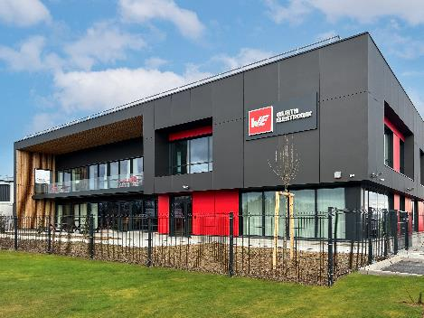Image source: Würth Elektronik ICS  The new headquarters of Würth Elektronik ICS in France | 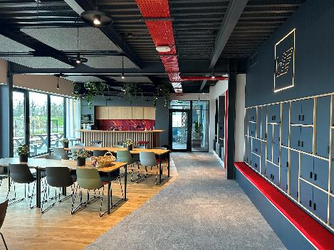Image source: Würth Elektronik ICS  The cafeteria of the new branch in Ittenheim near Strasbourg
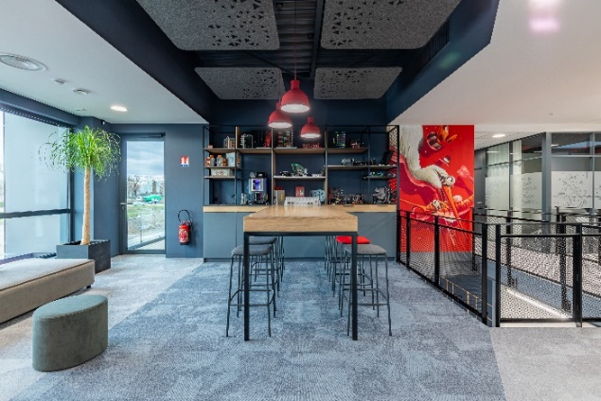Image source: Würth Elektronik ICS
The ‘Creativity Room’ – Würth Elektronik attaches great importance to creating a working environment that promotes creative collaboration.

About Würth Elektronik ICS GmbH & Co. KG
Würth Elektronik ICS is a system supplier for electromechanical and electronic solutions for signal and power distribution, control, and display and operating solutions. The company’s key customers include well-known manufacturers of construction and agricultural machinery as well as commercial vehicles. Sectors such as industrial technology or renewable energies also benefit from products and services provided by ICS. The company is headquartered in Niedernhall-Waldzimmern (Germany). Further subsidiaries are located in France, Great Britain, Italy, the USA, and India.
Würth Elektronik is part of the Würth Group, the global market leader in the development, production, and sale of fastening and assembly materials, and employs 7,900 people. In 2023, the Würth Elektronik Group generated sales of 1.24 billion Euro.
Würth Elektronik: more than you expect!
Further info at www.we-online.com/ics

More information:  Würth Elektronik ICS GmbH & Co. KG  Sandra Herter  Gewerbepark Waldzimmern  Würthstrasse 1  74676 Niedernhall  Germany  Phone: +49 7940 9810-1503  E-mail: sandra.herter@we-online.de  www.we-online.com/ics | Press contact:  HighTech communications GmbH  Marcus Planckh  Brunhamstrasse 21  81249 Munich  Germany  Phone: +49 89 500778-22  E-mail: m.planckh@htcm.de  www.htcm.de

