PRESS RELEASE
ASMPT successful at PCIM Europe
Process chain for
power module production
Munich, June 24, 2024 – At the PCIM Europe industry fair in Nuremberg, ASMPT exhibited a complete power module manufacturing concept. With its presentation of innovative laser dicing and sintering technologies, the global market and technology leader in hardware and software solutions for semiconductor and electronics production addresses current challenges in the production of power electronics for the automobile industry and beyond.
“Against the backdrop of recent supply chain challenges, the European automobile electronics industry has a great interest in having more chips and components manufactured in Europe. Power electronics in particular are developing great momentum, as was apparent at the PCIM show,” says Johann Weinhändler, Managing Director at ASMPT AMICRA GmbH in Regensburg, who is responsible for ASMPT’s Semiconductor Solutions segment in EMEA in addition to the global AMICRA business. “With our help, European EMS providers will conquer new business areas.”
David Felicetti, Business Development & Product Marketing Manager at ASMPT, added: “With their high efficiency and thermal conductivity, power modules that are based on silicon carbide (SiC) and firmly bonded to heat sinks via silver sintering are increasingly in demand for automotive electronics, but other application areas will play a significant role in the future as well. Accordingly, many PCIM visitors showed great interest in our POWER VECTOR die and module bonding platform.” Weinhändler adds:” We can now offer machines for the complete process chain in power module production. This does not mean, however, that these machines must be arranged in a line, as in our model. I can well imagine that some EMS providers will specialize in process steps such as sintering.”
As part of its sustainability strategy, ASMPT refrained from shipping giant machines to Nuremberg and instead presented its machines as mock-ups and models in combination with 3D videos.
In addition to the process chain for power modules, the presentation of the ALSI LASER1205 multi-beam laser dicing platform sent another important message: With its patented new process, it improves the yield in the separation of thin, sensitive and still very expensive SiC wafers. The innovative system processes wafers ranging from 10 to 250 microns in thickness with a positioning accuracy of less than 1.5 microns, and it operates 50 percent faster than conventional methods.

Illustrations for downloading
The following print-ready artwork is available on the internet for downloading:
https://kk.htcm.de/press-releases/asmpt/
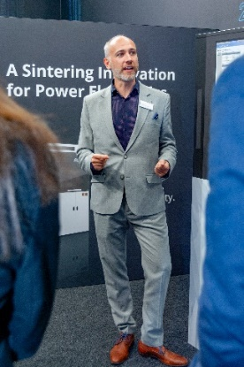 | 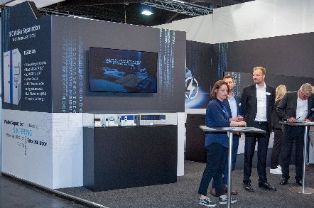
David Felicetti, Business Development & Product Marketing Manager at ASMPT, presented ASMPT’s concepts for power electronics manufacturing at PCIM Europe.  Image credit: ASMPT | Shown as a model, the line for power module production includes the DEK NeoHorizon solder paste printer, the POWER VECTOR (die, clip and component tacking for sintering), the SilverSAM sintering platform, and the 3GeP, a transfer molding system for a wide range of packaging applications.  Image credit: ASMPT

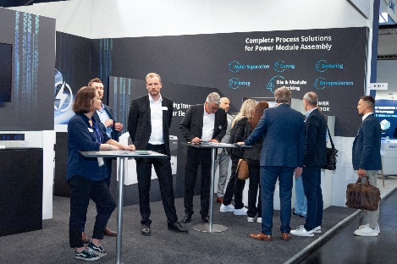 | 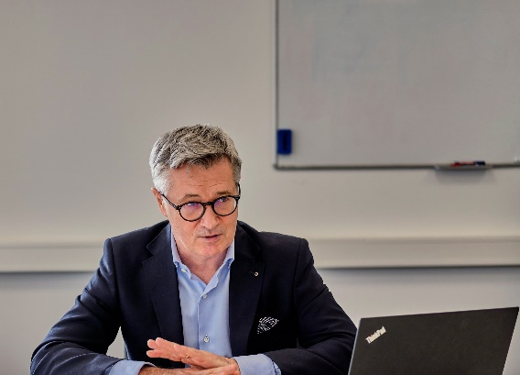
Visitors at the PCIM Europe showed great interest in the powerful POWER VECTOR die and module bonding platform.  Image credit: ASMPT | Dr. Johann Weinhändler, Managing Director at ASMPT AMICRA GmbH in Regensburg, is responsible for ASMPT’s Semiconductor Solutions segment in EMEA.  Image credit: ASMPT

About ASMPT Limited (“ASMPT”)
ASMPT Limited is a leading global supplier of hardware and software solutions for the manufacture of semiconductors and electronics. Headquartered in Singapore, ASMPT’s offerings encompass the semiconductor assembly & packaging, and SMT (surface mount technology) industries, ranging from wafer deposition to the various solutions that organize, assemble and package delicate electronic components into a vast range of end-user devices, which include electronics, mobile communications, computing, automotive, industrial and LED (displays). ASMPT partners with customers very closely, with continuous investments in R&D helping to provide cost-effective, industry-shaping solutions that achieve higher productivity, greater reliability, and enhanced quality.
ASMPT is listed on the Stock Exchange of Hong Kong (HKEX stock code: 0522) and is one of the constituent stocks of the Hang Seng Composite MidCap Index under the Hang Seng Composite Size Indexes, the Hang Seng Composite Information Technology Industry Index under Hang Seng Composite Industry Indexes, the Hang Seng Corporate Sustainability Benchmark Index, and the Hang Seng HK 35 Index.
To learn more about ASMPT, please visit www.asmpt.com.

About ASMPT Semiconductor Solutions (“ASMPT SEMI”)
ASMPT SEMI is the leading provider of forward-looking solutions for advanced packaging and semiconductor assembly. With its commitment to innovation and customer satisfaction, ASMPT SEMI offers a comprehensive range of products and services that meet the evolving needs of the microelectronics industry. Expert knowledge covers areas such as flip-chip and wafer-level packaging, advanced interconnect technologies, and more. ASMPT SEMI’s state-of-the-art solutions enable customers to achieve higher performance, greater reliability, and improved cost-efficiency in the manufacturing of their semiconductor devices.
For more information about ASMPT SEMI, visit semi.asmpt.com.

Media contacts:
Global ASMPT Press Office
ASMPT Ltd
Susanne Oswald
Rupert-Mayer-Strasse 48
81379 Munich
Germany
Tel: +49 89 20800-26439
E-mail: susanne.oswald@asmpt.com
Website: asmpt.com

HighTech communications GmbH
Barbara Ostermeier
Brunhamstrasse 21
81249 Munich
Germany
Tel.: +49-89 500778-10|
E-mail: b.ostermeier@htcm.de
Website: www.htcm.de

