

NEWS RELEASE

For Release: IMMEDIATELY With Art: Two Digital Images

Editorial Michael McCue OPEN MIND Alan Levine
Contact: McCue & Associates LLC Contact: OPEN MIND Technologies USA, Inc.
978-733-1353 339-225-4557 mmccue@mccueassociates.com alan.levine@openmind-tech.com

OPEN MIND Technologies Joins Georgia Tech Manufacturing 4.0 Consortium

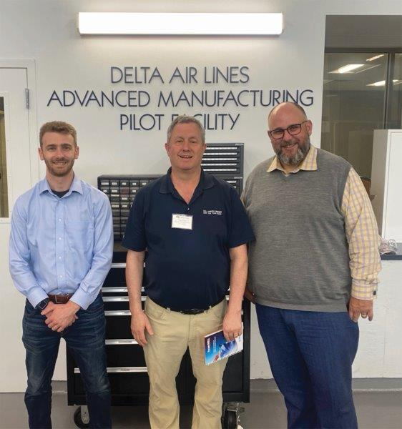
NEEDHAM, MA U.S.A. (March 15, 2024) – OPEN MIND Technologies, a leading developer of hyperMILL® CAD/CAM software solutions worldwide, announced it has joined the Georgia Tech Manufacturing 4.0 Consortium. The consortium is a membership-based organization that facilitates key collaborations between industry, academia, and government to develop and deploy advanced manufacturing technologies as well as provide workforce development. Initial members have contributed funding, technology, and skilled resources supported by the staff at the Georgia Tech AI Manufacturing Pilot Facility located in Atlanta, Georgia.
OPEN MIND and the Manufacturing 4.0 Consortium leadership during a visit to Georgia Tech’s Advanced Manufacturing Pilot Facility. (Left to Right) Kyle Saleeby - Manufacturing 4.0 Consortium Research Program Director, Alan Levine – OPEN MIND Managing Director for North America, Prof. Aaron Stebner – GA-AIM and Manufacturing 4.0 Consortium Executive Director.
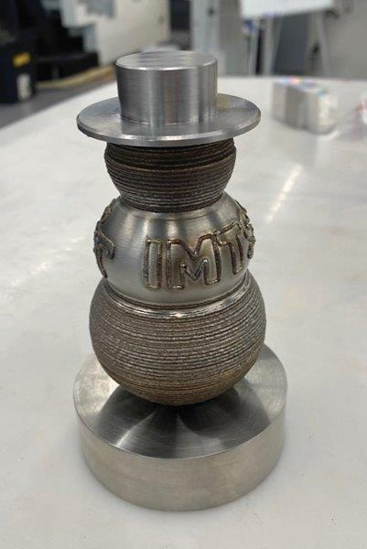
Alan Levine, Managing Director of OPEN MIND Technologies USA, said, “We are very pleased to join the Georgia Tech Consortium which provides a great opportunity to participate in leading research and connect with other members focused on advancing manufacturing. The Consortium offers a unique opportunity to expand OPEN MIND’s collaboration with Georgia Tech to the full membership and their specialized projects.”

“OPEN MIND’s commitment to the Manufacturing 4.0 Consortium and support of manufacturing education enables students to leverage top-tier CAD/CAM software for collaborative development of Hybrid AM/ CNC technologies. Together, we look forward to pushing the boundaries of precision manufacturing,” said Kyle Saleeby, Manufacturing 4.0 Consortium’s research program director and research engineer at Georgia Tech.
Snowman figurine built in a single hyperMILL® training session by Alan Buri, PhD Candidate at Georgia Tech. This figurine combnes additive manufacturing, turning and blending techniques to create the hollow spheres, with subtractive machining to create the hat and base.

- more -
Consortium research projects cover an extensive range of topics that seek cost effectiveness, piloting new manufacturing systems, accelerating product development cycles, and adopting Industry 4.0 technologies. In addition to technology development focused on additive manufacturing, participating Georgia Tech graduate students have continued to push forth research positions within the U.S. National laboratory system, such as Sandia, NIST, Oak Ridge, and Los Alamos National Labs, or have taken industrial roles in top engineering and manufacturing companies including Lockheed-Martin, Boeing, Caterpillar, Ford, Delta TechOps, and Georgia Pacific.

About OPEN MIND Technologies AG
Headquartered in Wessling, Germany, OPEN MIND is one of the world's leading developers of powerful CAM solutions for machine and controller-independent programming. The company develops optimized CAM solutions that include many innovative features unavailable elsewhere, to deliver significantly higher performance in both programming and machining. Strategies such as 2.5D, 3D, as well as 5-axis milling, mill/ turning, and machining operations like HSC and HPC, are efficiently designed into the hyperMILL® CAM system, providing maximum user benefit and compatibility with all current CAD solutions and extensive programming automation. OPEN MIND strives to be the best, most innovative CAD/ CAM developer in the world, and has earned the top five ranking in the CAD/ CAM industry according to the 2023 NC Market Analysis Report by CIMdata. OPEN MIND CAD/ CAM solutions meet and exceed the requirements of the most demanding industries such as automotive, tool and mold manufacturing, production machining, medical, job shops, energy and aerospace industries, and is represented in all key markets of Asia, Europe and the Americas. OPEN MIND is a Mensch und Maschine Company. http://www.mum.de/ For more information visit https://www.openmind-tech.com/en.html.

About the Georgia Institute of Technology
The Georgia Institute of Technology, or Georgia Tech, is one of the top public research universities in the U.S., developing leaders who advance technology and improve the human condition. The Institute offers business, computing, design, engineering, liberal arts, and sciences degrees. Its more than 45,000 undergraduate and graduate students, representing 50 states and more than 148 countries, study at the main campus in Atlanta, at campuses in France and China, and through distance and online learning. As a leading technological university, Georgia Tech is an engine of economic development for Georgia, the Southeast, and the nation, conducting more than $1 billion in research annually for government, industry, and society.
Hosted by the Georgia Tech Manufacturing Institute, the Advanced Manufacturing Pilot Facility (AMPF) is a 20,000 square foot reconfigurable research and development high bay manufacturing facility in Midtown Atlanta supporting industrial, academic, and government stakeholders that also serves as a teaching laboratory. Recently, Georgia Tech and the AMPF facility are supporting a statewide initiative that combines artificial intelligence and manufacturing innovations with transformational workforce and outreach programs. AMPF is where industry works alongside researchers and students to take early-stage concepts from idea to reality.
# # # # #

