PRESS RELEASE

cts presents intralogistics solution for electronics production at SMT-Connect
Smart logistics with a shared warehouse
Burgkirchen, Nuremberg (Germany), June 20, 2024 - cts GmbH made a major appearance at SMT-Connect to present its contribution to the Smart Factory in PCB assembly. The focus was on the Mini Smart Warehouse as a production-related automatic storage option for PCBs in magazines, assemblies and components in boxes or trays. An autonomous mobile robot (AMR), a drop point unit and an unloader from Flexlink as the end point of an SMT line brought the innovative concept to life. This makes cts the first intralogistics and automation specialist to offer a standardized solution for automating material flows and short-term intermediate storage in production. The goals: Avoiding employees having to walk around in production and saving space.
The intelligent software from cts, which can also be used to manage larger smart warehouses, is supplied with information via ERP or MES. Based on this data, the system consisting of the Smart Warehouse and a self-organizing AMR fleet ensures that all materials are available at the right place along the lines at the right time. Materials that are not needed are removed from the way. At SMT-Connect, the process was demonstrated using PCB magazines, trays and KLT boxes, just as it had been at SEMICON Malaysia. Thanks to its compact form with storage areas around a central robot, it is even possible to set up the Mini Smart Warehouse in clean rooms. The cts Smart Warehouse portfolio is completed by the SMT warehouse for component reels.
"Printed circuit boards and components, but also consumables such as solder paste or cleaning fluid - there are many things on SMT lines that need to be tidied up and are also needed again quickly. We are convinced that mixed automatic storage and delivery using a production-related intelligent system is the right way forward," explains Alfred Pammer, VP of Sales, Marketing and Product Management at cts. "Our system is open for integration with existing software and hardware. The discussions we have had at the past two trade fairs show that our intralogistics concept is a very practical smart factory approach that is well received."

Available image material
The following printable images are available for download on the Internet: https://kk.htcm.de/press-releases/cts/
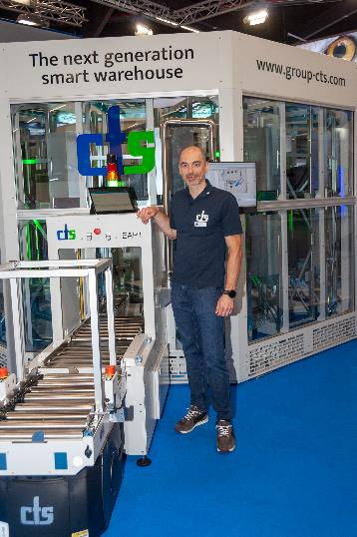  Image source: cts  Alfred Pammer, VP of Sales, Marketing and Product Management at cts, at the I/O port of the Mini Smart Warehouse | 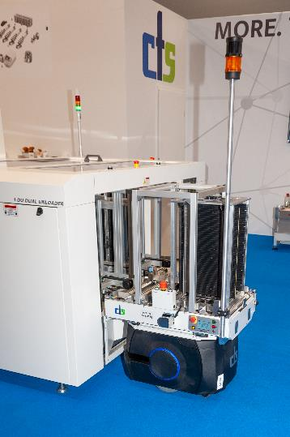  Image source: cts  The AMR has just picked up a PCB tray from the Flexlink Unloader
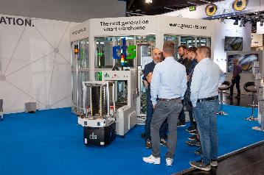Image source: cts  cts convinces with a new concept for mixed automatic storage of materials in SMT production | 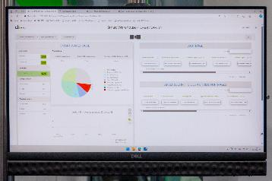Image source: cts  The software for managing the Smart Warehouse

About cts GmbH
"cts - more than automation": cts GmbH, Burgkirchen, founded in 2006, offers customers a complete range of services for process and factory automation. More than 350 employees develop innovative solutions at several locations in Germany, Austria, the Czech Republic, Slovenia, USA and Singapore. These range from the construction of a single control cabinet to the automation of complete production plants, including information management. The comprehensive range of services offered by the established system integrator from southern Bavaria includes feasibility studies, conceptual design, planning, implementation, maintenance and servicing of running systems and plants.
cts installs stationary and mobile robots in plant and mechanical engineering for high-tech industries such as automotive, electronics, radiopharmaceuticals and the semiconductor industry. As one of the leading companies for the integration and operation of heterogeneous fleets of autonomous, intelligent transport vehicles (AMR/AIV/AGV/FTS), cts also sets standards in automated material supply. Here, cts solutions are often used in combination with production-related or centralized automated storage systems.
In highly sensitive industry segments such as chemicals and petrochemicals, life sciences and pharmaceuticals, cts supports its customers from planning to qualification as part of plant automation. The Robotics business field at cts includes the programming, installation and optimization of welding and production robots as well as fully automated packaging systems. The extensive portfolio of the specialist for process and production automation is complemented by software solutions for data acquisition, evaluation, visualization and optimization of machines and systems as well as a suitable service and support offering.
Further information at www.group-cts.de

Contact:  cts GmbH  Susanne Meidl  Fuhrmannstrasse 10  84508 Burgkirchen  Germany  Mobile: +49 163 3054 186  E-Mail: Susanne.Meidl@group-cts.de  www.group-cts.de | Press agency:  HighTech communications GmbH  Brigitte Basilio  Brunhamstraße 21  81249 Munich  Germany  Phone: +49 89 500778-20  E-mail: b.basilio@htcm.de  www.htcm.de

