PRESS RELEASE

Hufschmied: Open Day arouses great interest
The fascination of machining
Bobingen (Germany), June 20, 2024 – The Open Day on June 13, 2024 and the Technology Day on June 14 at the Hufschmied Zerspanungssysteme GmbH Technology Center attracted a large number of visitors. A total of over 500 interested visitors came to Bobingen near Augsburg to be brought up to date with demonstrations of machining technologies. The patented Hufschmied tools for difficult-to-machine materials such as CFRP, graphite or technical ceramics in particular impressed visitors with their performance. Most participants agreed that there is great potential for competitiveness in the optimization of machining processes.
More than 20 internationally active companies took part in the event as exhibitors. The strong networking of Hufschmied with partners from areas such as materials, machines, CAM or measurement technology grows from the motivation to see the entire process chain of users. "Hufschmied always impresses us with its industry expertise. Thanks to the many individual tool solutions and optimization projects, Hufschmied's application engineers know the industry-specific challenges that our customers face," said Matthias Dreher, Head of Global Key Account Management at Schwäbische Werkzeugmaschinen GmbH. Stephan Encke, Sales Engineer at CHIRON Group, praises: "We have enjoyed working with Hufschmied for 20 years and together we have mastered the special requirements of customers in the medical technology sector, among others."
Innovative solutions
What runs through the company's entire success story was also evident at this event: Hufschmied supports technological developments by developing innovative solutions for emerging challenges in machining. This time, for example, these included the machining of bipolar plates for fuel cells, ceramic materials and 3D-printed carbon fiber-containing plastics.

Available images
The following images can be downloaded from the Internet in printable quality:
https://kk.htcm.de/press-releases/hufschmied/
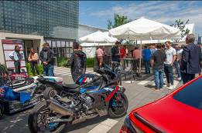  Image source: Hufschmied Zerspanungssysteme  The get-together area in front of the Hufschmied building is traditionally decorated with cars, motorcycles and Formula Student racing cars whose composite components have been machined using Hufschmied tools. | 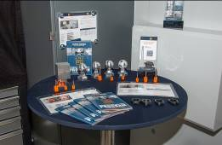  Image source: Hufschmied Zerspanungssysteme  A soccer trophy as an example of high-gloss aluminum processing.
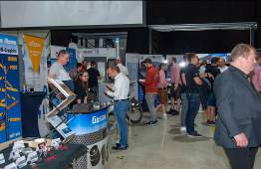Image source: Hufschmied Zerspanungssysteme  Among the companies exhibiting as partners at the well-attended open day were suppliers of graphite, ceramics and plastics. | 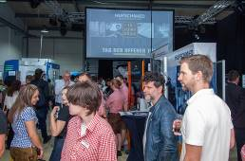  Image source: Hufschmied Zerspanungssysteme  Presentations and insights into the working areas of CNC machines were broadcast on a screen.

About Hufschmied Zerspanungssysteme GmbH
Established in 1991 and headquartered in Bobingen near Augsburg, Hufschmied Zerspanungssysteme GmbH is a manufacturer of high-quality tools for machinable production and friction stir welding. By specializing at an early stage in the machining of plastics, fiberglass materials and carbon fiber, Hufschmied has become a leader in Europe in the development of solutions for new materials. The company is an established system supplier to renowned machine tool manufacturers. Tools and manufacturing process consulting from Hufschmied are particularly valued in the automotive and aerospace industries as well as in medical technology. The company is involved in numerous organizations, including Composites United Deutschland e. V. Hufschmied's manufacturing operations are located in Bobingen, Winterlingen and Sigmaringen on the Swabian Alb. Hufschmied is certified according to ISO 9001:2015 (quality management) and ISO 14001:2015 (environmental management).

Hufschmied is the only tool manufacturer with its own diamond coating plant.
For more information: www.hufschmied.net

Additional information:  Hufschmied Zerspanungssysteme GmbH  Marco Beigl  Edisonstrasse 11d  86399 Bobingen  Germany  Phone: +49 8234 9664-0  Telefax: +49 8234 9664-99  E-Mail: info@hufschmied.net  www.hufschmied.net | Press contact:  HighTech communications GmbH  Brigitte Basilio  Brunhamstrasse 21  81249 Munich  Germany  Phone: +49 89 500778-20  E-Mail: b.basilio@htcm.de  www.htcm.de

