MEDIA INFORMATION
cts presents OVD filling machine for radiopharmaceuticals
Precisely dosed, safely
Burgkirchen (Germany), June 5, 2024 - With the cts OVD (Open Vial Dispensing System), cts GmbH is launching the most compact device to date for dosing and filling radioactive pharmaceuticals into open injection vials. The user-friendly device automatically dispenses and fills up to 100 vials per hour. The self-calibrating scale achieves a dosing accuracy of ± 1 µl. cts is known for its cleanroom-compatible systems in various industries and the OVD system is also optimised for laminar flow. The cGMP-compliant system is designed for installation in class A isolators.
Filling SPECT and PET radiodiagnostics as well as radiopharmaceuticals for therapy into open vials is a critical process. The risk of contamination must be minimised and diffusion of the product must be avoided. The cts OVD makes it easy to comply with the relevant regulations; the entire system is cGMP-compliant.
The volume transfer system consists of a high-precision peristaltic pump and electric valves with zero dead volume. The pharmaceuticals can be diluted in the pump syringe or in the vial. The entire filling phase process is automated. This includes removing and adding the crimp cap and septum, volume filling and crimping.
Sterile and GMP-compliant
The compact design of the cts OVD is perfectly suited for integration in class A isolators with laminar flow and operation with standard manipulators and tongs. The smooth surfaces of the device made of VHP-resistant materials are easy to clean. The intuitive user interface of the cts OVD provides clear guidance through the software to enable full management of the workflow in compliance with the GAMP regulation and the requirements of CFR21 Part 11.

Available images
The following images are available for download on the Internet: https://kk.htcm.de/press-releases/cts/
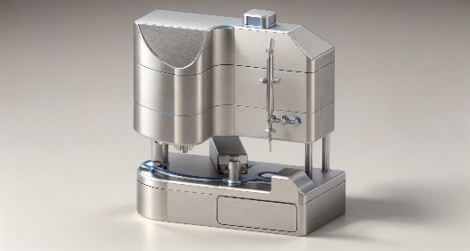Image: cts
cts OVD, the Open Vial Dispensing System for radiopharmaceuticals

About cts GmbH
"cts - more than automation": cts GmbH, Burgkirchen, founded in 2006, offers customers a complete range of services for process and production automation. More than 350 employees develop innovative solutions at several locations in Germany, Austria, the Czech Republic and Slovenia. These range from the construction of a single control cabinet to the automation of complete production plants, including information management. The comprehensive range of services offered by the established system integrator from southern Bavaria includes feasibility studies, conceptual design, planning, implementation, maintenance and servicing of running systems and plants.
cts installs stationary and mobile robots in plant and mechanical engineering for high-tech industries such as automotive, electronics, radiopharmaceuticals and the semiconductor industry. As one of the leading companies for the integration and operation of heterogeneous fleets of autonomous, intelligent transport vehicles (AMR/AIV/AGV/FTS), cts also sets standards in automated material supply. Here, cts solutions are often used in combination with production-related or centralized automated storage systems.
In highly sensitive industry segments such as chemicals and petrochemicals, life sciences or pharmaceuticals, cts supports its customers in plant automation from planning to qualification. The Robotics business field at cts includes the programming, installation and optimization of welding and production robots as well as fully automated packaging systems. The extensive portfolio of the specialist for process and production automation is complemented by software solutions for data acquisition, evaluation, visualization and optimization of machines and systems as well as a suitable service and support offering.

Further information can be found at www.group-cts.de

Contact:  cts GmbH  Susanne Meidl  Fuhrmannstrasse 10  84508 Burgkirchen  Germany  Mobil: +49 163 3054 186  E-Mail: Susanne.Meidl@group-cts.de  www.group-cts.de | Press agency:  HighTech communications GmbH  Brigitte Basilio  Brunhamstrasse 21  81249 Munich  Germany  Telefon: +49 89 500778-20  E-Mail: b.basilio@htcm.de  www.htcm.de

