MEDIA INFORMATION

Smart Warehouse / Mini Smart Warehouse
Modular storage system from cts now also processes KLT boxes and tray stacks
Burgkirchen, June 5, 2024 - The intralogistics and automation specialist cts GmbH is expanding the functional scope of its successful Smart In-Production Warehouse for the electronics and automotive industry: both the Smart Warehouse and the smaller Mini Smart Warehouse variant can now store and retrieve KLT boxes and tray stacks from various manufacturers in addition to PCB magazines in a mixed and automated manner.
Intelligent and space-saving storage systems from cts have been successfully used for PCBs across all industries since 2020. Fully automated on request, both PCB magazines and standardized small load carriers, so-called KLT boxes, as well as tray stacks can now be stored temporarily - either in the same area or in an additional, separate area in the warehouse, but always in a space-saving and efficient manner close to the production lines.
"Mixed storage has many advantages for the customer," explains Alfred Pammer, Head of Sales and Marketing at cts. "In addition to the PCBs, for example, consumables such as solder paste or cleaning fluid can now also be stored in a space-saving manner and integrated into the fully automated intralogistics system. This is because both the PCB magazines and the KLT boxes can be tracked precisely - an important basis for seamless material flow monitoring, for example by an ERP system or in the SAP world."
Customizable, open interfaces
Storage and retrieval is carried out either manually or fully automatically by autonomous vehicles (AMRs - Autonomous Mobile Robots), which deliver the material either directly to the line or to a transfer station. The containers are identified using RFID chips or DMC/barcodes, for example. Open REST interfaces (Representational State Transfer)/MQTT are available for connection to planning software.
Hardware and room layout can be individually configured according to customer requirements, as can the algorithms for optimizing storage and retrieval. In addition to the sophisticated and low-maintenance mechanics, the cts Warehouse is characterized by intelligent software and simple operation. Any browser-enabled end device is sufficient to access the control system.
"Valuable storage space must be used as economically as possible," summarizes Pammer. cts ensures flexibility in day-to-day production, not only in terms of the size and configuration of the interim storage facility, but also in terms of the storage content. Whether large or small storage requirements, PCB magazines, KLT boxes or tray stacks, normal store floor or clean room: "Our experienced development team works out the optimum solution for each customer, which can also be seamlessly integrated into the existing intralogistics software.

Available images
The following images are available for download on the Internet: https://kk.htcm.de/press-releases/cts/
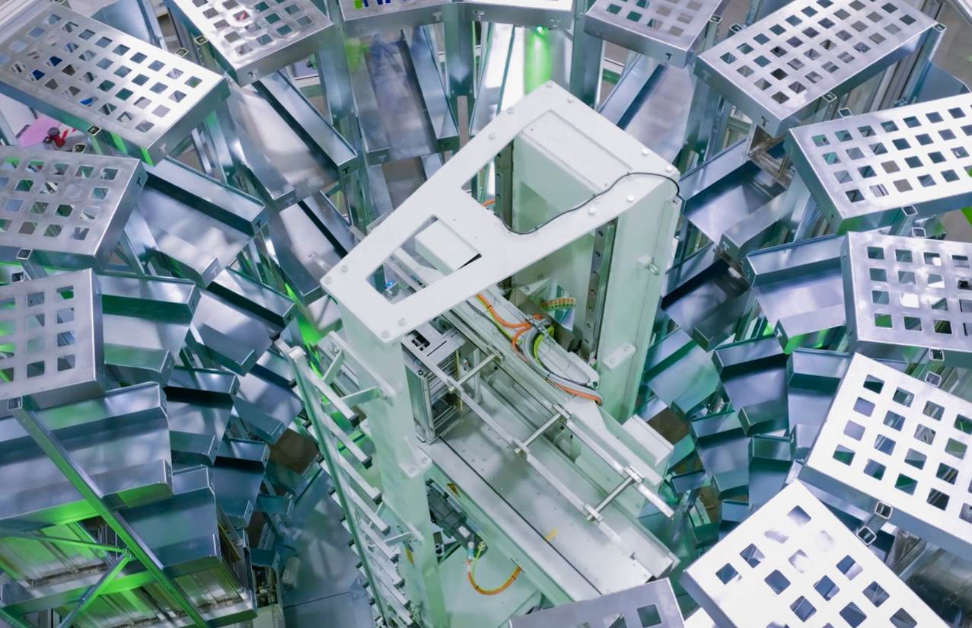
Image: cts
cts Smart Warehouse Mini, Interior view: freely configurable, low-maintenance mechanics, now also for mixed storage.

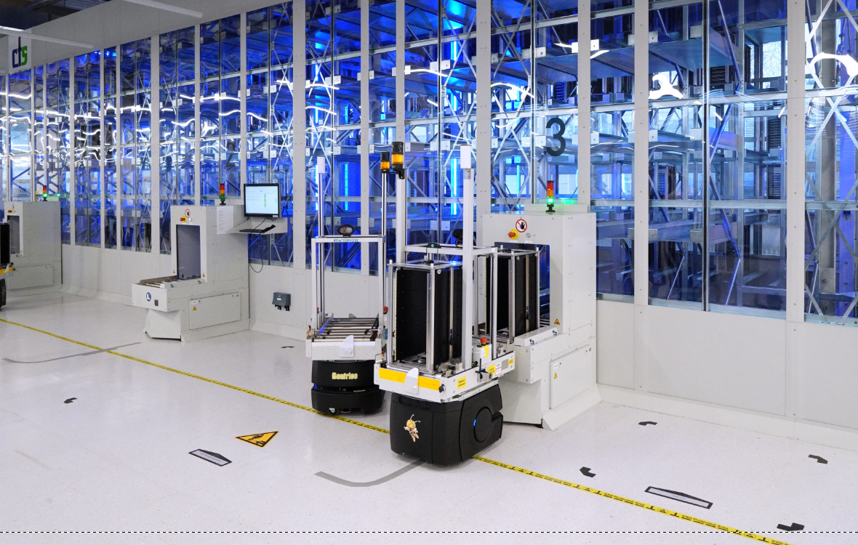
Image: cts
cts Smart Warehouse: Storage and retrieval can be carried out both manually and automatically by AMRs. Mixed storage combines PCBs and consumables in one place to save space.

About cts GmbH
"cts – more than automation": cts GmbH, Burgkirchen, founded in 2006, offers customers a complete range of services for process and production automation. More than 350 employees develop innovative solutions at several locations in Germany, Austria, the Czech Republic and Slovenia. These range from the construction of a single control cabinet to the automation of complete production plants, including information management. The comprehensive range of services offered by the established system integrator from southern Bavaria includes feasibility studies, conceptual design, planning, implementation, maintenance and servicing of running systems and plants.
cts installs stationary and mobile robots in plant and mechanical engineering for high-tech industries such as automotive, electronics, radiopharmaceuticals and the semiconductor industry. As one of the leading companies for the integration and operation of heterogeneous fleets of autonomous, intelligent transport vehicles (AMR/AIV/AGV/FTS), cts also sets standards in automated material supply. Here, cts solutions are often used in combination with production-related or centralized automated storage systems.
In highly sensitive industry segments such as chemicals and petrochemicals, life sciences or pharmaceuticals, cts supports its customers in plant automation from planning to qualification. The Robotics business field at cts includes the programming, installation and optimization of welding and production robots as well as fully automated packaging systems. The extensive portfolio of the specialist for process and production automation is complemented by software solutions for data acquisition, evaluation, visualization and optimization of machines and systems as well as a suitable service and support offering.

Further information can be found at www.group-cts.de

Contact:  cts GmbH  Susanne Meidl  Fuhrmannstrasse 10  84508 Burgkirchen  Germany  Mobil: +49 163 3054 186  E-Mail: Susanne.Meidl@group-cts.de  www.group-cts.de | Press agency:  HighTech communications GmbH  Brigitte Basilio  Brunhamstrasse 21  81249 Munich  Germany  Telefon: +49 89 500778-20  E-Mail: b.basilio@htcm.de  www.htcm.de

