PRESS RELEASE

Swissbit presents leading-edge FIDO2 solutions at Identiverse 2024
May 28-31, 2024
Booth #2432
Westford, Massachusetts, USA, May 7, 2024 – Swissbit, a leading manufacturer of storage, security, and embedded IoT solutions, is proud to participate for the first time in the prestigious Identiverse event taking place from May 28 to May 31, 2024, in Las Vegas, Nevada. With its conference and exhibition, this important industry event marks a significant milestone for Swissbit as it introduces to the community its cutting-edge iShield Key product series, thereby emphasizing the importance of robust hardware-based authentication in today’s digital age.
Swissbit’s showcase will focus especially on its iShield Key Pro, a cornerstone of the company’s iShield Key series, which was designed to fortify online accounts with unparalleled hardware authentication capabilities. The iShield Key Pro is much more than just another FIDO security stick because it supports a wide array of security standards, including FIDO2, HOTP, TOTP, and PIV. And its capability to double as a physical access control tool makes it unique in the market, especially with the impending adoption of FIPS 140-3 standards, thus ensuring the highest level of cryptographic security.
New iShield Key Pro with USB-C Interface
Just in time for the Identiverse event, Swissbit is also excited to unveil the latest addition to its hardware token portfolio: the new iShield Key Pro with USB-C interface. It maintains the versatility and robust security features of its predecessors while offering the convenience of state-of-the-art USB-C connectivity. The iShield Key FIDO2, another variant in the lineup, is limited to the FIDO2/WebAuthn and U2F predecessor standard, making it a cost-efficient option to securely log into websites and services. The iShield Key FIDO2 will also be available with USB-C and USB-A interfaces.
As Kai Imgenberg, Director Sales, Embedded IoT Solutions Americas at Swissbit, states, “Swissbit is at the forefront of a digital transformation where securing digital identities and transactions has never been more critical. Our presence at the Identiverse event signifies Swissbit’s commitment to FIDO2-based authentication solutions in North America. By empowering our customers to seamlessly implement zero-trust security principles and phishing-resistant multi-factor authentication, we are not just participating in the industry’s evolution – we are leading it. We are confident that this event will be a catalyst for Swissbit in setting new benchmarks and delivering pioneering solutions to our customers. Swissbit will lead the Fido market by being the first to introduce FIPS 140-3 and as well as the only FIDO2 security dongle for logical and physical access control to the market.”
At the forefront in FIDO2 authentication for North America
Swissbit’s desire to become the premier provider of FIDO2 solutions in North America is well in line with the growing demand for flexible yet secure authentication methods that can keep pace with rapid advances in technology and cyberthreats. By introducing innovative products like the iShield Key Pro, Swissbit is making significant advances that enable businesses to adopt stronger, phishing-resistant authentication mechanisms, thereby enhancing the overall security of organizations across the continent.
Swissbit invites attendees at the Identiverse event to visit Booth #2432 on the exhibition floor to explore the future of hardware authentication and see for themselves how Swissbit can help them to implement robust security frameworks within their respective organizations.

Available images
The following images are available for download in printable format at: https://kk.htcm.de/press-releases/swissbit/
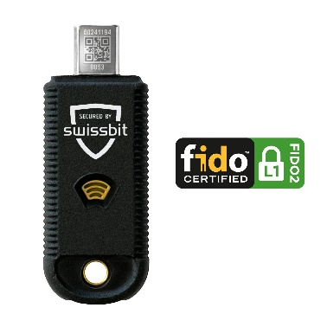  Source: Swissbit  Featuring a UBC-C interface, the new iShield Key Pro makes its U.S. debut at the Identiverse event in Las Vegas. | 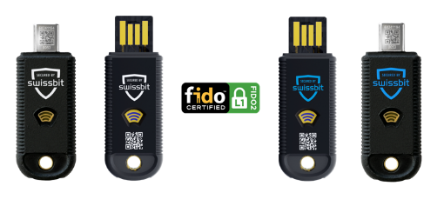  Source: Swissbit  The iShield Key family from Swissbit includes the iShield Key Pro and the iShield Key FIDO2, both featuring USB-A and USB-C interfaces.
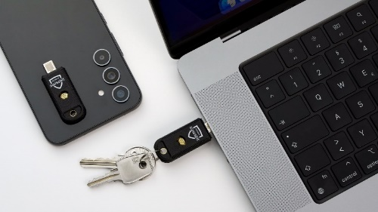  Source: Swissbit  The iShield Key series also offers NFC connectivity in addition to the USB interface. |   Source: Swissbit  Kai Imgenberg, Director Sales Embedded IoT Solutions Americas at Swissbit
About Swissbit
Swissbit AG is the leading European manufacturer of storage, security and embedded IoT solutions for demanding applications. Swissbit combines its unique competences in storage and embedded IoT technology with its advanced packaging know-how. This expertise allows our customers to reliably store and protect data in industrial, NetCom, automotive, medical and fiscal applications as well as across the Internet of Things (IoT).
Swissbit develops and manufactures industrial-grade storage and security products “Made in Germany” with high reliability, long-term availability, and custom optimization.
Besides FIDO2 security sticks, Swissbit offers a wide range of storage devices includes SSDs with PCIe and SATA interface such as mSATA, Slim SATA, CFast™, M.2 and 2.5” as well as CompactFlash, USB flash drives, SD Memory Cards, micro SD Memory Cards and managed NAND BGAs like e.MMC. All security products are available in various application specific editions as USB flash drives, SD Memory Cards, and micro SD Memory Cards.
Swissbit was founded in 2001 and has offices in Switzerland, Germany, USA, Japan and Taiwan. Swissbit owns the registered trademarks Swissbit® and Hyperstone®. Since 2020, the independent investment firm Ardian is holding a majority stake in the company to support its growth.
For further information, please visit www.swissbit.com

Regional Headquarters North and South America:
Swissbit NA Inc.
238 Littelton Rd #202b
Westford, MA 01886
USA
Tel: +1 978-490-3252
Email: salesna@swissbit.com
www.swissbit.com

Regional Headquarters Germany:
Swissbit Germany AG
Bitterfelder Strasse 22
12681 Berlin
Germany
Tel: +49 30 936 954 0
Email: info@swissbit.com
www.swissbit.com

Headquarters Switzerland:
Swissbit AG
Industriestrasse 4
9552 Bronschhofen
Switzerland
Tel: +41 71 913 03 03
Email: info@swissbit.com
www.swissbit.com

Contact Headquarters:  Swissbit AG  Marian Weber  Industriestrasse 4  9552 Bronschhofen  Switzerland  Tel: +49 172 854 88 26  Email: marian.weber@swissbit.com  www.swissbit.com | Press Agency:  HighTech communications GmbH  Brigitte Basilio  Brunhamstrasse 21  81249 Munich  Germany  Tel: +49 89 500778-20  Email: b.basilio@htcm.de  www.htcm.de

