PRESS RELEASE
OPEN MIND Releases hyperMILL® Version 2024
Milling, turning and CAD functions for daily CAM tasks
Wessling (Germany), April 29, 2024 – hyperMILL® 2024 the latest version of OPEN MIND’s CAD/CAM suite delivers new turning features and improved algorithms. This makes the digital process chain even more efficient, from CAD data and CAM programming to optimized NC code. Simplified rest machining and interaction with machine are just a few examples of how the software has been further refined.
Previous versions of hyperMILL® already offer a broad range of functions and strategies for turning, turn-milling and mill-turning. The key extension in hyperMILL® TURNING Solutions is turret support for lathes. This also underscores OPEN MIND’s determination to push ahead with the integration of digital twins of machining centers: Lathes with one main spindle, one turret and a Siemens control system are now mapped with all tools true to the original machine with the help of hyperMILL® VIRTUAL Machining. Users can conveniently equip the turret with turret holders and tools in the Virtual Machine machining planner and use the resulting setup for NC code simulation.
Reading Back Measuring Points
Another useful application of virtual machining technology is the reading back of measuring points. This means that users can use the 3D model of a component to see at a glance which measuring points are outside the tolerance. As a result, it becomes much easier to analyze inaccuracies and tool wear after milling and then compensate for these in the CAD/CAM system. Moreover, the hyperMILL® SHOP Viewer makes this new function directly available on the machine tool.
CAD for CAM
hyperMILL® 2024 also offers various new features concerning ‘CAD for CAM.’ hyperMILL® supports the import of PMI (Product Manufacturing Information) and MBD (Model-Based Definition) data in various formats such as STEP, CATIA V5, SOLIDWORKS, Creo and Siemens. Improved functions for surface modelling now allow users to generate surfaces from a large number of grid curves. Another important CAD innovation is an improved electrode creation strategy that now supports three-dimensional eroding.
5-Axis Path Correction
Comparable to the 3D radius correction to account for the tool wear or deflections, 5-axis path correction is now possible – initially for Heidenhain control systems. Vectors are written to the cutter contact point in the NC program to ensure precision correction on the machine control. The NC control uses these contact vectors to move the NC points by a defined adjustment value during machining.
Improved Machining Strategies
A new algorithm for rest material detection ensures automatic complete detection of all rest material areas in both 3D and 5-axis machining. The algorithms for calculating the trajectory have also been optimized. The cutting edge machining for punching tools 3D strategy has undergone several improvements. This includes the optimization of collision avoidance when performing machining based on a reference job. Machining is carried out collision-free as far as this is possible for the given tool clamping length. The ‘Soft overlap’ option makes it possible to smoothen the approach and retraction moves. A new algorithm also improves the toolpath calculation for 3D plane machining, resulting in even faster, more uniform and more tool-friendly machining.
Safety in ‘Unmanned’ Production
To safeguard against long unattended machining cycles, hyperMILL® now allows tool breakage monitoring to be activated in the tool database to make it part of the machining program. This information is processed during NC generation on the virtual machine. The generated NC program includes the corresponding control macro call.
Tool Synchronization with the Hummingbird MES
In the new version, tools from the hyperMILL® tool database can be synchronized with the Hummingbird MES at the touch of a button. This means that tools used for CAM programming are automatically transferred to the Hummingbird tool management system. All other processes such as machine setup, measuring, tracking and the use of tools in machines are mapped in the Hummingbird MES, thus ensuring a consistent exchange of information within the company.

Strong for the Future: CAD for CAM Technologies Under a Single Name
OPEN MIND has always been known for its pioneering CAD/CAM solution, which seamlessly combines CAD functionalities with CAM programming. Bringing these two sides closely together results in considerable time savings in workpiece processing and shows that CAM without CAD is no longer viable today. To make this even clearer, hyperMILL® will combine CAD and CAM under a single name from Version 2024 onward. Jasmin Huber, Director of Marketing & Communication at OPEN MIND Technologies AG, explains: “With hyperMILL® CAD/CAM, we bring together what belongs together. Our innovative and powerful complete CAD/CAM solution combines unique CAD and CAM technologies for high-performance, end-to-end processes in both areas. We are thus consolidating ‘CAD for CAM’ for the future and are further improving our software for users.”

Available images
The following images are available for download in printable format at:
https://kk.htcm.de/press-releases/open-mind/
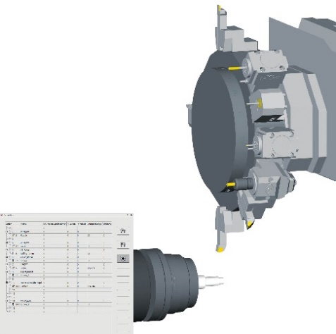  Source: OPEN MIND  hyperMILL® TURNING Solutions: Turret support for lathes with one turret, one main spindle and Siemens control system | 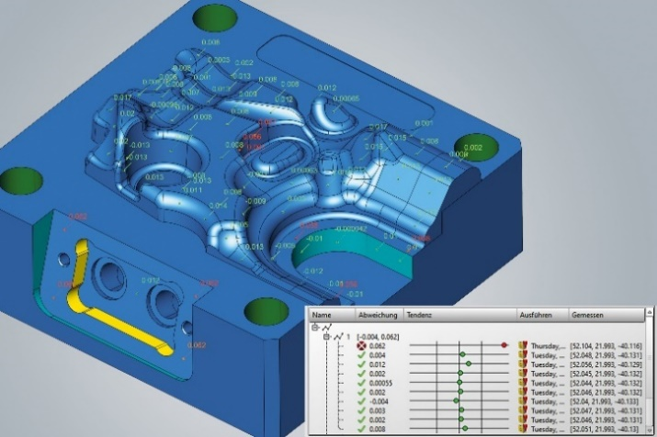  Source: OPEN MIND  Measuring points read back for improved quality and process control. The 3D model of the component shows at a glance which measuring points are outside the tolerance.

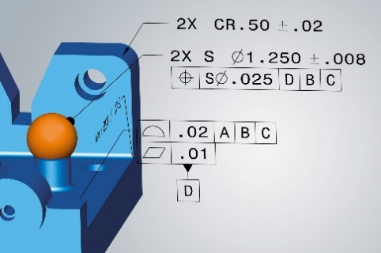
Source: OPEN MIND

CAD for CAM: hyperMILL® supports the import of PMI and MBD data in various formats

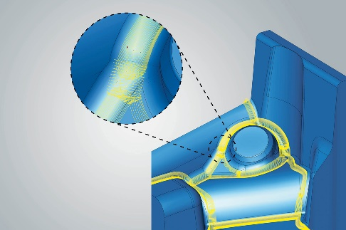  Source: OPEN MIND  In 3D machining (image) and 5-axis machining, new algorithms for rest material detection ensure that all rest material areas are automatically accounted for in full. | 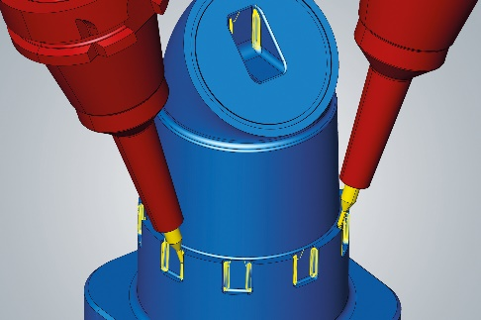  Source: OPEN MIND  In 3D and 5-axis machining (image), new algorithms for rest material detection ensure that all rest material areas are automatically accounted for in full.


Source: OPEN MIND

Jasmin Huber, Director of Marketing & Communication at OPEN MIND Technologies AG

Available videos
You can find the following videos on our YouTube channel:
https://youtu.be/EYW3XLKVKU4

Source: OPEN MIND

hyperMILL® TURNING Solutions: Turning Ideas into Success

About OPEN MIND Technologies AG
OPEN MIND Technologies AG is one of the world’s leading developers of powerful CAD/CAM solutions for machine and controller-independent programming.
OPEN MIND develops optimized CAD/CAM solutions that include a large number of innovative and unique features that can deliver significantly higher performance in both programming and machining. hyperMILL® is a completely modular CAD/CAM solution that provides state-of-the-art CAM technologies on its own CAD platform: from 2.5D, 3D and 5-axis machining as well as turning strategies and solutions for additive manufacturing, HSC and HPC machining. Whether automation, simulation or virtual machine – trendsetting technologies expand the product range and enable continuous digital process chains. Special applications, the perfect interaction with all popular CAD solutions and a customer-oriented service complete the product range.
According to the "NC Market Analysis Report 2023" compiled by CIMdata, hyperMILL® is ranked in the top 4 CAD/CAM solutions worldwide. The innovative CAD/CAM technologies fulfil the highest demands in the automotive, tool and mold manufacturing, production machining, medical, job shops, energy, semiconductor and aerospace industries.
OPEN MIND's majority stake in manufacturing execution system (MES) developer Hummingbird expands the CAD/CAM manufacturer's product portfolio and enhances the range of connected digitalized manufacturing technologies.
OPEN MIND is a Mensch und Maschine company and has subsidiaries and qualified sales partners on all continents.
You can find more information at www.openmind-tech.com.

OPEN MIND Technologies UK Ltd., Oxford
Unit 3
Bicester Business Park
Telford Road
Bicester
Oxfordshire OX26 4LN
England
Phone: +44 1869 290 003
Fax: +44 1869 369 429
E-mail: Info.UK@openmind-tech.com

OPEN MIND Technologies USA, Inc.
1492 Highland Avenue, Unit 3
Needham MA 02492
USA
Phone: +1 339 225 4557 office
Phone: +1 888 516 1232 x0 toll-free
Fax: +1 270 912 5822
E-mail: Info.Americas@openmind-tech.com

OPEN MIND Technologies Asia Pacific Pte Ltd
MOVA Building, 22 Jalan Kilang #03-00
Singapore 159419
Phone: +65 6742 95-56
E-mail. Info.Asia@openmind-tech.com

Head office:
OPEN MIND Technologies AG, Argelsrieder Feld 5, 82234 Wessling, Germany
Tel.: (+49-8153) 933-500, Fax: (+49-8153) 933-501
E-mail: Info@openmind-tech.com, website: www.openmind-tech.com

Press contact:
HighTech communications GmbH
Brigitte Basilio
Brunhamstrasse 21
81249 Munich
Germany
Tel.: (+49-89) 500778-20
E-mail: b.basilio@htcm.de
Website: www.htcm.de

