PRESS RELEASE
Würth Elektronik unveils its high-temperature inductors
Resistant to Thermal Aging
Waldenburg (Germany), April 23, 2024 – Würth Elektronik supplements its molded power inductors series with the high-temperature versions: WE-MAPI and WE-LHMI. The new inductors can be used continuously at high rated currents in a temperature range from -55°C to +150°C. The compact components have been tested for thermal aging for over 1000 hours at 200ºC and are qualified to AEC-Q200.
High temperatures in inductors with an iron alloy magnetic core result in thermal aging phenomena. Core losses rise sharply and efficiency drops. Aging can lead to increased self-heating in the component, which in turn exacerbates thermal aging. By expanding its inductor series, Würth Elektronik now offers power inductors that are not only unaffected by thermal aging but also do not suffer any performance loss.
The SMT power inductors boast low losses, high efficiency, lightweight design, and a low package profile. Their high-current-carrying capacity and capability of handling high transient current peaks can be utilized in applications such as DC/DC converters for high currents in power supplies or for field programmable gate arrays (FPGA), point of load (POL) converters or CPU/RAM power supplies.
The high-temperature versions of both series are now available from stock. Free samples are available for developers.

Available images
The following images can be downloaded from the Internet in printable quality: https://kk.htcm.de/press-releases/wuerth/

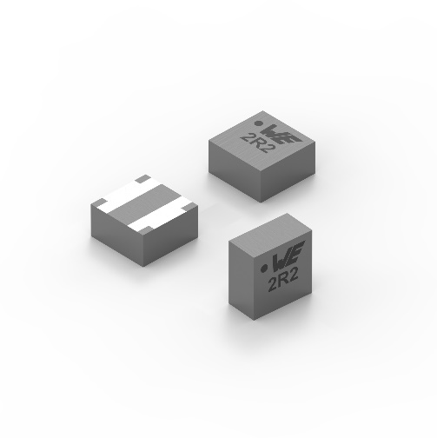Image source: Würth Elektronik  Thanks to their innovative design, WE-MAPI power inductors have the lowest AC and DC losses. | 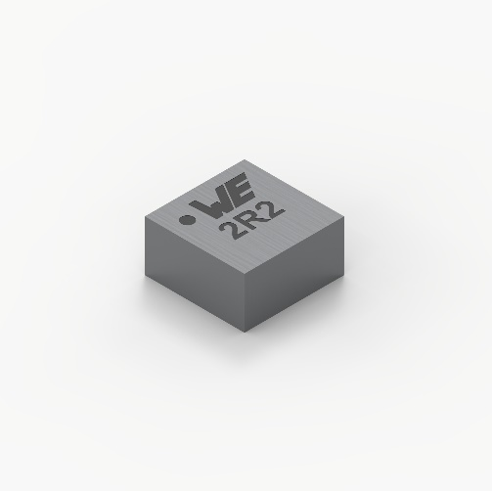  Image source: Würth Elektronik  WE-MAPI: Now also available as a high-temperature version.

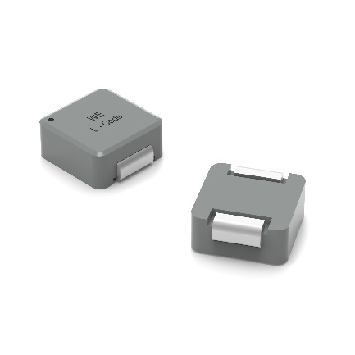  Image source: Würth Elektronik  The 4020HT, 5020HT, 7030HT and 7050HT versions of the WE-LHMI power inductors can be operated at 150°C. | 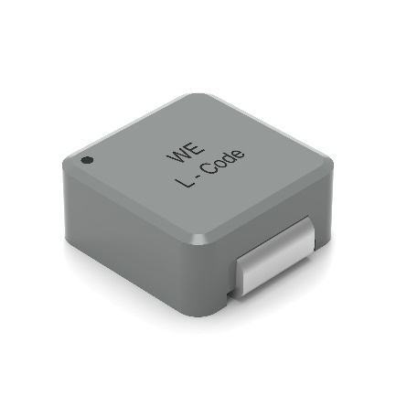  Image source: Würth Elektronik  The WE-LHMI series is an extremely flat, molded power inductor.

About the Würth Elektronik eiSos Group
Würth Elektronik eiSos Group is a manufacturer of electronic and electromechanical components for the electronics industry and a technology company that spearheads pioneering electronic solutions. Würth Elektronik eiSos is one of the largest European manufacturers of passive components and is active in 50 countries. Production sites in Europe, Asia and North America supply a growing number of customers worldwide.

The product range includes EMC components, inductors, transformers, RF components, varistors, capacitors, resistors, quartz crystals, oscillators, power modules, Wireless Power Transfer, LEDs, sensors, radio modules, connectors, power supply elements, switches, push-buttons, connection technology, fuse holders and solutions for wireless data transmission. The portfolio is complemented by customized solutions.
The unrivaled service orientation of the company is characterized by the availability of all catalog components from stock without minimum order quantity, free samples and extensive support through technical sales staff and selection tools.
Würth Elektronik is part of the Würth Group, the global market leader in the development, production, and sale of fastening and assembly materials, and employs 7,900 people. In 2023, the Würth Elektronik Group generated sales of 1.24 Billion Euro.
Würth Elektronik: more than you expect!
Further information at www.we-online.com

Further information:  Würth Elektronik eiSos GmbH & Co. KG  Sarah Hurst  Clarita-Bernhard-Strasse 9  81249 Munich  Germany  Phone: +49 7942 945-5186  E-mail: sarah.hurst@we-online.de  www.we-online.com | Press contact:  HighTech communications GmbH  Brigitte Basilio  Brunhamstrasse 21  81249 Munich  Germany  Phone: +49 89 500778-20  E-mail: b.basilio@htcm.de  www.htcm.de

