PRESS RELEASE
Digital identity protection: Swissbit introduces iShield Key Pro with USB-C interface
Bronschhofen, Switzerland, April 18, 2024 – Swissbit is expanding its portfolio of hardware-based security keys with the new iShield Key Pro featuring a USB-C interface. Like its USB-A counterpart, the new model supports the FIDO2 standard as well as the PIV, HOTP and TOTP security protocols. The iShield Key Pro can also be used for physical access control applications, making it one of the most flexible security keys. In addition to the two Pro variants, Swissbit offers the iShield Key FIDO2, a model that is limited to FIDO2 functionality and therefore ideal for secure logins to websites and services. The iShield Key FIDO2 will also be available with a USB-S or USB-C interface.
With the new iShield Key Pro, Swissbit is continuing to expand its authentication offerings. The new USB-C interface gives users even more options to protect their digital identities. The iShield Key Pro minimizes not only the risk of online threats such as phishing, social engineering or account hijacking. It is also suitable for implementing security guidelines such as NIS-2, which requires multifactor authentication (MFA) in connection with IT systems for access control.
Functions, compatibility, and configuration
The iShield Key Pro features more functions and protocols than a standard FIDO stick. They include PIV (Personal Identity Verification) for document signing and encryption. It is also compatible with older systems and security technologies, including HOTP (HMAC-based One-Time Password) for offline applications and TOTP (Time-based One-Time Password). The iShield Key Pro supports up to 42 TOTP slots. Temporary passwords for NFC-capable Android devices can be generated via an Android TOTP app. To configure TOTP, HOTP, and PIV functionalities, iShield Key Manager software is available free of charge for Windows, macOS, and Linux.
Versatile application capabilities
As an all-in-one security key, the iShield Key Pro supports USB as well as NFC connectivity, making it suitable for use with mobile phones. The contactless transfer of data also opens up many application capabilities in the access control field. To implement this functionality, Swissbit cooperates with selected technology partners and is available for project inquiries.
The iShield Key family
In addition to the iShield Key Pro, Swissbit also offers the iShield Key FIDO2. By being limited to the FIDO2/WebAuthn standards and their predecessor U2F, it provides a low-cost entry into the world of phishing-resistant authentication. The iShield Key FIDO2 will also be available in USB-A and USB-C versions.
All sticks are manufactured in Swissbit's own semiconductor factory in Berlin and are designed for use in temperatures ranging from -25 °C to 70 °C (-13 °F to 158 °F).

Available images
The following images are available for download in printable format at: https://kk.htcm.de/press-releases/swissbit/
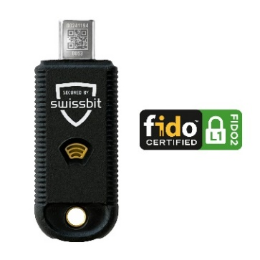  Source: Swissbit  The new iShield Key Pro with USB-C interface | 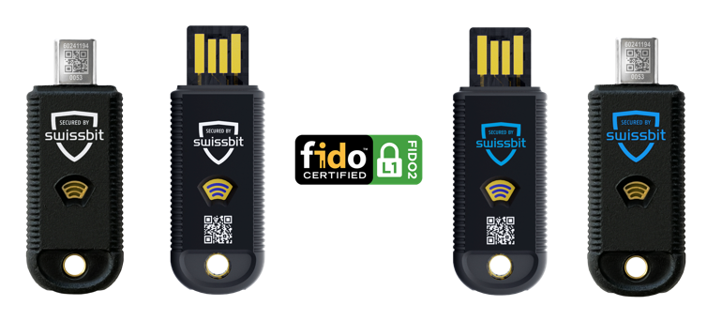  Source: Swissbit  Swissbit’s iShield Key family
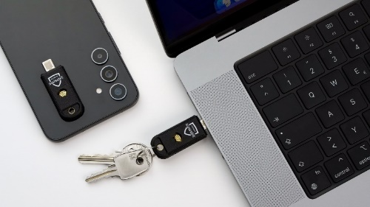
Source: Swissbit
In addition to USB, the iShield Key series also features NFC connectivity.

About Swissbit
Swissbit AG is the leading European manufacturer of storage, security and embedded IoT solutions for demanding applications. Swissbit combines its unique competences in storage and embedded IoT technology with its advanced packaging know-how. This expertise allows our customers to reliably store and protect data in industrial, NetCom, automotive, medical, and fiscal applications as well as across the Internet of Things (IoT).
Swissbit develops and manufactures industrial-grade storage and security products “Made in Germany” with high reliability, long-term availability, and custom optimization.
Swissbit’s storage range includes SSDs with PCIe and SATA interface such as mSATA, Slim SATA, CFast™, M.2 and 2.5” as well as CompactFlash, USB flash drives, SD Memory Cards, micro-SD Memory Cards and managed NAND BGAs like e.MMC. Security products are available in various application specific editions as USB flash drives, SD Memory Cards, and micro-SD Memory Cards.
Swissbit was founded in 2001 and has offices in Switzerland, Germany, USA, Japan and Taiwan. Swissbit owns the registered trademarks Swissbit® and Hyperstone®. Since 2020, the independent investment firm Ardian is holding a majority stake in the company to support its growth.
For further information, please visit www.swissbit.com
Regional Headquarters:  Swissbit Germany AG  Bitterfelder Strasse 22  12681 Berlin  Germany  Tel: +49 30 936 954 0  Email: info@swissbit.com  www.swissbit.com | Headquarters:  Swissbit AG  Industriestrasse 4  9552 Bronschhofen  Switzerland  Tel: +41 71 913 03 03  Email: info@swissbit.com  www.swissbit.com
Contact:  Swissbit AG  Marian Weber  Industriestrasse 4  9552 Bronschhofen  Switzerland  Tel: +49 172 854 88 26  Email: marian.weber@swissbit.com  www.swissbit.com | Press Agency:  HighTech communications GmbH  Brigitte Basilio  Brunhamstrasse 21  81249 Munich  Germany  Tel: +49 89 500778-20  Email: b.basilio@htcm.de  www.htcm.de

