MEDIA INFORMATION
Fully automated packaging
Autobagging Tool for wafers in FOSBs
Burgkirchen (Germany), April 11, 2024 - cts GmbH, Burgkirchen, a universal service provider for process and factory automation, presents a fully automated packaging system for FOSBs. The system increases efficiency and quality, reduces the error rate and takes the strain off staff.
Preparing wafers for transportation to a semiconductor production facility is a complex process and is subject to the strictest quality criteria. The sensitive products are placed in special containers known as front opening shipping boxes (FOSBs). These must be carefully packed in absolutely leak-proof plastic bags under cleanroom conditions.
"Packaging is always a uniform process, but it has to be absolutely reliable - after all, the contents are sensitive and expensive," explains Alfred Pammer, Head of Sales and Marketing at cts. "If it is carried out manually, errors are inevitable simply because of the monotonous nature of the work - and qualified applicants for such a job are rare. It therefore made sense to automate the entire process. And here at cts we have found a very efficient and reliable solution."
The new autobagging tool combines the packaging machine, test chamber, handling robot and all other components in one complete cell. All packaging and testing processes take place here without manual assistance.
Fully automated packaging, labeling and testing
The unpackaged FOSBs with the wafers are first placed on a conveyor belt by OHT, AMR or operator and from there enter the system. A cross-slot check and add-on part check are then used to determine whether processing is possible with the current configuration. The FOSBs are then packed first in an inner bag and then in an outer bag filled with desiccant. After gluing, the tightness of the packaging is determined for each unit individually using a test gas. The FOSB and wrapping are given a label, the quality and correct positioning of which is also checked. The finished packaged products then leave the system via an outfeed conveyor. If the system detects any faults, the affected units are automatically removed for visual inspection. The throughput is 3,000 to 8,000 FOSBs per month, which corresponds to around 75,000 to 200,000 wafers.
A semi-automated version of the autobagging tool is also available for companies with a lower throughput. In this case, employees feed and remove the FOSBs from the packaging unit and the test chamber.

Can be combined with other cts automation solutions
"With our autobagging tool, we have automated another important production step," summarizes Pammer. "Our solution avoids all too human errors, it works more efficiently and better than conventional manual workflows. In most cases, no set-up time is required. It also noticeably reduces dust pollution. The new system fits harmoniously into our portfolio. Both the transfer of the FOSBs to the infeed conveyor and the collection from the outfeed conveyor do not have to be done manually. The cts Smart Logistics material logistics solutions enable a completely autonomous, automated transport process without the need for time-consuming conversion work in the production environment. And with our Smart Warehouse, we even offer a suitable and also fully automated interim storage solution."

Available images
The following images are available for download on the Internet: https://kk.htcm.de/press-releases/cts/
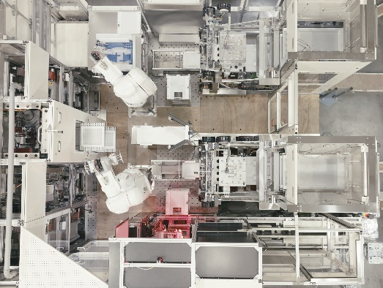Image: cts
Autobagging Tool from cts: The new system combines packaging machine, test chamber, handling robot and all other components in one complete cell.

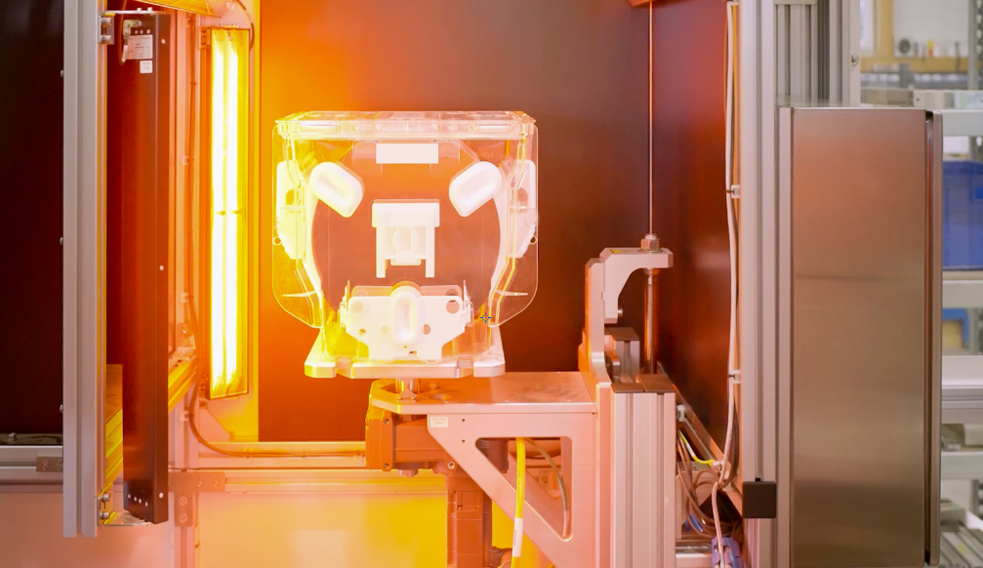Image: cts
Cross-slot check and add-on part check before packaging: objects that do not match the configuration are automatically sorted out.

Available videos
You can find a video on this topic on our YouTube channel:
https://www.youtube.com/watch?v=k5IzhJDeh84
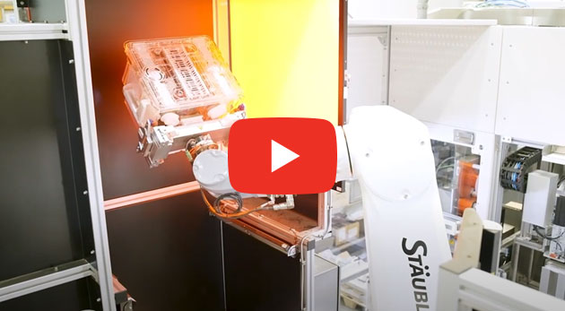
Video: cts
The cts autobagging system in action.

About cts GmbH
"cts - more than automation": cts GmbH, Burgkirchen, founded in 2006, offers customers a complete range of services for process and production automation. More than 350 employees develop innovative solutions at several locations in Germany, Austria, the Czech Republic and Slovenia. These range from the construction of a single control cabinet to the automation of complete production plants, including information management. The comprehensive range of services offered by the established system integrator from southern Bavaria includes feasibility studies, conceptual design, planning, implementation, maintenance and servicing of running systems and plants.
cts installs stationary and mobile robots in plant and mechanical engineering for high-tech industries such as automotive, electronics, radiopharmaceuticals and the semiconductor industry. As one of the leading companies for the integration and operation of heterogeneous fleets of autonomous, intelligent transport vehicles (AMR/AIV/AGV/FTS), cts also sets standards in automated material supply. Here, cts solutions are often used in combination with production-related or centralized automated storage systems.
In highly sensitive industry segments such as chemicals and petrochemicals, life sciences or pharmaceuticals, cts supports its customers in plant automation from planning to qualification. The Robotics business field at cts includes the programming, installation and optimization of welding and production robots as well as fully automated packaging systems. The extensive portfolio of the specialist for process and production automation is complemented by software solutions for data acquisition, evaluation, visualization and optimization of machines and systems as well as a suitable service and support offering.

Further information can be found at www.group-cts.de

Contact:  cts GmbH  Susanne Meidl  Fuhrmannstrasse 10  84508 Burgkirchen  Germany  Mobil: +49 163 3054 186  E-mail: Susanne.Meidl@group-cts.de  www.group-cts.de | Press agency:  HighTech communications GmbH  Brigitte Basilio  Brunhamstrasse 21  81249 Munich  Germany  Phone: +49 89 500778-20  E-mail: b.basilio@htcm.de  www.htcm.de

