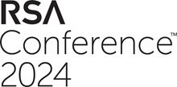
PRESS RELEASE
Swissbit makes its debut at the
RSA Conference 2024 showcasing
leading-edge FIDO2 solutions
May 6-9, 2024
Booth 5270
Westford, Massachusetts, USA, April 11, 2024 – Swissbit, a leading manufacturer of storage, security, and embedded IoT solutions, is thrilled to announce its first participation in the prestigious RSA Conference taking place from May 6 to May 9, 2024, at the Moscone Center in San Francisco. This marks a significant milestone for Swissbit as it introduces its cutting-edge iShield Key product series to the RSA community, emphasizing the importance of robust hardware authentication in today’s digital age.
Swissbit’s showcase will be centered around the iShield Key Pro, a cornerstone of the iShield Key series, which was designed to fortify online accounts with unparalleled hardware authentication capabilities. The iShield Key Pro distinguishes itself as more than just another FIDO security stick by supporting a wide array of security standards, including FIDO2, HOTP, TOTP, and PIV. Its unique capability to double as a physical access control tool sets it apart in the market, especially with the impending adoption of FIPS 140-3 standards, ensuring the highest level of cryptographic security.
New iShield Key Pro with USB-C Interface
In concert with the RSA Conference, Swissbit is excited to unveil the latest addition to its hardware token portfolio: the new iShield Key Pro with a USB-C interface. It maintains the versatility and robust security features of its predecessors while offering the modern convenience of USB-C connectivity. The iShield Key FIDO2, another variant in the lineup, is limited to the FIDO2/WebAuthn and U2F predecessor standard, making it a cost-efficient entry into the world of secure logins to websites and services. The iShield Key FIDO2 will also be available with USB-C and USB-A interfaces in the future.
According to Kai Imgenberg, Director Sales, Embedded IoT Solutions Americas at Swissbit, “Swissbit is at the forefront of a digital transformation where securing digital identities and transactions has never been more critical. Our presence at the RSA Conference signifies Swissbit’s commitment to FIDO2-based authentication solutions in North America. By empowering our customers to seamlessly implement zero-trust security principles and phishing-resistant MFA, we are not just participating in the industry’s evolution – we are leading it. We are confident that this event will be a catalyst for Swissbit in setting new benchmarks and delivering pioneering solutions to our customers. Swissbit will lead the Fido market by being the first to introduce FIPS 140-3 and as well as the only FIDO2 security dongle for logical and physical access control to the market.”

Leading the charge in FIDO2 authentication for North America
Swissbit’s vision to become the premier provider of FIDO2 solutions in North America is well in line with the growing demand for secure, flexible authentication methods that can keep pace with rapid advancements in technology and cyber threats. By introducing innovative products like the iShield Key Pro, Swissbit is set to make significant strides in enabling businesses to adopt stronger, phishing-resistant authentication mechanisms, thereby enhancing the overall security posture of organizations across the continent.
Swissbit invites attendees of the RSA Conference to visit Booth 5270 to explore the future of hardware authentication and discuss how Swissbit can support the implementation of robust security frameworks within their operations.

Available images
The following images are available for download in printable format at: https://kk.htcm.de/press-releases/swissbit/
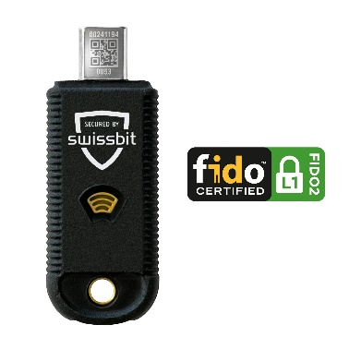  Source: Swissbit  The new iShield Key Pro, featuring a USB interface, makes its U.S. debut at the RSA Conference. | 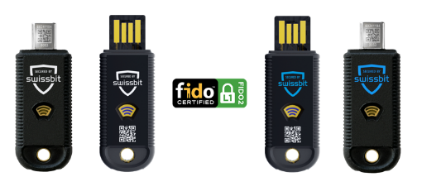  Source: Swissbit  The iShield Key family from Swissbit includes the iShield Key Pro and the iShield Key FIDO2, both featuring USB-A and USB-C interfaces.
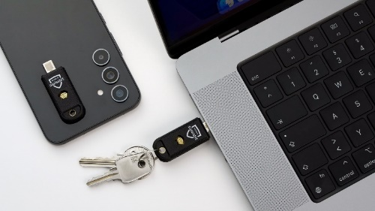  Source: Swissbit  In addition to USB, the iShield Key series also offers NFC connectivity. |   Source: Swissbit  Kai Imgenberg, Director Sales, Embedded IoT Solutions Americas, at Swissbit
About Swissbit
Swissbit AG is the leading European manufacturer of storage, security and embedded IoT solutions for demanding applications. Swissbit combines its unique competences in storage and embedded IoT technology with its advanced packaging know-how. This expertise allows our customers to reliably store and protect data in industrial, NetCom, automotive, medical and fiscal applications as well as across the Internet of Things (IoT).
Swissbit develops and manufactures industrial-grade storage and security products “Made in Germany” with high reliability, long-term availability, and custom optimization.
Besides FIDO2 security sticks, Swissbit offers a wide range of storage devices includes SSDs with PCIe and SATA interface such as mSATA, Slim SATA, CFast™, M.2 and 2.5” as well as CompactFlash, USB flash drives, SD Memory Cards, micro SD Memory Cards and managed NAND BGAs like e.MMC. All security products are available in various application specific editions as USB flash drives, SD Memory Cards, and micro SD Memory Cards.
Swissbit was founded in 2001 and has offices in Switzerland, Germany, USA, Japan and Taiwan. Swissbit owns the registered trademarks Swissbit® and Hyperstone®. Since 2020, the independent investment firm Ardian is holding a majority stake in the company to support its growth.
For further information, please visit www.swissbit.com

Regional Headquarters North and South America:
Swissbit NA Inc.
238 Littelton Rd #202b
Westford, MA 01886
USA
Tel: +1 978-490-3252
Email: salesna@swissbit.com
www.swissbit.com

Contact Headquarters:  Swissbit AG  Marian Weber  Industriestrasse 4  9552 Bronschhofen  Switzerland  Tel: +49 172 854 88 26  Email: marian.weber@swissbit.com  www.swissbit.com | Press Agency:  HighTech communications GmbH  Brigitte Basilio  Brunhamstrasse 21  81249 Munich  Germany  Tel: +49 89 500778-20  Email: b.basilio@htcm.de  www.htcm.de

